



**2022**

**REAL CHEMISTRY**

**FORM ONE AND TWO**

**1/1/2022**



Compile by: Mr. *Ahmed Yarrow Kheir.*

Mobile number: *+254724706355/+254768388373*

E-mail: *ahmadkheir1988@gmail.com*

P.O.BOX 427 WAJIR

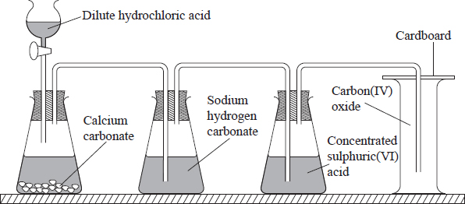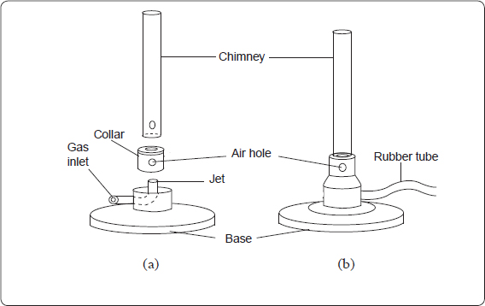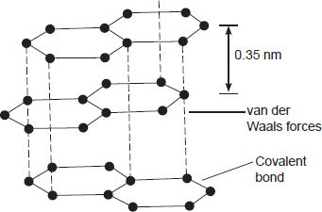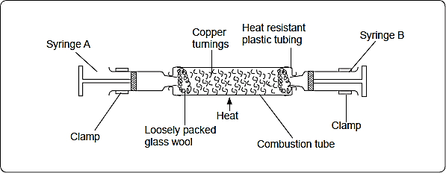

**REAL CHEMISTRY FORM ONE AND TWO REVISION BOOK**

INTRODUCTION TO CHEMISTRY

# Table of Contents

What is Chemistry?

Matter

Properties of matter

Mixtures

Conductors and non conductors

Drugs and drug abuse

Role of Chemistry in society

Apparatus used in Chemistry

Sources of heat

The Bunsen burner

Safety in the laboratory

Revision

# Objectives

**By the end of this chapter, the learner should be able to:**

* Define Chemistry.
* Identify the topics studied in Primary School Science which are part of Chemistry.
* State the role of Chemistry in society and identify some applications of Chemistry in everyday life.
* Identify and state the use of common apparatus in the laboratory.
* Operate a Bunsen Burner.
* Observe safety in the laboratory.

# Content

1. Review the following topics:

* properties of matter
* states of matter
* mixtures and their separations - conductors and non-conductors of electricity
* Mention of drugs (prescription, dosage and abuse)

1. Chemistry and the Society

* Definition of chemistry and its role in the society

1. Chemistry laboratory

* heating apparatus
* parts of a Bunsen burner and its flame
* measuring apparatus (volume, temperature, mass, time)
* other apparatus
* laboratory safety rules.

INTRODUCTION TO CHEMISTRY⚗

Chemistry is one of the three Science subjects. The other two subjects are Biology and Physics.

# What is Chemistry?

***Chemistry is the study of the structure, properties and composition of matter and the changes that matter undergoes*.**

States of matter and its properties, mixtures and their methods of separation and drugs are studied under Chemistry.

The study of Chemistry involves carrying out experiments, making observations, analysis, interpretation and making conclusions.

There are many branches of chemistry. The five main branches are considered to be:

1. **Organic Chemistry,**
2. **Inorganic Chemistry,**
3. **Analytical Chemistry,**
4. **Physical Chemistry,**and
5. **Biochemistry.**

# Review of Chemistry topics learned in the Primary Science course

Topics covered in primary science, which are studied under Chemistry include: Properties of matter, mixtures and methods of separation, drugs and pollution.

## Matter

***Matter is anything that has mass and occupies space***. Matter exists in three states namely solid, liquid and gas (vapour).

The three states of matter are inter convertible.

## ImageProperties of matter

***Physical properties of solids***

Solids have **definite shapes** that are not easily changed. Solids also have a **definite mass and volume.**

Mass is a **measure of the amount of matter in a substance.** Volume is the **space occupied by a substance.**

Different sizes of the same substance contain different amounts of matter and therefore have different masses. When a solid is put in water, the water level rises. The rise in water level represents the volume of the solid.

***Physical properties of liquids.***

Liquids have a **definite mass and volume** but **take the shape of the containers in which they are placed** due to their ability to flow.

***Physical properties of gases.***

Gases have a definite mass but do not have definite volume or shape. They can therefore be compressed to occupy small spaces and also expanded.

## Mixtures

Matter is found either as pure substances or mixtures. A pure substance is one that consists of only one type of matter.

A mixture consists of two or more substances mixed together and in which the individual components forming the mixture retain their physical and chemical properties.

A mixture can be separated by physical means such as winnowing, sieving, filtering, evaporating, decanting and use of magnets.

The choice of method to separate a given mixture depends on the nature and properties of the individual components forming the mixture.

## Conductors and non-conductors

Substances which allow electrical energy to flow through them are **conductors.**

Substances which do not allow electricity to flow through them are **non conductors.**

## Drugs and drug abuse

*A drug is* ***any substance, natural or manufactured which when used alters the way the body functions*.**

Drugs used to treat diseases in human beings and other animals are known as medicines.

Medicines are administered by qualified medical officers in specific amounts called **doses.**

The written instructions by a qualified medical officer, giving details on the type of drugs and how the drugs should be used is called a **prescription.**

The use of a drug for a purpose **other than what it is meant for**, or use of **overdose** or **underdose ofprescribed drugs** constitutes **drug abuse.**

Drug abuse has harmful effects on the state of health of the user. The harmful effects include **stress, depression, hallucination, addiction and dependency** or may be **fatal**.

The **commonly abused drugs** are **tobacco, alcohol,** **bhang and khat (miraa).**

Harmful effects of smoking **tobacco** include **lung cancer and heart failure.**

**Alcohol** abuse leads to **liver problems (liver cirrhosis).**

Misuse of bhang leads to **mental disorders**.

Prolonged use of **khat** leads to **addiction, dependency** and **vascular disorders.**

# Role of chemistry in the society

In Chemistry, substances are referred to as **chemicals**. The people who work with chemicals are **Chemists**.

Chemistry offers various **career opportunities** in various fields such as **medicine, pharmacy, food technology, education and engineering.**

Chemistry has helped to **improve standards of living** in areas such as:

1.    Manufacture of drugs to fight diseases.

2.    Food production to fight hunger.

3.    Manufacture of cheaper alternative fabrics such as nylon, polyester and tetron.

4.    Manufacture of plastics for roofing, packaging and domestic use.

5.    Manufacture of detergents.

6.    Production of fuels for transport and domestic use. This includes alternative fuels to reduce global pollution as well as to supplement the fossil fuels.

**Review Exercise 1.**

1. (a) Define chemistry.

(b) What role does chemistry play in the society?

1. (a)  What is a drug?

(b) Name three frequently abused drugs

(c)  State two long-term effects of drug abuse

(d) Differentiate between a dose and a prescription.

1. (b) Name four career opportunities open to a Chemist.

# The Chemistry Laboratory

A **laboratory** is a **building or special room** where **chemicals and apparatus are kept** and **in which practical subjects such as Chemistry are studied.**

## Safety in the laboratory

Since learning chemistry emphasises on practical work, it is necessary that certain rules are followed to ensure safety in the Chemistry laboratory.

The two common **causes of accidents in the laboratory** are **ignorance** and **carelessness**. Accidents are minimised when safety rules are followed.

All chemicals with environmental and health impacts must be stored in well labelled containers with appropriate safety warning symbols clearly visible*.*

**Laboratory safety rules**

1.    NEVER run while in the laboratory because you may trip, fall and injure yourself or other users of the laboratory.

2.    NEVER taste or eat anything in the laboratory to avoid poisoning.

3.    Always consult your teacher before trying any experiment to avoid accidents.

4.    Label all the chemicals you are using to avoid confusion.

5.    Always use a clean spatula for scooping a substance from a container to prevent contamination.

6.    Always hold test-tubes or boiling tubes using a test-tube holder when heating to avoid being burned.

7.    When heating a substance in a test tube or boiling tube, NEVER let the open end face you or anybody else because the liquid may spurt out and cause injury.

8.    NEVER look directly into flasks and test-tubes where reactions are taking place, because the chemicals may spurt into your eyes and cause injury.

9.    NEVER smell gases directly, instead waft the gas towards your nose with your hand.

10.  Experiments in which poisonous gases are produced must be carried out in a fume cupboard or outdoors.

11.  Always keep flammable substances away from flames because they easily catch fire.

12.  Report any accidents to the teacher or the laboratory technician immediately for necessary action.

13.  In case of a serious accident such as fire, calmly walk out, DONT SCRAMBLE for the exit. Doing so would hinder easy escape.

14.  Always extinguish flames that are not in use to avoid accidents and minimise fuel wastage.

15.  If a chemical gets on your skin or in your mouth rinse it immediately with a lot of clean water.

16.  Chemicals already used must always be disposed off safely to avoid contamination.

17.  Always work on a clean bench. Clean all the pieces of apparatus used and store them at the end of each experiment.

# Apparatus used in Chemistry

Most laboratory apparatus which are used as containers and reaction vessels are **made of transparent glass or plastic.**

**The reasons why most apparatus in the laboratory are made of glass andplastic is:**

1. To allow one to see through while observing the reactions taking place or to determine the level of the liquids held there in.
2. Glass and plastic also do not react with most of the reagents used in the laboratory.
3. **Apparatus for measuring volume**

All apparatus used for measuring volumes of liquids are usually of **transparent glass or plastic.** The apparatus used for measuring volumes of liquids include a graduated beaker 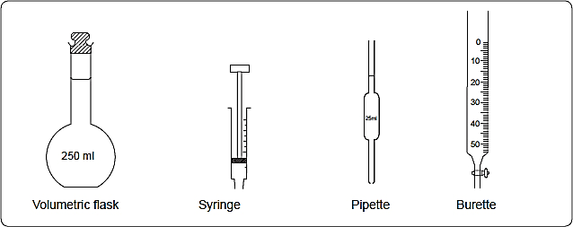and flask, a measuring cylinder, volumetric flask, syringe, pipette and burette.

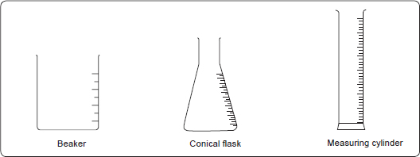To measure**approximate volumes, graduated beakers, flasks and measuring cylinders** are used.

When fairly accurate volumes are required, **volumetric flasks, syringes, pipettes and burettes** are used.

1. **Apparatus for general uses**

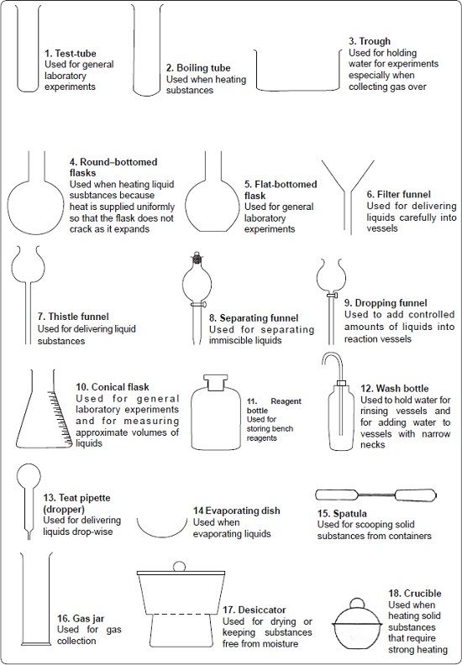

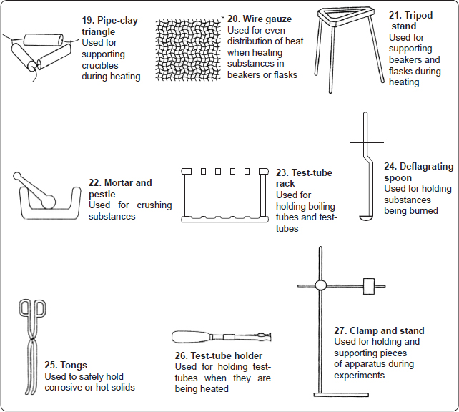

1. **Apparatus for measuring temperature**

Temperature is measured using thermometers. There are different types of thermometers such as maximum and minimum, clinical and general purpose thermometers such as the one shown below which is commonly used in the laboratory.

1. **Apparatus for measuring mass**

Mass is measured using weighing balances. There are different types of weighing balances such as beam balances, electronic balances and top pan balances.

1. **Apparatus for measuring time**

The apparatus for measuring time are watches and clocks. For **accuracy** during experiments in the laboratory, **stop watches and stop clocks** are used.

1. **Sources of Heat**

The pieces of apparatus used as sources of heat include the Bunsen burner, spirit lamp, candle, gas stove (portable burner), kerosene stove and electric heater. The Bunsen burner is the most suitable source of heat in laboratories.

**Review Exercise 2**

1. (a) What is a laboratory?

(b) Explain why most laboratory apparatus are made of glass.

1. (a) What are the two causes of accidents in the laboratory?

(b) Putting off flames after use is one of the safety rules in the laboratory. State five other rules

1. Give two apparatus used in the chemistry laboratory for:
   1. measuring accurate volumes of liquids
   2. measuring approximate volumes of liquids
   3. measuring mass

## The Bunsen Burner

A Bunsen burner consists of three major parts. These are the **chimney**, the **collar** and the **base** as shown below.

*Parts of a Bunsen burner*.

* + 1. **Functions of the different parts of a Bunsen burner**
* The base is made of **thick metallic material** into which a small **hollow metal with a jet** is fitted. The **base** is **heavy and wide** to keep the Bunsen burner **stable**.
* The **jet allows the laboratory gas into the chimney.**
* The **gas inlet** in the Bunsen burner is normally connected to an **external source of laboratory gas** by **rubber tubing**to let in the lab gas.
* The **collar** is a **metal ring** which may have an **air hole whose diameter is the same size as that of the hole in the chimney.** The diameter of the collar is **slightly bigger than that of the chimney so that the chimney can just fit into it.** The collar is used to **regulate the amount of air entering the chimney.**
* The **chimney** is a **hollow metallic cylinder** with an **air hole** near its lower end. The **air hole** in the chimney **allows air to enter** and mix with the laboratory gas from the jet. This mixture of gases (laboratory gas and air), when ignited **burn at the top of the chimney** to produce a **flame**.
  + 1. ***Types of flames produced by a Bunsen burner***

*A* ***flame*** *is a* ***mass of burning gases***.

When in use, a Bunsen burner produces two types of flames depending on the amount of air allowed into the chimney.

**The luminous flame**

A **luminous flame** is produced when the **air hole is closed** such that **no air enters the chimney of a Bunsen burner.**

**The luminousflame produces light because it containsunburnt tiny particles of hot glowing solid carbon which give out light**due to**incomplete** combustion of the gas since there is **limited supply of air.**

To produce a luminous flame, connect the burner to a gas tap and close the air hole. Turn on the 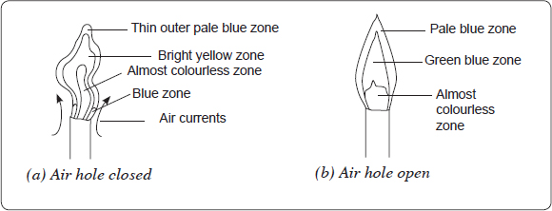gas fully and light the burner.

The luminousflame is:

1. Bright yellow
2. Large and wavy.
3. It gives out much light (**luminous)**
4. A luminous flame has four zones.
5. Produces soot
6. Burns silently

The **blue zone** occurs at the **bottom** of the flame. Air near the flame rises rapidly and mixes with the burning gas. This makes burning **almost** complete.

The **almost colourless zone** of the flame consists mainly of **unburnt** gases.

The luminous **bright yellow zone** consists mainly of **unburnt tiny particles of hot glowing solid carbon which give out light.** The **unburnt carbon particles** form the **black soot** which makes apparatus dirty during heating. Air supply in the **bright yellow zone** is limited and there is **incomplete** combustion of the gas.

In the **thin outer pale blue zone,** the gas burns **completely** because it **mixes with plenty of air.** However, this region is normally difficult to see.

**The non-luminous flame**

The **non-luminous flame** is produced when the **air hole** of the Bunsen burner is **open**. When the air hole is open, air enters the chimney and mixes with the laboratory gas. There is **complete combustion** of the gas and therefore the flame produced is pale blue in colour. It does not give out much light.

To obtain a non-luminous flame, connect the burner to a gas tap and close the air hole. Turn on the gas fully and light the burner. Turn the collar gradually until the hole is fully open.

The non-luminous flame:

1. Has three zones.
2. Is short and steady
3. Does not give out much light
4. Burns with a roaring sound
5. Does not produce soot.

The **almost colourless zone** consists of **unburnt gases**.

The **green blue zone** contains **partially burnt gases** due to **insufficient supply of air.**

In the **outer pale blue zone**, the gases **burn completely** because **there is plenty of air.**

The non-luminous flame gives out **only a little light because it contains fewer hot carbon particles.**

* + 1. ***Heating effects of the luminous and non-luminous flames.***

Light a Bunsen burner and adjust the collar to produce a luminous flame. Pour 30cm3 of water into 100ml glass beaker. Heat the water in the beaker and note the time it takes to 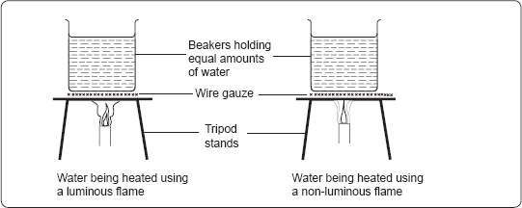boil.

Repeat the experiment using 30cm3 of water in an identical beaker and heat it with a non-luminous flame of the same Bunsen burner. In each case, observe the part of the beaker that was in contact with the flame.

**Questions**

1. **Which water sample took a shorter time to boil?**

Water heated by a non-luminous flame took a shorter time to boil than the same amount of water heated by a luminous flame. This shows that the non-luminous flame is hotter than the luminous flame.

1. **What was observed at the bottom of each beaker?**

The bottom of the beaker heated using the **luminous flame is covered with soot** while the beaker heated using a **non-luminous flame remains clean.**

1. **Explain the observations you have made.**

The Water heated by a non-luminous flame took a shorter time to boil than the same amount of water heated by a luminous flame because the non-luminous flame is hotter than the luminous flame due to complete combustion.

The luminous flame produces soot due to the presence of unburnt carbon particles. .

1. **Which type if flame is preferred for heating and why?**

The non-luminous flame. Because:

* 1. The non-luminous flame is **very hot** compared to the luminous flame
  2. The non-luminous flame does not produce soot.

1. **Which flame is preferred for lighting and why?**

Luminous flames such as the candle flame and flame of lantern lamps are normally used for lighting because they give out light.

***Which is the hottest part of a non-luminous flame?***

Light a Bunsen burner and adjust the collar to obtain a non-luminous flame. Slip a piece of white manilla paper into the flame in region (i) as shown below.

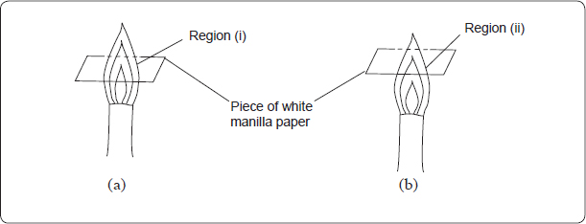Quickly remove the paper before it catches fire. Slip a fresh piece of white manilla paper into region (ii) of the flame as shown in figure 1.0 (b). Quickly remove it before it catches fire.

Now repeat the experiments using wooden splints instead of white manilla paper. Let each splint stay in the flame until some of its parts get charred. Record your observations.

**Questions**

1. **Draw diagrams to show how the pieces of paper and the splints were affected when placed in:**
   * 1. **region (i).**

When a piece of paper is quickly slipped in and out of region (i) of the non-luminous flame, the paper is partly burnt in the regions that are in contact with the pale blue zone. The middle part 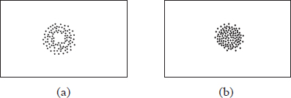of the paper remains unburnt (no charring).

* + 1. **region (ii) of the flame.**

When a piece of paper is slipped in and out of region (ii) of the non-luminous flame, it burns uniformly.

1. **Draw diagrams to show how the wooden splints were affected when placed in both regions.**

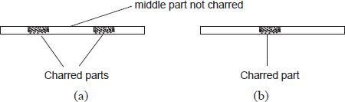 When wooden splints are used instead of paper, similar results

1. **What conclusions can be made from these experiments?**

These experiments show that the **outer most zone** in a non-luminous flame is **hotter** than the inner zones.

1. **Which part of the flame is suitable for heating substances?**

**T**he **outermost region** of the flame. This is the hottest region of the flame because of complete combustion.

**Review Exercise 3**

* 1. The following diagram represents a non-luminous flame of the Bunsen burner.

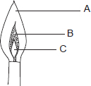

(a)   Name the parts of the flame labelled A, B and C.

(b)   Which of the parts in (a) above is the hottest?

(c)   A non-luminous flame is preferred for heating. Explain.

(d)   (i)    Name the other type of flame produced by a Bunsen burner.

(ii)   Under what conditions does the Bunsen burner produce the flame you have named in d (i)?

(e)   After use, a non-luminous flame should be put off or adjusted to a luminous flame. Explain.

2. (a) What is a flame?

(b) Which type of flame is produced when the air hole of a Bunsen burner is closed?

(c) Draw a well labeled diagram of the type of flame in (b) above.

(d)State four observable differences between a luminous and a non-luminous flame.

3. A piece of paper was slipped in and out of the regions (i) and (ii) of the non-luminous flame as shown below.

(a) Draw diagrams to show how the pieces of paper were affected when placed in:

(i)   region (i).

(ii)   region (ii) of the flame.

(b) Explain the observations made.

(c) What would be observed if wooden splints were used instead of the paper?

(c) From the experiments above, which part of the flame is preferred for heating? Why?.

**Revision exercise**

1. (a) What is chemistry?

(b) Is chemistry important to the society? Explain.

1. Name three careers where knowledge of chemistry is required.
2. (a) What is a drug?

(b) Define the following terms

i) Drug abuse

ii) Prescription

iii) Dose

(c) Give **four** drugs that are commonly abused by the youth.

(d ) give any 5 harmful effects of drug abuse

(e)Why is it very necessary to follow the doctor’s prescription when taking medication?

3. Give the names of the apparatus used for

(i) measuring accurate volumes of substances

(ii) measuring approximate volumes of substances.

(iii) measuring mass.

1. Why are most of the apparatus in chemistry laboratories made of glass?
2. Which other apparatus can be used for heating purposes in the laboratory apart from the Bunsen burner?
3. Name the three states of matter.
4. (a) The diagram below shows apparatus commonly used in a school laboratory.

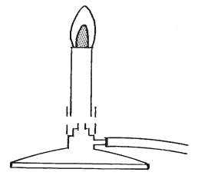

* 1. What is the name of apparatus?
  2. Label the following parts: region of unburnt gas, chimney, jet, collar.

(b) What do you call the flame produced when the air hole is open?

(c) Explain briefly why the luminous flame, produces light while the non-luminous flame does not.

1. Name the regions labelled **a, b and c** in the diagram below. Which region is used for heating? Give a reason.

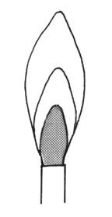

(

a

)

(

b

)

(

c

)

1. Wooden splints **F** and **G** were placed in different zones of a Bunsen burner flame. The diagram below gives the observations that were made

**G**

**F**

Burnt parts

Burnt part

(a) Explain the difference between **F** and **G**

(b) Name the type of flame that was used in the above experiment

1. State two reasons why we use the non-luminous flame in the laboratory instead of the luminous flame.
2. State six differences between a luminous and non-luminous flam
3. 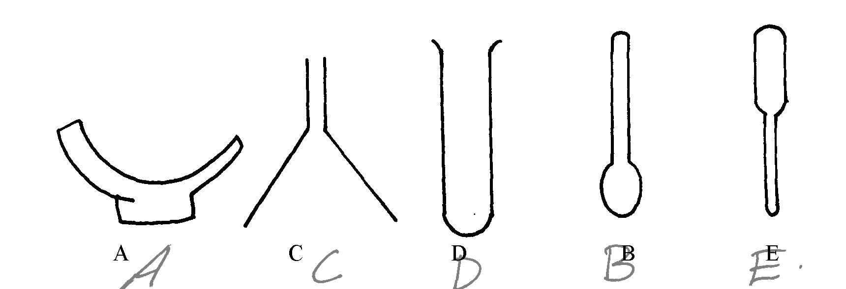(a). The diagrams below represent a list of apparatus which are commonly used in a chemistry laboratory:-

**A B C D E**

Give the names and uses of all the apparatus.

1. State any 5 laboratory rules.
2. What do you call the method of obtaining clean water from muddy water?
3. Name a non-metal which conducts electricity.

13. (a) When the air-hole is fully opened, the bunsen burner produces a non-luminous flame.Explain

(b) Draw a labelled diagram of anon-luminous flame

14. (a) What is a drug?

(b) Give **two** drugs that are commonly abused by the youth.

15. The diagrams below are some common laboratory apparatus. Name each apparatus and state its use

|  |  |  |
| --- | --- | --- |
| **Diagram** | **Name** | **Use** |
|  | (½mk ) | (½mk) |
|  | (½mk) | (½mk) |

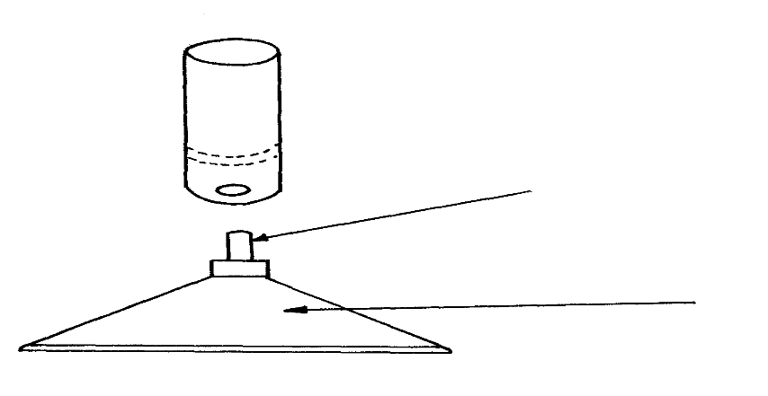16. The diagram below shows some parts of a Bunsen burner

**T**

**U**

Explain how the parts labelled **T** and **U** are suited to their functions

**CLASSIFICATION OF SUBSTANCES**

Substances are either pure or impure. A pure substance is one which contains only one substance.

An impure substance is one which contains two or more substances. A pure substance is made up of a pure solid, pure liquid or pure gas.

A mixture is a combination of two or more pure substances which can be separated by physical means. The three states of matter in nature appear mainly as mixtures of one with the other.

Common mixtures include:

**(a)Solutions/solid-liquid dissolved mixture**

**Experiment:**

To make a solution of copper (II) sulphate (VI)/Potassium magnate(VII) /sodium chloride

Procedure

Put about 100 cm3 of water in three separate beakers. Separately place a half spatula end full of copper (II) sulphate (VI), Potassium manganate (VII) and sodium chloride crystals to each beaker. Stir for about two minutes.

Observation

Copper (II) sulphate (VI) crystals dissolve to form a blue solution

Potassium manganate (VII) crystals dissolve to form a purple solution

Sodium chloride crystals dissolve to form a colourless solution

**Explanation**

Some solids, liquids and gases dissolve in some other liquids.

A substance/liquid in which another substance dissolves is called solvent.

A substance /solid /gas which dissolves in a solvent is called solute.

When a solute dissolves in a solvent it forms a uniform mixture called **solution**.

A solute dissolved in water as the solvent exists in another state of matter called **aqueous state.** Water is referred as the **universal solvent** because it dissolves many solutes. A solute that dissolves in a solvent is said to be **soluble**. Soluble particles uniformly spread between the particles of water/solvent and cannot be seen.

**Solute**  **+**  **Solvent**  **->**  **solution**

**Solute**  **+**  **Water**  **->**  **aqueous solution of solute**

The solute dissolved in water gives the **name** of the solution e. g.

1. Sodium chloride solution is a solution formed after dissolving sodium chloride crystals/solid in water. Sodium chloride exists in aqueous state after dissolving.

Sodium chloride + Water -> Sodium chloride solution

NaCl(**s**) + (aq) -> NaCl(**aq**)

2. Ammonia solution is a solution formed after dissolving ammonia gas in water. Ammonia exists in aqueous state after dissolving.

Ammonia gas + Water -> aqueous ammonia

NH3 (**g**) + (aq) -> NH3 (**aq**)

3. Copper (II) sulphate (VI) solution is a solution formed after dissolving Copper (II) sulphate (VI) crystals/solid in water. Copper (II) sulphate (VI) exists in aqueous state after dissolving.

Copper (II) sulphate (VI) + Water -> Copper (II) sulphate (VI) solution

CuSO4(**s**) + (aq) -> CuSO4 (**aq**)

4. Potassium manganate(VII) solution is a solution formed after dissolving Potassium manganate(VII) crystals/solid in water.

Potassium manganate(VII)exist in aqueous state after dissolving.

Potassium manganate(VII) + Water -> Potassium manganate(VII) solution

KMnO4(**s**) + (aq) -> KMnO4 (**aq**)

**(b)Suspension/ precipitates/solid-liquid mixture which do not dissolve**

**Experiment: To make soil, flour and Lead (II) Iodide suspension/precipitate**

**Procedure**

Put about 100 cm3 of water in three separate beakers. Separately place a half spatula end full of soil, maize and lead (II) Iodide to each beaker. Stir for about two minutes.

**Observation**

Some soil, maize and lead (II) Iodide float in the water

A brown suspension/precipitate/particles suspended in water containing soil

A white suspension/precipitate/particles suspended in water containing flour

A yellow suspension/precipitate/particles suspended in water containing Lead (II) iodide. Some soil, maize and lead (II) Iodide settle at the bottom after some time.

**Explanation**

Some solid substances do not dissolve in a liquid. They are said to be **insoluble** in the solvent .When an insoluble solid is put in liquid:

(i) Some particles remain **suspended/floating** in the liquid to form a **suspension** /**precipitate**.

(ii) Some particles **sink/settle** to the bottom to form **sediments** after being allowed to stand.

An **insoluble** solid acquire the colour of the suspension/precipitate .e.g.

1. A white suspension /precipitate have some fine white particles suspended /floating in the liquid. **Not** “white solution”

2. A blue suspension /precipitate has some fine **blue** particles suspended /floating in the liquid.

3. A green suspension /precipitate has some fine **green** particles suspended /floating in the liquid.

4. A **brown** suspension /precipitate has some fine **brown** particles suspended /floating in the liquid.

4. A yellow suspension /precipitate has some fine yellow particles suspended /floating in the liquid.

(c) (i) Miscibles /Liquid-liquid mixtures

**To form water-ethanol and Kerosene-turpentine miscibles**

**Procedure**

(i)Measure 50cm3 of ethanol into 100cm3 beaker. Measure 50cm3 of water. Place the water into the beaker containing ethanol. Swirl for about one minute.

(ii)Measure 50cm3 of kerosene into 100cm3 beaker. Measure 50cm3 of turpentine oil. Place the turpentine oil into the beaker containing kerosene. Swirl for about one minute.

**Observation**

Two liquids do not form layers.

Ethanol and water form a uniform mixture.

Kerosene and turpentine oil form uniform mixture

**Explanation**

Ethanol is miscible in Water. Kerosene is miscible in turpentine oil. Miscible mixture form uniform mixture. They do not form layers. The particles of one liquid are smaller than the particles of the other. The smaller particles occupy the spaces between the bigger particles.

Immiscibles /Liquid-liquid mixtures

**To form water-turpentine oil and Kerosene-water miscibles**

**Procedure**

(i)Measure 50cm3 of water into 100cm3 beaker. Measure 50cm3 of turpentine oil. Place the oil into the beaker containing water. Swirl for about one minute.

(ii) Measure 50cm3 of water into 100cm3 beaker. Measure 50cm3 of kerosene. Place the kerosene into the beaker containing water. Swirl for about one minute.

**Observation**

Two liquids form layers.

Turpentine and water do not form a uniform mixture.

Water and kerosene do not form uniform mixture

**Explanation**

Kerosene is immiscible in Water. Water is immiscible in turpentine oil. Immiscible mixtures do not form uniform mixtures. They form layers. The size of the particles of one liquid is almost equal to the particles of the other. The particles of one liquid cannot occupy the spaces between the particles of the other. The heavier particles settle at the bottom. The less dense particles settle on top.

**(d)Solid-solid mixtures/Alloys**

Before solidifying, some heated molten/liquid metals dissolve in another metal to form a uniform mixture of the two. On solidifying, a uniform mixture of the metals is formed. A uniform mixture of two metals on solidifying is called **alloy**. In the alloy, one metallic particle occupies the spaces between the metallic particles of the other.

**c) Common alloys of metal.**

|  |  |  |
| --- | --- | --- |
| **Alloy name** | **Constituents of the alloy** | **Uses of the alloy** |
| Brass | Copper and Zinc | Making screws and bulb caps |
| Bronze | Copper and Tin | Making clock springs, electrical contacts and copper coins |
| Soldier | Lead and Tin | Soldering, joining electrical contacts because of its low melting points and high thermal conductivity |
| Duralumin | Aluminum, Copper and Magnesium | Making aircraft, utensils, and windows frames because of its light weight and corrosion resistant. |
| Steel | Iron, Carbon ,Manganese and other metals | Railway lines, car bodies girders and utensils. |
| Nichrome | Nichrome and Chromium | Provide resistance in electric heaters and ovens |
| German silver | Copper, Zinc and Nickel | Making coins |

**METHODS OF SEPARATING MIXTURES**

Mixtures can be separated from applying the following methods:

**(a) Decantation**

Sediments can be separated from a liquid by pouring out the liquid. This process is called **decantation.**

**Experiment**

Put some sand in a beaker. Add about 200cm3 of water. Allow sand to settle. Pour off water carefully into another beaker.

**Observation**

Sand settles at the bottom as sediments.

Less clean water is poured out.

**Explanation**

Sand does not dissolve in water. Sand is denser than water and thus settles at the bottom as **sediment**. When poured out, the less dense water flows out.

**(b)Filtration**

Decantation leaves suspended particles in the liquid after separation. Filtration is thus improved decantation.Filtration is the method of separating insoluble mixtures/particles/solids from a liquid.

**Experiment: To separate soil and water using filtration**

Fold a filter paper to fit well into a filter funnel. Place the funnel in an empty 250 cm3 beaker.

Put one spatula end full of soil into 50cm3 of water. Stir. Put the soil/water mixture into the filter funnel.

**Observations**

Clean water is collected **below** the filter funnel.

Soil remains **above** the filter paper.

**Explanation**

A filter paper is **porous** which act like a fine sieve with very small **holes**. The holes allow smaller water particles to pass through but do not allow bigger soil particles. The liquid which passes through is called **filtrate**. The solid which do not pass through is called **residue**.

**Set up of apparatus**

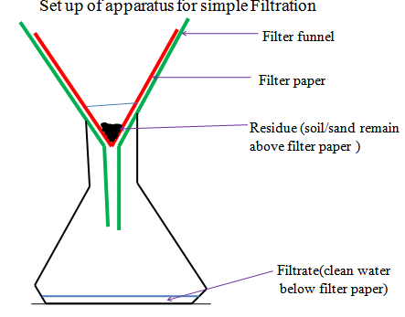

In industries, filtration is used in engine filters to clean up air.

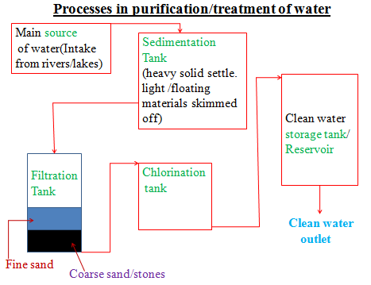

**(c)Evaporation**

Evaporation is a method of separating a solute/solid from its solution. This involves heating a solution (solvent and solute)to vapourize the solvent out of the solution mixture leaving pure solute/solid. If a mixture contain insoluble solid, they are filtered out.

Experiment: **To separate a mixture of soil and salt (sodium chloride).**

**Procedure:**

Put one spatula end full of soil on a filter paper.

Put one spatula full of common salt/sodium chloride into the same filter paper. Mix well using the spatula,.

Place about 200cm3 of water into a beaker.

Put the contents of the filter paper into the water. Stir thoroughly using a glass/stirring rod for about one minute.

Fold a filter paper into a filter funnel.

Pour half portion of the contents in the beaker into the filter funnel.

Put the filtrate into an evaporating dish. Heat on a water bath.

**Observation**

(i)On mixing

Colourless crystals and brown soil particles appear on the filter paper.

(ii)On adding water

Common soil dissolves in water. Soil particles do not dissolve in water.

(iii)On filtration

Colourless liquid collected as filtrate below the filter funnel/paper.

Brown residue collected above the filter funnel/paper.

(iv)On evaporation

Colourless crystals collected after evaporation

**Explanation**

Solid mixture of sand and common salt take the colors of the two.

On adding water, common salt dissolves to form a solution.

Soil does not because it is insoluble in water and thus forms a suspension.

On filtration, a residue of insoluble soil does not pass through the filter paper.

It is collected as residue.

Common salt solution is collected as filtrate.

On heating the filtrate, the solvent/water evaporate/vaporize out of the evaporating dish leaving common salt crystals.

Vapourization/evaporation can take place even without heating.

This is the principle/process of drying wet clothes on the hanging line.

Set up of apparatus

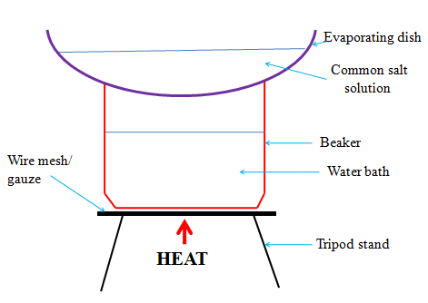

**(d) Distillation**

Distillation is an improved evaporation where both the solute and the solvent in the solution are separated /collected. Distillation therefore is the process of separating a solution into constituent solid solute and the solvent. It involves heating the solution to evaporate/vaporize the solvent out. The solvent vapour is then condensed back to a liquid.

**Experiment: To obtain copper (II) sulphate (VI) crystals and water from copper (II) sulphate (VI) solution.**

**Procedure:**

Put one spatula end full of copper (II) sulphate (VI) crystals into a 250cm3 beaker.

Place about 200cm3 of water into the beaker.

Stir thoroughly using a glass/stirring rod for about one minute.

Pour half portion of the contents in the beaker into a round bottomed/flat/conical flask broken porcelain/sand/glass into the flask.

Put a few pieces of b Stopper the flask.

Connect the flask to a Liebig condenser using delivery tube.

Place a 200cm3 clean empty beaker/conical flask as a receiver at the end of the Liebig condenser.

Circulate water in the Liebig condenser.

Heat the flask strongly on a tripod stand with wire mesh/gauze until there is no more visible **boiling bubbles** in the flask.

**Observation**

Copper (II) sulphate (VI) crystals dissolve in water to form a blue solution.  
On heating, colourless liquid is collected in the receiver.

Blue crystals are left in the flask.

(If gently heated further, the blue crystals turn to white powder)

**Explanation**

On heating blue Copper (II) sulphate (VI) solution, the colourless liquid solvents evaporate/vaporize.

The liquid vapour/gas passes through the delivery tube to the Liebig condenser.

The Liebig condenser has a cold water **inlet** near the receiver and cold water **out** let.

This ensures efficient cooling. If the cold water **outlet/inlet** is reversed, the water circulation would be less efficient.

The water in the receiver would be warm. In the Liebig condenser, the cold water condenses the liquid vapour into liquid.

The condensed liquid collects in the receiver as **distillate**.

The solute of blue Copper (II) sulphate (VI) crystals is left in the flask as **residue**.

During simple distillation, therefore, the solution is heated to vaporize /evaporate the solvent/one component which is condensed at a different part of the apparatus.

The purpose of pieces of broken porcelain/porous pot/glass/sand/ is to:

(i) Prevent bumping of the solution during boiling.

(ii) Ensure smooth and even boiling.

Salty sea water can be made pure through simple distillation.

Any mixture with a large difference /40oC in boiling point can be separated using simple distillation.

**Set up of apparatus**

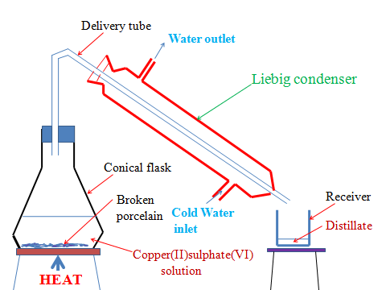

**e)Fractional distillation**

Fractional distillation is an improved simple distillation used specifically to separate miscible mixtures with very **close /near** boiling points.

**Fractional distillation involves:**

(**i**) Heating the mixture in a conical/round bottomed /flat bottomed flask.

The pure substance with a lower boiling point and thus more volatile evaporates/boils/vaporize first.e.g. Pure ethanol has a boiling point of 78oC.Pure water has a boiling point of 100 oC at sea level/one atmosphere pressure.

When a miscible mixture of ethanol and water is heated, ethanol vaporizes /boils/ evaporates first because it is more volatile.

(**ii**)The conical/round bottomed /flat bottomed flask is connected to a long glass tube called **fractionating column**.

The purpose of the fractionating column is to offer areas of condensation for the less volatile pure mixture.

The fractionating column is packed with glass beads/broken glass/ porcelain/ shelves to increase the surface area of condensation of the less volatile pure mixture.

(**iii**)When the vapors rise they condense on the glass beads/broken glass /porcelain / shelves which become hot.

When the temperature of the glass beads/broken glass/porcelain/shelves is beyond the boiling point of the less volatile pure substance, the pure substance rise and condensation take place on the glass beads/broken glass/porcelain/shelves at a higher level on the fractionating column.

The less volatile pure substance trickles/drips back down the fractionating column or back into the conical/round bottomed /flat bottomed flask to be heated again. e.g.

If the temperature on glass beads/broken glass/porcelain/shelves is beyond 78oC, the **more volatile** pure ethanol rise to condense on the glass beads/broken glass /porcelain/shelves **higher** in the fractionating column.

Water condenses and then drip/trickle to the glass beads/broken glass /porcelain /shelves **lower** in the fractionating column because it is **less volatile.**

(**iv**) The fractionating column is connected to a Liebig condenser. The Liebig condenser has a cold water inlet and outlet circulation.

The more volatile mixture that reach the top of the fractionating column is condenses by the Liebig condenser into a receiver. It is collected as the first fraction.

(**v**)At the top of the fractionating column, a thermometer is placed to note/monitor the temperature of the boiling mixtures.

Pure substances have constant/fixed boiling point. When one mixture is completely separated, the thermometer reading rises.

E.g. the thermometer reading remains at78oC when ethanol is being separated. When no more ethanol is being separated, the mercury/alcohol level in the thermometer rises.

(**vi**)The second /subsequent fractions are collected in the receiver after noting a rise the mercury/alcohol level in the thermometer.

E.g. the thermometer reading rises to 100oC when water is being separated. It is passed through the Liebig condenser with the cold water inlet and outlet circulation. It is collected different receiver as the second/subsequent fraction.

(vii)Each fraction collected should be confirmed from known physical/chemical properties/characteristic.

Example

**Ethanol**

Ethanol is a colourless liquid that has a characteristic smell .When it is put in a watch glass then ignited, it catches fire and burn with a blue flame.

**Water**

Water is a colourless liquid that has no smell/odour .When it is put in a watch glass then ignited, it does not catch fire.

**Set up of apparatus**

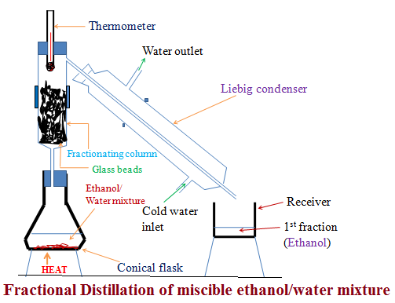

**Industrial application of Fractional distillation**

On a large scale,fractional distillation is used:

**(i)**In fractional distillation of crude oil in an oil refinery.

Crude oil is a mixture of many fractions. When heated in a furnace, the different fractions separate out according to their boiling point. In Kenya,fractional distillation takes place at Changamwe in Mombasa.

**(ii)**In fractional distillation of air.

Air contain a mixture of three main useful gases which are condensed by cooling to very low temperature (-200oC) to form a liquid. The liquid is then heated. Nitrogen is the most volatile (-196 oC) and thus comes out as the first fraction. Argon (at -186 oC) is the second fraction. Oxygen ( at -183 oC) is the last fraction. The three gases are very useful industrial gases.

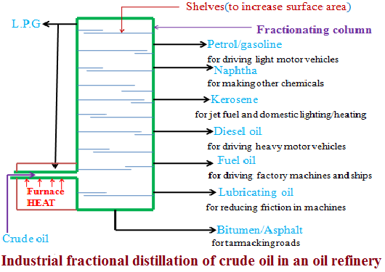

**(f)Separation of immiscibles (Using a separating funnel)**

Two or more liquids that form layers on mixing are immiscible. Immiscible mixture arrange themselves according to their densities

i.e. The denser liquid sink to the bottom. The less dense liquid floats on the denser one. Immicible mixtures can be separated from each other by using a **separating funnel**.

**Experiment:** To separate an immiscible mixture of paraffin and water.

**Procedure**

Place about 100cm3 of water into a 250cm3 beaker. Add about 100cm3 of paraffin into the beaker. Stir.

Transfer the mixture into a separating funnel. Allow to settle for about one minute. Open the tap, run out the lower layer out slowly into a clean beaker. Close the tap when the upper layer is very close to the tap.

Run out the intermediate small amount of the mixture near the tap into a beaker. Discard it.

Run out the remaining upper layer into a fresh beaker.

Place a portion of upper and lower layer into a watch glass separately after separating each. Ignite.

**Observation**

Water and paraffin are both colourless liquids.

Two layers are formed on mixing.

Colourless odorless liquid collected first. It does not catch fire.

A colourless liquid with characteristic smell collected later/second. It catches fire and burn with a yellow smoky flame.

**Explanation**

Water and paraffin are immiscible. Water is denser than paraffin. When put in a separating funnel, paraffin float on water. On opening the tap, water runs out. A mixture of water and paraffin at the junction of the two is discarded. It is not pure.

**Set up of apparatus**

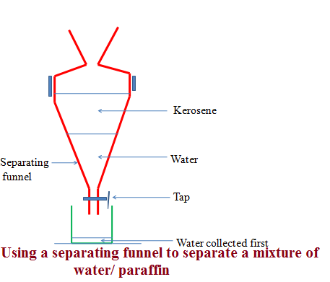

**(g)Sublimation/deposition**

Some solids on heating do not melt to a liquid but change directly to a gas. The process by which a solid changes to a gas is called **sublimation**. The gas cools back and changes directly to a solid. The process by which a gas changes to a solid is called **deposition.** Sublimation and deposition therefore are the same but opposite processes.

Sublimation Deposition

Some common substances that undergo sublimation/ deposition include:

(i)Iodine (ii)Carbon(IV)oxide (iii)Camphor (iv) ammonium chloride (v)Iron(III)chloride (vi)Aluminum(III)chloride

(vii) benzoic acid

If a mixture has any of the above as a component, then on heating it will change to a gas and be deposited away from the source of heating.

**Procedure**

Place about one spatula full of ammonium chloride crystals into a clean dry 100cm3 beaker. Add equal amount of sodium chloride crystals into the beaker. Swirl to mix.

Place the beaker on a tripod stand.

Put about 100cm3 of water into another beaker. Place carefully the beaker containing water on top of the beaker containing the solid mixture. Light/ignite a burner and heat the solid.

Set up of apparatus:

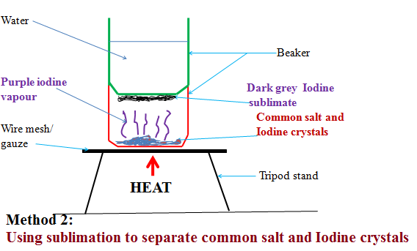

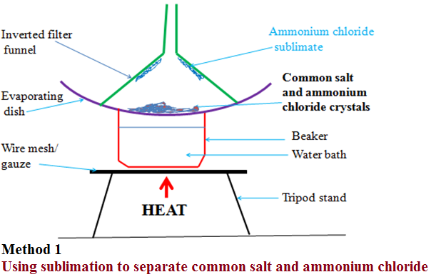

Observation

(i)With ammonium chloride/common salt mixture

White fumes produced.

White sublimate deposited

Colourless residue left

(ii)With Iodine/common salt mixture

Purple fumes produced.

Dark grey sublimate deposited

Colourless residue left

**Explanation**

(i)On heating a mixture of ammonium chloride and common salt, a white fume of ammonium chloride is produced. The white fumes solidify as white sublimate on the cooler parts. Common salt remains as residue.

Chemical equation:

Ammonium chloride **solid** Ammonium chloride **gas**

NH4Cl(**s**) NH4Cl(**g**)

(ii)On heating a mixture of Iodine and common salt, a purple fume of Iodine vapour is produced. The purple fumes solidify as dark grey sublimate on the cooler parts. Common salt remains as residue.

Chemical equation:

Iodine **solid** Iodine **gas**

I2(**s**) I2 (**g**)

**(h)Chromatography**

Chromatography is a method of separating components of a solution mixture by passing it through a medium where the different components move at different rates. The medium through which the solution mixture is passed is called **absorbent material**.

Paper chromatography is a method of separating colored dyes by using paper as the absorbent material.

Since dyes are insoluble/do not dissolve in water, ethanol and propanone are used as suitable solvents for dissolving the dye.

Practically, a simple paper chromatography involve placing a dye/material on the absorbent material, adding slowly a suitable soluble solvent on the dye/material using a dropper, the solvent spread out on the absorbent material carrying the soluble dye away from the origin.

The spot on which the dye is initially/originally placed is called **baseline**. The farthest point the solvent spread is called **solvent front**.

The farthest a dye can be spread by the solvent depend on:

(i) Density of the dye-the denser the dye, the less it spread from the basely ne by the solvent.

(ii) Stickiness of the dye-some dyes sticks on the absorbent material more than other thus do not spread far from baseline.

**Experiment: To investigate the colors in ink**

Procedure

**Method 1**

Place a filter paper on an empty beaker. Put a drop of black/blue ink in the centre of the filter paper. Wait for about one minute for the ink drop to spread. Using a clean teat pipette/dropper add one drop of ethanol/propanone. Wait for about one minute for the ink drop to spread further. Add about twenty other drops of ethanol waiting for about one minute before each addition. Allow the filter paper to dry.

**Experiment: To investigate the colors in ink**

Procedure

**Method 2**

Cut an 8 centimeter thin strip of a filter paper. At about 3cm on the strip, place a drop of ink. Place the filter paper in a 10cm length boiling tube containing 5cm3 of ethanol. Ensure the cut strip of the filter paper just dips into the ethanol towards the ink mark. Cover the boiling tube. Wait for about twenty minutes. Remove the boiling tube and allow the filter paper to dry.

Set up of apparatus

Method 1

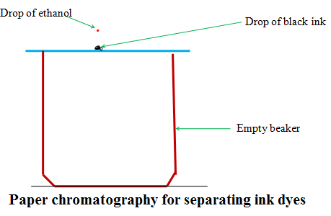

Set up of apparatus

Method 2

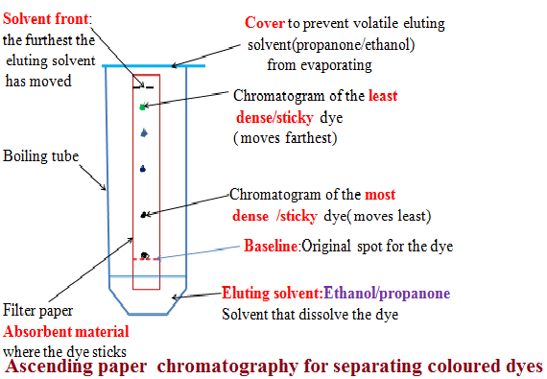

**Explanation**

When a drop of ink is placed on an absorbent material it sticks. On adding an eluting solvent, it dissolves the dye spread out with it. The denser and sticky pure dye move least. The least dense/sticky pure dye move farthest. A pure dye will produce the same chromatogram/spot if the same eluting solvent is used on the same absorbent material. Comparing the distance moved by a pure dye with a mixture, the coloured dyes in a mixture can be deduced as below:

**Example 1**

The chromatogram of pure dyes A, B ,C and a dye mixture D is shown below Determine the pure dyes present in D. On the diagram show:

(i)the solvent front

(ii) Baseline

(Iii) the most soluble pure dye

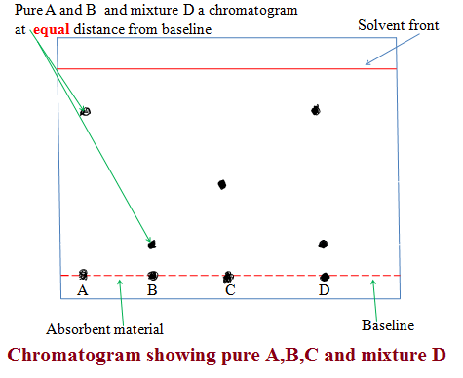

**(i) Solvent extraction**

Solvent extraction is a method of separating oil from nuts/seeds. Most nuts contain oil. First the nuts are crushed to reduce their size and increase the surface area. A suitable volatile solvent is added. The mixture is filtered. The filtrate solvent is then allowed to crystallize leaving the oil/fat. If a filter paper is rubbed/smeared with the oil/fat, it becomes translucent. This is the test for the presence of oil/fat.

**Experiment: To extract oil from Macadamia nut seeds**

Procedure

Crush Macadamia nut seeds form the hard outer cover .Place the inner soft seed into a mortar. Crush (add a little sand to assist in crushing).

Add a little propanone and continue crushing. Continue crushing and adding a little propanone until there is more liquid mixture than the solid. Decant/filter. Put the filtrate into an evaporating dish. Vapourize the solvent using solar energy /sunlight. Smear/rub a portion of the residue left after evaporation on a clean dry filter paper.

Observation /Explanation

Propanone dissolve fat/oil in the macadamia nuts. Propanone is more volatile (lower boiling point) than oil/fat. In sunlight/solar energy, propanone evaporate/vaporize leaving oil/fat(has a higher boiling point).Any seed like corn, wheat , rice, soya bean may be used instead of macadamia seed. When oil/fat is rubbed/ smeared on an opaque paper, it becomes translucent.

**(j) Crystallization**

Crystallization is the process of using solubility of a solute/solid to obtain the solute/solid crystals from a saturated solution by cooling or heating the solution.

A crystal is the smallest regular shaped particle of a solute. Every solute has unique shape of its crystals.

Some solutions form crystals when heated. This is because less solute dissolves at higher temperature. Some other solutions form crystals when cooled. This is because less solute dissolves at lower temperature.

**Experiment; To crystallize copper (II) sulphate (VI) solution**

**Procedure:**

Place about one spatula full of hydrated copper sulphate (VI) crystals into 200cm3 of distilled water in a beaker. Stir. Continue adding a little more of the hydrated copper sulphate (VI) crystals and stirring until no more dissolve. Decant/filter. Cover the filtrate with a filter paper. Pierce and make small holes on the filter paper cover. Preserve the experiment for about seven days.

**Observation/Explanation**

Large blue crystals formed

When hydrated copper (II) sulphate crystals are placed in water, they dissolve to form copper (II) sulphate solution. After some days water slowly evaporate leaving large crystals of copper (II) sulphate. If the mixture is heated to dryness, small crystals are formed.

**Physical/Temporary and Chemical changes**

A physical/temporary change is one which **no new** substance is formed and is **reversible** back to original.

A chemical/permanent change is one which **a new** substance is formed and is **irreversible** back to original.

**The following experiments illustrates physical and chemical changes**

**(a)Heating ice**

Place about 10g of pure ice in a beaker. Determine its temperature. Record it at time “0.0” in the table below. Heat the ice on a strong Bunsen flame and determine its temperature after every 60seconds/1minute to complete the table below:

|  |  |  |  |  |  |  |  |  |  |
| --- | --- | --- | --- | --- | --- | --- | --- | --- | --- |
| Time/minutes | 0 | 1 | 2 | 3 | 4 | 5 | 6 | 7 | 8 |
| Temperature (oC) | -2 | 0 | 0 | 40 | 80 | 90 | 95 | 95 | 96 |

Plot a graph of time against Temperature (y-axes)

Explain the shape of your graph

**Melting/freezing/fusion/solidification** and **boiling /vaporization /evaporation** are the two physical processes.

Melting /freezing point of pure substances is fixed /constant.

The boiling point of pure substance depends on **external** atmospheric **pressure**.

Melting/fusion is the physical change of a **solid** to **liquid**.

Freezing is the physical change of a **liquid** to **solid**.

Melting/freezing/fusion/solidification is therefore two **opposite** but **same** reversible physical processes i.e.

A (**s**) A (**l**)

Boiling/vaporization/evaporation is the physical change of a **liquid** to **gas**.

Condensation/ liquidification is the physical change of **gas** to **liquid**.

Boiling/vaporization/evaporation and condensation/ liquidification are therefore two **opposite** but **same** reversible physical processes i.e.

B (**l**) B(**g**)

**Practically**

(i) Melting/liquidification/fusion involves **heating** a solid to **weaken** the strong bonds holding the solid particles together.

Solids are made up of very strong bonds holding the particles **very close** to each other (**Kinetic Theory of matter**).

On heating these particles gain energy/heat from the surrounding heat source to form a liquid with **weaker** bonds holding the particles close together but with some degree of **freedom**.

(ii)Freezing/fusion/solidification involves cooling a liquid to reform /rejoin the very strong bonds to hold the particles **very close** to each other as solid and thus lose their degree of **freedom** (**Kinetic Theory of matter**).

Freezing /fusion / solidification is an **exothermic** (**-**∆H) process that require particles holding the liquid together to lose energy to the surrounding.

(iii)Boiling/vaporization/evaporation involves **heating** a liquid to completely **break/free** the bonds holding the liquid particles together.

Gaseous particles have high degree of **freedom** (**Kinetic Theory of matter**).

Boiling /vaporization / evaporation is an **endothermic** (**+**∆H) process that require/absorb energy from the surrounding.

(iv)Condensation/liquidification is **reverse** process of boiling /vaporization / evaporation.

It involves gaseous particles losing energy to the surrounding to form a liquid.

**Criteria of Purity**

Pure substances melt and boil at constant temperatures that are specific for a

particular substance. Melting and boiling points are therefore used for

determining purity of substances.

Temporary and permanent changes

Substances undergo various changes when subjected to different conditions of

temperature. This section classifies and defines changes that take place in

substances.

When zinc oxide is heated, its colour changes from white to yellow. On cooling,

the yellow solid turns white. This change can be represented as:

Wax melts on heating. When cooled, liquid wax changes back to solid.

When iodine is heated, the shiny black solid turns to a purple vapour. When

cooled, the purple vapour changes back to the shiny black solid.

Heating zinc oxide, wax and iodine does not result in the formation of a new

substance. Cooling, reverses the changes these substances undergo. A changewhich can easily be reversed and in which no new substance is formed is calleda temporary physical change. The following are the characteristics of

**temporary physical changes.**(a) They are easily reversible.(b) No new substance is formed.(c) The mass of the substance does not change.(d) They are not accompanied by net heat change.

Crystals of copper (II) sulphate contain water of crystallisation. It is said to be

hydrated. When heated it decomposes to produce white copper (II) sulphate

powder and water. The white copper (II) sulphate powder does not contain water

of crystallisation and is said to be anhydrous.

The white anhydrous copper (II) sulphate does not regain the original blue

colour on cooling.

Similarly pink cobalt (II) chloride decomposes to form blue anhydrous cobalt

(II) chloride and water vapour.

The blue cobalt (II) chloride does not regain the pink colour on cooling.

The decomposition of a substance when it is heated is referred to as thermal

dissociation.

Heat is evolved when a little water is added to the anhydrous copper sulphate orthe blue anhydrous cobalt (II) chloride. The anhydrous substances become

hydrated and regain their original colour.

Heating hydrated copper (II) sulphate or hydrated cobalt (II) chloride results

into a temporary chemical change. The characteristics of temporary chemical

change are:

(a) A new substance is formed.

(b) Heat energy is evolved or absorbed.

(c) There is change in mass.

(d) The change can be reversed.

**CAUTION** Small quantities of copper (II) Nitrate and Potassium Manganate (VII) should be used as the fumes produced on heating could be harmful when inhaled.

When copper (II) nitrate is heated it decomposes to form a black solid and a

mixture of gases. The black solid is copper (II) oxide. The mixture of gases

consists of a red brown gas and another gas which relights a glowing splint. The

red brown gas is nitrogen (IV) oxide while the gas which relights the glowing splint is oxygen. The mass of copper (II) oxide is found to be less than that of copper (II)nitrate because the gaseous products escaped into the atmosphere.Potassium manganate (VII) decomposes to form a black-green solid and acolourless gas, which relights a glowing splint. The black-green solid is amixture of black manganese (IV) oxide and green potassium manganate (VI).The black-green solid weighs less than the original potassium manganate (VII).The decomposition of copper (II) nitrate and potassium manganate (VII) areexamples of permanent chemical **changes. Permanent chemical changes have**

**the following characteristics.**

(a) New substances are formed.

(b) The change is irreversible.

(c) The change is accompanied by change in mass.

(d) Heat energy is released or absorbed.**Constituents of Matter** matter has been classified as solid, liquid or gas.Pure substances can be classified as elements or compounds.

**Elements**Elements are pure substances which can not be split into simpler substances by chemical means. Examples of elements include oxygen, hydrogen, copper,

sulphur, carbon and iron. There are over a hundred known elements.

Elements are made up of atoms. The atom is defined as the smallest particle

of an element, which can take part in a chemical change. Atoms of the same

element are similar.

The atoms of some elements can not exist independently but join together to

form small groups of atoms. These discreet particles are called molecules.

molecule is defined as the smallest particle of an element or compound, which can exist separately.

**Compounds**

A compound is a pure substance made up of two or more elements chemically combined. The

compound formed when iron and sulphur chemically combine is called iron (II)

sulphide.

It is possible to tell which elements are present in a compound from its name.

Names ending in –ide means the compound is composed of two elements only.e.g:Sodium Chloride is made up of Sodium and Chlorine.

Iron (II) Sulphide is made up of Iron and Sulphur.

Calcium Nitride is made up of Calcium and nitrogen.

Calcium carbide is made up of Calcium and Carbon.

Sodium hydride is made up of Sodium and hydrogen.

An exception to this are the hydroxides.

Names ending in –ate means the compound is composed of three elements

one of which is oxygen. eg: Sodium Sulphate is made up of sodium, sulphur and oxygen.

Sodium Carbonate is made up of sodium, carbon and oxygen.Potassium chlorate is made up of potassium, chlorine and oxygen.Calcium nitrate is made up of calcium, nitrogen and oxygen.Exceptions to this rule are the hydrogen carbonates and hydrogensulphates.

Names ending in –ite means the compound is made up of three elements oneof which is oxygen. However, the amount of oxygen is less than in thosecompounds whose names end in –ate e.gSodium Sulphite is made up of sodium, sulphur and oxygen.Calcium Sulphite is made up of calcium, sulphur and oxygen. **Chemical Equation**

Iron and sulphur combine chemically to form iron (II) sulphide. In this process

iron and sulphur are referred to as the reactants whereas the iron (II) sulphide is

referred to as the product.

Chemical combination of elements is known as a reaction.

When a reaction is represented as shown, the representation is called a word

equation. In a chemical equation reactants are written on the left hand side of

the arrow sign while the products are written on the right hand side.

**NOTE**

When charcoal burns the mostly carbon material combines with oxygen to form carbon dioxide, the ash left behind constitutes impurities in the charcoal. An example of a useful chemical reaction.

The forward arrow sign is used where the reactions are permanent and

proceed only in one direction. Two arrow signs in opposite directions are

used where the reactions are reversible. This means the reaction can proceed in

either direction.

**NOTE**

**The plus sign on the reactants side means “react with.” The plus sign on the product side means “and” The arrow sign between the reactants and the products means to “yield”.**

ACIDS, BASES AND INDICATORS

**Contents**

**Indicators** - 2 -

Simple Acid-Base Indicators: Flower extracts - 2 -

Commercial Indicators - 2 -

Litmus indicator - 2 -

Phenolphthalein and methyl orange - 2 -

Universal Indicators and the pH Scale - 3 -

**Acids** - 4 -

Properties of Acids - 4 -

**Bases** - 6 -

Reactions of Acids with Bases - 6 -

Effects of Acids on Substances - 7 -

Applications of Acids and Bases - 8 -

Review Exercises - 9 -

In the papers…. - 11 -

**Objectives**

**By the end of this Chapter, the learner should be able to:**

•   Define indicator, acid, base and pH.

•   Prepare and use plant extracts as acid–base indicators.

•   Describe and use the pH scale.

•   Use indicators to identify acids and bases.

•   State properties of acids and bases.

•   Name the uses of acids and bases.

•   State and explain the effects of acids.

ACIDS, BASES AND INDICATORS

Some of the foods that man eats are sour while others are bitter. The sour taste is due to the presence of acids whereas the bitter taste is due to the presence of bases. Examples of substances that contain acids are fruits such as oranges, lemons and sour milk. Examples of substances that contain bases include anti-acid tablets and wood ash solution.

# Indicators

**Indicators** are substances which show different colours when in acids or bases. Such substances are used to classify various substances as either acids or bases.

## Simple Acid-Base Indicators: Flower extracts

When flower extracts are used as indicators, solutions of hydrochloric acid, sulphuric acid, orange juice and lemon juice give similar colour changes with the same flower extract.

Lime water, solutions of sodium hydroxide potassium hydroxide, wood ash and baking powder give a similar but different colour.

Water and sugar solution have no effect on flowerextracts. They are neutral substances.

The composition of flower extracts continuously changes with time causing the colour of the extract to change. The mixture of the flower extract and acid or base also changes colour with time.

Flower extracts therefore **give inconsistent results** when used as acid-base indicators.

For the best results flower extracts should be used when freshly prepared. Other coloured parts of plants may also be used, for example tradescantia, red cabbage and beetroot.

## Commercial Indicators

The commercial acid-base indicators include **litmus indicator** (solution and paper), **phenolphthalein** and **methyl orange.**

### **Litmus indicator**

Litmus indicator is one of the commonly used commercial acid-base indicators. The indicator is also available in paper form as litmus paper.

Litmus indicator is **red** in an **acid solution and blue** in a **basic solution.**

Litmus indicator retains its **purple colour** in a **neutral** solution.

### **Phenolphthalein and methyl orange**

**Phenolphthalein** indicator is **colourless** in **acidic**, **pink** in **basic** and **colourless** in **neutral** solution. **Methyl orange** indicator is **pink** in **acidic**, **yellow** in **basic** and **orange** in **neutral** solution.

These commercial indicators provide no information about the strength of an acid or a base.

|  |  |  |  |
| --- | --- | --- | --- |
| Indicator | Colour in: | | |
| Acid | Base | Neutral |
| Litmus | Red | Blue | Purple |
| Phenolphthalein | Colourless | Pink | Colourless |
| Methyl orange | Pink | Yellow | Orange |

**⚗Practically Speaking🔊 📌**

Classifying substances

Take three test tubes and put 2cm3 of hydrochloric acid in each. To the first test-tube, add two drops of litmus solution. To the second and third add two drops of phenolphthalein and methyl orange respectively. Record your observation.

Repeat the experiment using water, lemon juice, solutions or suspensions of the following: soap, wood ash, baking powder, anti-acid tablets, toothpaste, sour milk, ammonia, ammonium sulphate, sodium chloride, sodium hydroxide, carbon (IV) oxide (carbon dioxide), sulphur (IV) oxide (sulphur dioxide), sulphuric acid, nitric acid, calcium hydroxide and magnesium oxide.

**Classify the substances as acidic, basic or neutral.**

|  |  |  |
| --- | --- | --- |
| **Acidic solutions** | **Basic solution**s | **Neutral solutions** |
| Hydrochloric acid  Lemon juice  Sour milk  Ammonium sulphate  Carbon (IV) solution  Sulphur dioxide solution  Sulphuric acid  Nitric acid | Soap solution  Wood ash solution  Baking powder  Anti-acid tablet solution  Toothpaste  Ammonia solution  Sodium hydroxide solution  Calcium hydroxide solution  Magnesium oxide solution | Water  Sodium chloride |

### **Universal Indicators and the pH Scale**

The **universal** indicator is a **mixture of several indicators.** It exhibits a **range of colours** in acids and in bases **depending on the strength of the solution**. These **shades** of colours are related to a **continuous acid-base scale** called the **pH scale**. The **pH scale** has values that range from **0** to **14.**

* 1. The pH values of **acids** range from **zero to values just less than seven.** Solutions of sulphuric acid, hydrochloric acid and nitric acid have pH values which range **between 0 to 4** and are strong acids.

Lemon juice and ethanoic acid have pH value which range **between 4 and 7,** and are weak acids.

As the pH values decreases from 7 to 0, the strength of the acids increases.

* 1. Distilled water and sodium chloride solution have a **pH value of 7.** They are **neither acidic nor basic** and are neutral.
  2. The pH values of **bases** range **between 7 and 14.** Solutions of ammonia, calcium hydroxide and sodium hydrogen carbonate have pH values **between 7 and 10.** They are weak bases.

Solutions of wood ash, soap, and sodium hydroxide have pH values ranging **from 10 to 14.** They are strong bases.

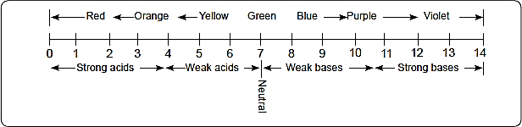

The pH scale is shown alongside.

# Acids

An acid is a compound that reacts with metals to form a salt and hydrogen gas.

**Metal + Acid**  **Metal salt + Hydrogen gas**

### **Properties of Acids**

Acids have several properties which are discussed below.

#### Reactions of Acids with Metals

Acids react with metals to produce a metal salt and hydrogen gas.

**⚗Practically Speaking🔊 📌**

Put a granule of zinc in two test-tubes. Add 2cm3 of dilute hydrochloric acid to the first test-tube as shown below.

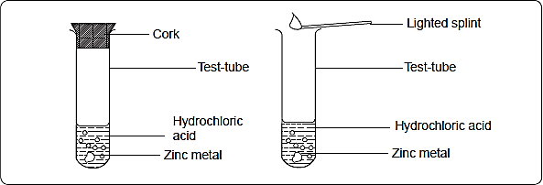

Record your observations. Repeat the procedure using dilute sulphuric acid in place of dilute hydrochloric acid. Repeat the experiment using clean magnesium ribbon, aluminium foil, iron filings, lead and copper turnings instead of zinc.

**Observations and Discussion**

When the dilute acids are added to zinc, magnesium, aluminium and iron, **bubbles of a colourless gas are evolved.**The gas produced is hydrogen gas

The production of bubbles of a gas is referred to as **effervescence.** To identify the gas produced, the gas is tested using a burning splint. A mixture of hydrogen and air burns with a ‘pop’ sound. This is the test for hydrogen gas.

When dilute sulphuric acid is added to zinc granules, hydrogen gas and zinc sulphate are produced.

The reaction can be represented using a word equation.

Zinc + Sulphuric acid Zinc sulphate + Hydrogen gas

Similarly, zinc reacts with dilute hydrochloric acid to form zinc chloride and hydrogen gas.

Zinc + hydrochloric acid Zinc chloride + Hydrogen gas

Magnesium and aluminium react more vigorously with the acids than zinc.

Magnesium + hydrochloric acid  Magnesium chloride + Hydrogen gas

Aluminium+ Sulphuric acid Aluminium sulphate + Hydrogen gas

**Side notes**

* The reaction of calcium with dilute sulphuric acid slows down and eventually stops due to the formation of insoluble calcium sulphate. The insoluble salt **coats the metal** and prevents further reaction.
* Lead reacts slowly with both hydrochloric and sulphuric acids but each reaction eventually stops due to the formation of **insoluble coating of lead chloride** and lead sulphate respectively.
* Copper **does not react** with either dilute hydrochloric acid or dilute sulphuric acid.
* Very reactive metals like potassium, sodium and calcium **react violently with acids**. These reactions should not be attempted in the laboratory.

The table below shows some salts produced by magnesium with different acids

|  |  |  |
| --- | --- | --- |
| **Dilute acid** | **Metal** | **Name of salt** |
| Hydrochloric acid  Sulphuric acid  Nitric acid  Carbonic acid  Phosphoric acid | Magnesium | Magnesium chloride  Magnesium sulphate  Magnesium nitrate  Magnesium carbonate  Magnesium phosphate |

#### Reaction of acids with carbonates and hydrogen carbonates

*Acids react* ***with carbonates*** *and* ***hydrogen carbonates*** *to produce a* ***salt, water and carbon (IV) oxide (carbon dioxide).***

The general equations for the reactions are;

**Acid + carbonate  Salt + Water + Carbon (IV) Oxide**

**Acid + Hydrogen carbonate  Salt + Water + Carbon (IV) Oxide**

**⚗Practically Speaking🔊 📌**

Experimentto react acids with carbonates and hydrogen carbonates

Add a spatulaful of sodium carbonate into a test-tube containing about 5cm3 of dilute hydrochloric acid. Set up the apparatus as shown below.

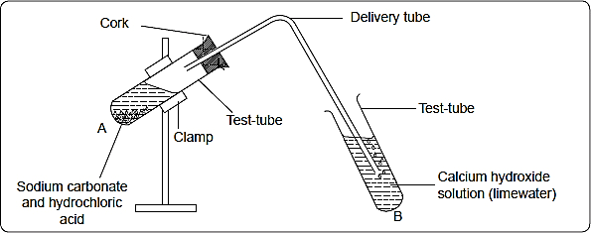

Record the observation. Repeat the procedure using dilute sulphuric acid and dilute nitric acid in place of hydrochloric acid. Record the observations. Repeat the procedure using calcium carbonate and sodium hydrogen carbonate in place of sodium carbonate.

**Observations and Discussion**

* When carbonates or hydrogen carbonates are added to dilute acids, effervescence occurs in test tube A as the solid is used up.
* A white precipitate is formed in test tube B

The colourless gas produced is carbon (IV) oxide. When the carbon (IV) oxide gas is bubbled through calcium hydroxide solution (lime water), a white precipitate is formed. This is the test for carbon (IV) oxide. The white precipitate is calcium carbonate.

The following word equations represent some of the reactions between acids and carbonates or hydrogencarbonates.

Sodium carbonate + hydrochloric acid  Sodium chloride + water + carbon (IV) oxide

Calcium carbonate + nitric acid  Calcium nitrate + water + carbon (IV) oxide

Copper carbonate + Sulphuric acid  Copper Sulphate + water + carbon (IV) oxide.

Sodium hydrogen carbonate + hydrochloric acid  Sodium chloride + water + carbon (IV) oxide

**Side notes**

The reaction between sulphuric acid and calcium carbonate **stops after a short while** due to the formation of an **insoluble layer of calcium sulphate which stops further reaction.**

Calcium carbonate + Sulphuric acid  Calcium sulphate (solid) + water + carbon (IV) oxide

# Bases

A base is a substance which when reacted with acids forms salt and water as the only products. Metal oxides, metal hydroxides and ammonia solution are bases.

### Reactions of Acids with Bases

When acids react with bases, they form a **salt and water** as the only products. Salt and water are **neutral products** hence the reaction is referred to as a **neutralisation reaction.**

**⚗Practically Speaking🔊 📌**

Experiment to react acids with bases

(a)   Measure 10cm3 of dilute sodium hydroxide solution and put it in a clean conical flask. Add two to three drops of phenolphthalein indicator. Add dilute hydrochloric acid drop by drop, while shaking the conical flask, count the number of drops until the indicator just changes colour. Repeat without adding the indicator. Add the same number of drops of hydrochloric acid to 10 cm3 of dilute sodium hydroxide. Put the resulting solution in an evaporating dish and heat the solution to saturate it. Allow the saturated solution to cool. Record your observations.

(b)   Place a small sample of calcium oxide into a test-tube. Add to it 5cm3 of dilute nitric acid. Shake the mixture. Repeat the procedure using the following solids in different test-tubes. Zinc oxide, copper (II) oxide, magnesium oxide and lead (II) oxide. Record your observation. Repeat the experiment using dilute hydrochloric acid in place of dilute nitric acid.

**Side notes**

* Phenolphthalein indicator is used to determine the end of the reaction, **end point.** The indicator is used to determine the **quantity of acid needed to react with 10cm3 of dilute sodium hydroxide.**
* It is not used in the next reaction to avoid contamination of the product.

**Observations and discussion**

* The colour of phenolphthalein is pink in basic solution. At the end point, the colour of the indicator in the solution turns from pink to colourless.

Sodium hydroxide reacts with dilute hydrochloric acid to form sodium chloride and water only.

Sodium hydroxide + Hydrochloric acid Sodium chloride + Water

*(base) (acid) (salt)*

The following are the word equations for the reactions between some metal oxides and acids.

Calcium oxide + Hydrochloric acid  Calcium chloride + water

Zinc oxide + Hydrochloric acid  Zinc chloride + water

Magnesium oxide + nitric acid  Magnesium nitrate + water

Lead (II) oxide + nitric acid  Lead nitrate + water

Copper (II) oxide + sulphuric acid  copper sulphate + water

* The table below summarises the properties of acids and bases.

|  |  |
| --- | --- |
| **Acids** | **Bases** |
| Have a sour taste | Have a bitter taste |
| Have pH values below 7 | Have pH values above 7 |
| Turn litmus red | Turn Litmus blue |
| Turn phenolphthalein colourless | Turn phenolphthalein pink |
| Turn Methyl orange pink | Turn methyl orange yellow |
| React with bases to form salt and water only | React with acids to form salt and  water only. |
| React with carbonates to form salt, water and carbon (VI) oxide |
| React with metals to produce salt and hydrogen gas |

## Effects of Acids on Substances

Industries emit several gases and waste products into the environment leading to environmental pollution. Some of these gases dissolve in rain water to form acid rain. This rain reacts with stone work, iron roofs and other metallic surfaces causing damage. This effect is called corrosion. When these acidic gases in the atmosphere are inhaled they cause respiratory disorders.

Soil may become acidic due to leaching and water logging. Such soil is unsuitable for the growth of many plants.

## Applications of Acids and Bases

Acids and bases have several applications.

#### Uses of acids

Carbonic Acid is used in aerated drinks to enhance taste.

Hydrochloric acid is used to clean metal surfaces.

Sulphuric acid is used in car batteries, manufacture of ferterlizers, etching of metals, manufacture of paints and detergents.

Nitric acid is used to manufacture of dyes, paints, explosives and fertilizers.

Ethanoic acid and citric acid are used as a flavour in foods.

#### Uses of bases

|  |  |
| --- | --- |
| **Base** | **Use** |
| Magnesium oxide and hydroxide | Manufacture of anti-acid tablets. Lining of furnaces. |
| Calcium oxide and hydroxide | Neutralising soil acidity and industrial wastes. Making cement and concrete. Manufacture of toothpaste. |
| Sodium hydroxide | Manufacture of soap. As a degreasing agent. |
| Ammonia solution | As a degreasing agent. Manufacture of fertilizers. Manufacture of nitric acid. |

## Review Exercises

1. (a) Define the term.

(i) acid

(ii) base

(b) In terms of taste, differentiate between acids and bases.

1. Classify the following substances into those that contain acids and those that contain bases: vinegar, milk of magnesia, stomach secretions, lemon Juice, tooth paste and soapy water.
2. State two safety rules that you should follow when using acids and bases.
3. Acids are said to have a sour taste. Why is it advisable to use indicators rather than the sense of taste when testing for acids?
4. Acids can be divided into two groups. State the two groups and give an example of an acid that falls in each group.
5. Citric acid, lactic acid, methanoic acid and hydrochloric acid are found in various substances in plants and animals. State where these acids occur.
6. (a) What is an indicator?

(b) Name three commercial Indicators.

(c) State one advantage of commercial indicators over plant extract indicators.

1. Suggest the pH value of the following solutions:

(a) Dilute hydrochloric acid solution. (b) Wood ash solution.

(c) Sodium hydroxide solution. (d) Orange juice.

1. Describe how you can make acid-base indicators from flower petals and state how you can test it.
2. The table below shows pH values of solutions A, B, C, D and E.

|  |  |  |  |  |  |
| --- | --- | --- | --- | --- | --- |
| **solution** | **A** | **B** | **C** | **D** | **E** |
| pH | 6.5 | 2.0 | 8.5 | 11.5 | 7.0 |

(a) Which solution is likely to be

(i) Rain water? (ii) Wood ash?

(iii) Sodium chloride? (iv) Tooth paste?

(b) Which solution will react with magnesium ribbon most vigorously? Give a reason.

1. (a) What is a universal indicator? _________

(b) State the advantage universal indicator has over the common acid-base indicators.

1. (a) What is an alkali?

(b) Name two examples of alkalis.

1. Name the acids found in

(a) Car battery b) Lemon fruit

(b) Nitrate fertilisers d) Vinegar

1. State the colour of the following in universal indicator.

(a) Ethanoic acid b) Sodium hydroxide

(b) Sulphuric acid d) Ammonium hydroxide

1. Name two common commercial indicators and state their colours in acidic and basic solutions.
2. Tooth pastes contain bases such as calcium hydrogen carbonate. Explain.
3. Although hydrochloric acid in the gastric juice in our stomach helps break down the food we eat, if too much hydrochloric acid is produced, indigestion may result. Antacid tablets containing bases neutralise excess acids in the human stomachs.

(a) Name any two bases found in antacid tablets.

(b) Give the name of the type of reaction that takes place when antacid tablets are swallowed.

(c) Write a word equation for the reaction that occurs in the body during relieving of indigestion.

1. The sourness of a substance is a reasonable guide to Its acidity, since sourness increases with increasing acidity. If solution A is more sour than solution B, then it is likely that: (write true or false)

(a) Solution A has a higher pH than solution B________

(b) Solution A has more hydroxide ions than solution B.__________

(c) Solution B is a stronger acid than solution A._______

(d) Solution A has a higher concentration of hydrogen ions than B.________

1. Arrange the following substances starting with the most acidic to the most basic.

(i) Grape fruit juice of Ph 3.0 (ii) Detergent of pH 10.5

(iii) Gastric juice of pH = 1 .0 (iv) Sea water of pH = 8.5

1. (a) State three properties of a typical acid.

(b) State three properties of a base.

1. Write a word equation for the reaction between dilute sulphuric (Vl)acid and the following:

(a) Magnesium metal (b) Copper(ll)oxide

(c) Potassium hydroxide (d) Zinc carbonate

1. Give one use of each one of the following:

(a) Dilute hydrochloric acid ______________

(b) Dilute sulphuric (Vl)acid ______________

(c) Magnesium hydroxide _______________

## In the papers….

1. 2006 Q 19 P1

Give one use of magnesium hydroxide. (1 mark)

1. 2006 Q 24 P1

(a) Complete the table below to show the colour of the given indicator in (1 mark)

|  |  |  |
| --- | --- | --- |
| **Indicator** | **Colour in** | |
| **Acid solution** | **Basic solution** |
| Methyl orange |  | Yellow |
| Phenolphthalein | Colourless |  |

(b) How does the pH value of 0.1 M potassium hydroxide solution compare with that of 0.1M aqueous ammonia? Explain. (2 marks)

1. 2007 Q 5 P1

When a student was stung by a nettle plant, a teacher applied an aqueous solution of ammonia to the affected area of the skin and the student was relieved of pain Explain. (2 marks)

1. 2009 Q 22 P1

A student added very dilute sulphuric (VI) acid to four substance and recorded the observations shown in the table below.

|  |  |  |
| --- | --- | --- |
| **Test** | **Substance** | **Gas given off** |
| 1 | Sodium | Yes |
| 2 | Iron | No |
| 3 | Carbon | Yes |
| 4 | Copper | No |

For which tests were the observations wrong? Explain. (2 marks)

1. 2009 Q 30 P1

Starting with red roses, describe how;

(a) A solution containing red pigment may be prepared; (1 mark)

(b) The solution can be shown to be an indicator (2 marks)

1. 2011 Q 20 P1

Describe how the PH of anti- acid (Actal) powder can be determinedin the Laboratory (2 marks)

1. 2014 Q27 P1

(a) Name a suitable solvent for extracting an indicator from flowers. (1 mark)

(b) Give a reason why the solvent named in (a) above is used (1 mark)

1. 2015 Q15 P1, 2016 Q23 P1

Given the following substances: wood ash, lemon juice and sodium chloride.

(a) Name one commercial indicator that can be used to show whether wood ash, lemon juice and sodium chloride are acidic, basic or neutral. (1 mark)

(b) Classify the substances in (a) above as acids, bases or neutral (2 marks)

|  |  |  |
| --- | --- | --- |
| Acid | Base | Neutral |
|  |  |  |

1. 2016 Q29 P1

When a student was stung by a nettle plant, a teacher applied an aqueous solution of ammonia to the affected area of the skin and the student was relieved of pain. Explain. (2 marks)

1. 2017 Q14 P1

Using the elements chlorine, calcium and phosphorus:

(a) Select elements that will form an oxide whose aqueous solution has a pH less than 7. (1 mark)

(b) Write an equation for the reaction between calcium oxide and dilute hydrochloric acid. (1 mark)

(c) Give one use of calcium oxide. (1 mark)

1. 2018 Q26 P1

Explain why commercial indicators are preferred to flower extracts as acid-base indicators. (2 marks)

1. 2019 Q6 P1.

A farmer intended to plant cabbages in his farm. He first tested the pH of the soil and found it to be 3.0. If cabbages do well in alkaline soils, explain the advice that would be given to the farmer in order to realise a high yield. (2 marks)

1. 2019 Q16 P1

Complete the following table. (2 mark)

|  |  |  |
| --- | --- | --- |
| Solution | pH | Nature of solution |
| H | 1.0 |  |
| I |  | Neutral |
| J |  | Weak acid |
| K | 13.0 |  |

Explain why a solution of ammonia in methylbenzene has no effects on red litmus paper while in aqueous ammonia red litmus paper turns blue. (1 mark)

**AIR AND COMBUSTION**

Table of Contents

Composition of air - 2 -

Is air a mixture or a compound? - 2 -

Experiments to determine the percentage of oxygen in air by volume. - 2 -

(a) Burning of candle in air - 2 -

(b) Heating copper in a fixed volume of air - 4 -

(c) Rusting of iron fillings - 5 -

(d) Smouldering of phosphorous - 5 -

How to determine the presence of Carbon (IV) oxide and water in air - 6 -

Fractional Distillation of Liquefied Air - 7 -

Rusting - 8 -

Conditions necessary for rusting. - 8 -

Methods of Preventing Rusting - 9 -

Oxygen - 9 -

Laboratory preparation of oxygen - 9 -

Properties of oxygen. - 10 -

Burning of Substances in Air - 10 -

Competition for combined oxygen - 14 -

Atmospheric Pollution - 15 -

Uses of Oxygen - 15 -

Review Exercises - 16 -

In the papers…. - 19 -

**Objectives**

**By the end of this chapter, the learner should be able to:**

1. State the composition of air.
2. Determine experimentally the percentage of oxygen in air by volume.
3. Describe fractional distillation of air.
4. Define combustion.
5. Investigate the conditions for rusting and state the composition of rust.
6. State the methods of preventing rusting.
7. Prepare and investigate the properties of oxygen.
8. Experimentally compare the rates of combustion of elements in air and in oxygen.
9. State the nature of the products of burning elements in air and in oxygen.
10. State the pollution effects of combustion.
11. State the applications of the reactivity series.

**AIR AND COMBUSTION**

Air sustains life on earth. Living organisms need air for respiration. Plants need air for photosynthesis. Air is required for combustion of fuels to give energy.

# Composition of air

## Is air a mixture or a compound?

Air is a mixture of gases such as oxygen, nitrogen, carbon (IV) oxide and water vapour.

Air is considered a **mixture** and n**ot a compound** because the various components of air c**an be separated by physical means (fractional distillation of liquefied air).**

**Approximate percentage composition of air**

|  |  |
| --- | --- |
| ***Component*** | ***Percentage composition*** |
| Nitrogen | 78.1 |
| Oxygen | 20.9 |
| Carbon (IV) oxide | 0.03 |
| Noble gases | 0.97 |
| Water vapour | Variable |
| Dust | Variable |

## Experiments to determine the percentage of oxygen in air by volume.

The active part of air is oxygen. It occupies about 20% of air. Several experiments such as burning of candle, heating of copper(II) oxide (combustion), smoldering of phosphorus and rusting, all of which use oxygen, can be done to determine the active part of air.

### (a) Burning of candle in air

**Combustion** or burning is a **process in which a substance combines with oxygen with the production of heat.**

The part of **air that supports combustion is active air.** The active part is **oxygen**, which forms about 20% of dry air by volume.

**⚗Practically Speaking🔊 📌**

The active part of air can be determined experimentally using a burning candle as follows:

Put dilute sodium hydroxide solution in a trough. Place a small candle on a cork and float it on the solution. Cover it with a gas jar. Mark on the gas jar, the level of the solution. Measure the height of the air column and record it.

Remove the jar and light the candle. Gently cover the burning candle with the gas jar. After the candle has gone off leave the apparatus to cool to room temperature. Mark on the gas jar the final level of the solution. Measure and record the height of the air column once more.

Remove the gas jar and measure the change in height. Record all your observations.

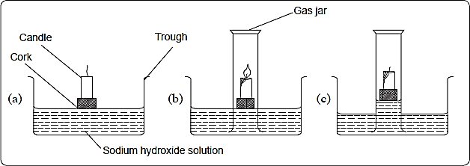

**Observations and Discussion**

**The candle burns for a while then it goes off.**

As the candle burns, it uses up the active part of air in the fixed amount of air enclosed**.**

**The level of dilute sodium hydroxide solution in the gas jar rises after the candle goes off.**

As the candle burns, it uses up the active part of air in the fixed amount of air enclosed in the gas jar. This leaves a partial vacuum in the jar. Greater atmospheric pressure acting on the surface of the sodium hydroxide forces the solution up into the jar.

The following are sample results for a similar experiment.

Height of air column before burning = 16.0cm

Height of air column after burning    = 12.9cm

**The percentage of air used up during the experiment can be determined as follows:**

Height of air used during burning     = 3.1cm

Percentage of air by volume used up = $\frac{\text{height of air used}}{\text{initial height of air}}$ × 100

= $\frac{\text{3.1}}{\text{16.0}}$ × 100

= 19.375%

**Side notes**

* **Dilute sodium hydroxide is preferably usedinstead of water** to absorb carbon (IV) oxide that was initially in the gas jar and that which is produced during combustion.
* The experimental result is not the same as the theoretical value of the percentage of oxygen in air by volume. This is due to **experimental errors**, which may result from:

1. The sodium hydroxide solution may not absorb all the carbon (IV) oxide gas.
2. The candle may go off before all the oxygen is used up due to the build-up of carbon (IV) oxide levels.

* Heating causes expansion of gases therefore the **apparatus should be allowed to cool before the final reading is taken.**

**Conclusion**

The active part of air is **oxygen**, which forms about 20% of dry air by volume. The part of air that remains in the gas jar does not support combustion. The component of air that is inactive is mainly nitrogen.

### (b) Heating copper in a fixed volume of air

When copper is heated in air, it reacts with oxygen in air to form black copper (II) oxide.

**⚗Practically Speaking🔊 📌**

Pack copper turnings in a long hard glass tube about 6cm long. Connect the tube with two glass syringes with one syringe containing a specific volume of air while the other is empty*.*



Heat the copper turnings until they are red hot. Slowly pass the air from syringe A through the hot turnings to syringe B and back. Repeat this process while heating the copper turnings until the new volume of air in syringe A is constant. Allow the glass tube to cool and record the volume of the gas in syringe A.

**Observations and Discussion**

**In the combustion tube, at the end of the experiment,** the **red-brown** copper turnings turn**black**.

Copper is a **red-brown** metal. When it is heated in air, it turns black. This is because **it combines with oxygen to form black copper (II) oxide.**

Below is a word equation for the reaction.

$$\begin{matrix}\text{Copper + } \\ \text{(red-brown solid}\text{)}\end{matrix}\begin{matrix}\text{ Oxygen }\underset{→}{} \\ \text{(colourless gas)}\end{matrix}\begin{matrix}\text{copper }\left(\text{II}\right)\text{oxide} \\ \text{(black solid)}\end{matrix}$$

**The sample readings below can be used to determine the percentage of air used up in this experiment.**

Volume of air in syringe A before heating = 7.5cm3

Volume of air in syringe A after heating    = 6.0cm3

Volume of air used up during heating       = 1.5cm3

Percentage by volume of air used during the experiment. = $\frac{\text{volume used during heating}× 100}{\text{original volume of air}}$

$=\frac{\text{1.5 ×}\text{100}}{\text{7.5}}$ = 20%

About 20% by volume of air is used during combustion and the 80% of air left does not react with heated copper. The gas left in the syringe does not react with copper. It is mainly nitrogen.

**Side notes**

* The glass wool plug is used to stop the copper turnings from being sucked into the syringes.
* The air is passed slowly to allow enough time of contact between the reactants.
* The air is passed repeatedly over heated copper to ensure that all oxygen in the syringes and tube is used up.
* The possible sources of error in this experiment include:

(a)   The air initially present in the tube is not accounted for.

(b)   There is possible leakage of air.

(c)   Not all the oxygen may have been used up.

### (c) Rusting of iron fillings

**⚗Practically Speaking🔊 📌**

Wet a measuring cylinder and sprinkle some iron filings on the wet surface. Remove the excess iron filings. Invert the measuring cylinder in a trough of water. Read the volume of air column in the measuring cylinder. Leave the set up for 48 hours. Read and record the volume of the air column. Record all your observations.

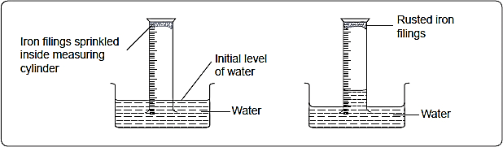

**Side notes**

* The measuring cylinder is made wet to ensure that the iron filings stick onto the wet surface.

**Observation and Discussion**

**After 48 hours;**

1. **A brown coating is formed on the filings.**

The brown coating is rust. Rust is a compound of iron and oxygen.

1. **The level of water in the measuring cylinder rises while that in the trough drops.**

During rusting, oxygen is used and therefore water rises up in the measuring cylinder to replace the volume of air used during rusting.

About 20% of air by volume is used up during rusting.

### (d) Smouldering of phosphorous

**⚗Practically Speaking🔊 📌**

Invert an empty measuring cylinder in a trough of water. Record the volume of the air column. Cut a small piece of white phosphorous under water. Attach the piece of white phosphorous to the end of a piece of copper wire.

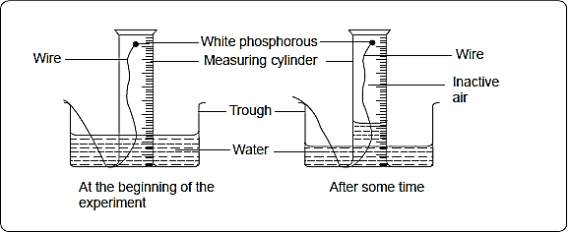

**Side notes**

* Phosphorous is stored under water as it does not react with water.
* **In order to obtain accurate results,** the white phosphorous should not be allowed to come in contact with the walls of the measuring cylinder because it stops smouldering.

**Observations and Discussion**

**When both y**ellow and white phosphorus are exposed to air, they smoulder (burn slowly with smoke but no flame).

This is because phosphorus reacts spontaneously with oxygen to form a mixture of oxides.

The reaction can be represented by the following word equations.

Phosphorous + oxygen  phosphorous (III) oxide

Phosphorous + oxygen  phosphorous (V) oxide

After 24 hours, the water level inside the measuring cylinder will have risen to occupy the volume of oxygen used up.

The difference in volume can be used to calculate the percentage of oxygen by volume in air.

## How to determine the presence of Carbon (IV) oxide and water in air

The presence of carbon(IV) oxide and water in air can be determined by using calcium hydroxide which forms a white precipitate when carbon(IV) oxide gas is bubbled through it and anhydrous copper (II) sulphate powder or anhydrous cobalt (II) chloride paper which turn from white to blue and blue to pink respectively when in contact with water.

**⚗Practically Speaking🔊 📌**

(a)   Place 2cm3 of fresh calcium hydroxide solution (lime water) in a boiling tube. Pass water slowly from a tap into an aspirator. Record your observations.

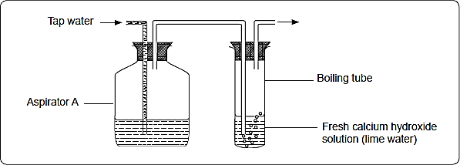

(b)   Pack the bottom of a U-tube with anhydrous calcium chloride. Pass air through the U-tube by means of an aspirator or a suction pump. Record your observations.

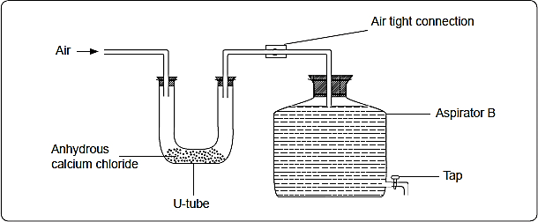

**Side notes**

* Water is allowed to flow into aspirator A to drive out air and bubble it through the calcium hydroxide solution.
* Water is allowed to flow out of aspirator B in order to create a suction force which draws air through the U-tube.

**Observations and Discussion**

When the stream of air is passed through calcium hydroxide solution, a white precipitate is formed. This indicates that carbon (IV) oxide gas is present in air.

When air is passed through the U-tube the **white anhydrous calcium chloride absorbs water vapour from the air and becomes wet**. It may form a colourless solution depending on the amount of moisture in the air.

Substances, **which absorb moisture from the air to form a solution** are called **deliquescent substances.** Other deliquescent substances are **anhydrous iron (III) chloride, magnesium chloride and zinc chloride.**

## Fractional Distillation of Liquefied Air

Air is a mixture of many gases. It can be separated into its constituent gases by fractional distillation of liquefied air.

The air is first **purified by passing it through filters to remove dust.**

The dust-free air is then passed through a solution of **concentrated sodium hydroxide to remove carbon (IV) oxide gas.**

The remaining part of air is then **cooled to -25°C to remove water vapour, which solidifies out as ice.**

The remaining part of air is then compressed to a **pressure of 200 atmospheres** and allowed to expand. Repeated compression and expansion of the air cools it to liquid at -200°C.

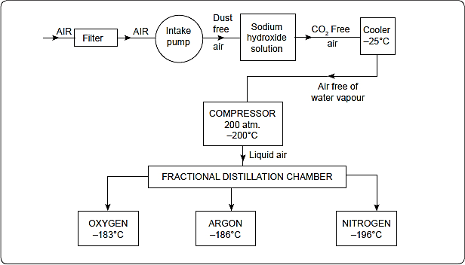

The **liquid air** consists of **oxygen, nitrogen and noble gases.** Since these gases **have different boiling points**, they can be separated by **fractional distillation**. Liquid **oxygen boils at -183°C** and **nitrogen at -196°C**.

**Nitrogen distils out first because it has a lower boiling point.**

The other gases, made of **mainly argon, boil at -186°C. They form the second fraction.**

The argon can be separated from oxygen by **further distillation**.

# Rusting

Rusting is the **corrosion of iron** due to its **reaction with atmospheric oxygen and moisture**.

**Rust** is **hydrated iron (III) oxide. The chemical formula for rust is Fe2O3.H2O**

Rust forms a brown coating on the surface of iron material. Because rust is porous, once an object starts to rust, the process continues until the object is completely destroyed.

## Conditions necessary for rusting.

For rusting to occur, moisture and air must be available.

**⚗Practically Speaking🔊 📌**

**The following experiment can be used to identify the conditions necessary for rusting to occur.**

Label five boiling tubes 1, 2, 3, 4 and 5 respectively. Put two clean nails in each of the boiling tubes. To the first tube add 10cm3 of tap water. To the second tube, add 10cm3 of boiling water followed by about 3cm3 of oil. To the third tube, push a piece of cotton wool half-way and place some anhydrous calcium chloride on it and cork the tube. To the fourth tube, add salted water. The fifth boiling tube contains nails only. Observe the nails after three days and record your observations.

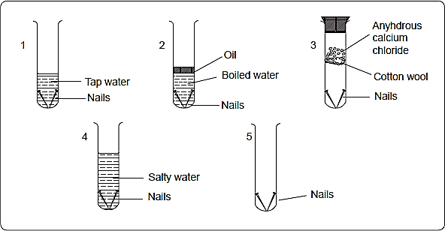

**Side notes**

* Water in the second tube is boiled to expel all dissolved gases.The layer of oil covering the boiled water prevents re-entry of air.
* Anhydrous calcium chloride absorbs moisture from the air, thus air in tube 3 is dry.
* It is necessary to cork tube 3 to prevent entry of water vapour from the atmosphere

**Observations and Discussion**

**After three days;**

It is observed that the nails in boiling tube 1 would have rusted after three days. The nails in tube 5 would have rusted to a smaller extent. The rusting in tube 4 is more intense. No rust is observed in tubes 2 and 3.

Tap water contains dissolved oxygen. The iron nails combine with oxygen in the presence of water to form hydrated iron oxide.

Iron + oxygen  Iron (III) oxide

Iron (III) oxide + water  hydrated iron (III) oxide (brown)

Rusting occurred in tube 1 because both water and oxygen were present. Some rusting occurred in tube 5 since there was some moisture in the air. Rusting was more intense in tube 4 due to presence of dissolved sodium chloride.

There was no oxygen in tube 2 and therefore the nails did not rust. The nails in tube 3 do not rust because there was no water in it.

**Learning outcome**

The presence of water and oxygen are thus necessary for iron to rust.

**The factors that accelerate rusting are salts and acids.**

Rusting occurs faster in salty or acidic surroundings. For example, cars rust faster in Mombasa than in Nairobi.

Rusting destroys machinery, equipment and roofs made of iron. Rusting can be very expensive. Prevention of rusting is therefore of great importance.

## Methods of Preventing Rusting

The basis of rust prevention is to keep iron out of direct contact with water and oxygen.

The following methods are widely used to prevent rusting of iron.

* 1. Painting e.g. cars, roofs, marine vessels etc.
  2. Coating with other metals. This can be done through galvanisation or electroplating.
  3. Alloying: This involves the mixing of iron with one or more metals to produce a substance, which does not rust.
  4. Oiling and greasing: This method is used in moving engine parts where other methods cannot be used due to friction.
  5. Sacrificial protection: In this arrangement, a more reactive metal such as zinc or magnesium is attached to the iron structure. The more reactive metal corrodes instead of iron. The method is applied in ships, water and oil pipes

# Oxygen

Oxygen exists freely in the atmosphere as a gas. Its chemical symbol is O. Two atoms of oxygen combine to form a molecule with a chemical formula of O2. Oxygen is also found combined with other elements such as hydrogen in water and metals in metal oxides. It is the most active component in air.

**⚗Practically Speaking🔊 📌**

## Laboratory preparation of oxygen

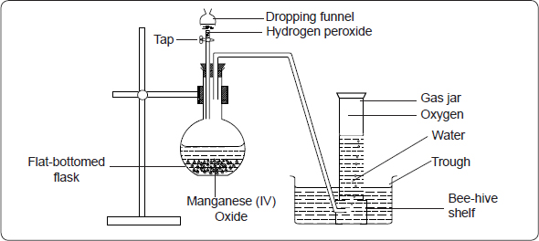In the laboratory, oxygen can be prepared by the decomposition of hydrogen peroxide using manganese(IV) oxide as a catalyst. Sodium peroxide may also be reacted with water to produce oxygen. When potassium permanganate (VII) is heated, oxygen is also produced.

**Side notes**

* The first few bubbles of oxygen are not collected because the gas is mixed with air which was originally in the flask.
* Oxygen is slightly soluble in water and so it can be collected over water.
* Manganese (IV) oxide acts as a **catalyst.A catalyst is a substance that alters the rate of a reaction.** In the absence of manganese (IV) oxide, the hydrogen peroxide can be warmed to speed up the reaction.

**Producing Oxygen: The Reactions**

Hydrogen peroxide decomposes slowly to produce oxygen and water under normal conditions. On adding manganese (IV) oxide the rate of decomposition is speeded up. Manganese (IV) oxide is used as a catalyst in the decomposition of hydrogen peroxide.

**Hydrogen peroxide $\underset{→}{\text{Manganese }\left(\text{IV}\right)\text{oxide }}$ Oxygen (gas) + Water**

**Adding water to Solid Sodium Peroxide**

Sodium peroxide + water → Sodium hydroxide + Oxygen

**Heating Potassium Manganate (VII) (Potassium Permanganate)**

PotassiumManganate (VII) $\underset{→}{\text{ Heat }}$ Potassium + Manganese (IV) oxide + Oxygen

**Test for Oxygen**

Oxygen relights a glowing splint. This is the test for oxygen

## Properties of oxygen.

Oxygen is a colourless, odourless gas with a low boiling point of -183°C.

### Burning of Substances in Air

The most familiar chemical reaction of air is burning. There are many substances, which burn in air. It has been established that oxygen is the active part of air, which supports burning.

#### Burning of metals in air

Many metals burn in air and in oxygen at different rates. They burn faster in oxygen than in air. Nitrogen is the component of air which slows down the rate of burning.

**⚗Practically Speaking🔊 📌**

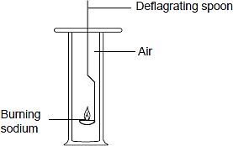Warm a piece of sodium in a deflagrating spoon until it begins to burn. Lower it into a gas jar of air as shown below Record your observations.

Allow the gas jar to cool, add some water to the product and shake the mixture. Test any gas given out with moist red and blue litmus paper. Test the solution in the gas jar using litmus papers and record your observations. Repeat the experiment using oxygen instead of air.

Repeat the whole procedure using calcium, magnesium, iron and copper in place of sodium.

**Discourse**

Sodium reacts most vigorously with oxygen while copper is the least reactive.

|  |  |  |  |  |  |
| --- | --- | --- | --- | --- | --- |
| Metal | How it burns in air | Appearance of product | Name of product | Solubility of product in water | Nature of solution |
| Sodium | Burns with a yellow-orange flame | White solid | Sodium oxide and sodium nitride | Soluble, alkaline gas evolved | Alkaline |
| Calcium | Burns with a red flame in air enriched with oxygen. | White solid | Calcium oxide and calcium nitride | Soluble, alkaline gas evolved | Alkaline |
| Magnesium | Burns with a brilliant white flame. | White powder | Magnesium oxide and magnesium nitride | Soluble, alkaline gas evolved | Alkaline |
| Iron | Glows red with sparks | Red-brown solid | Iron(III) oxide | Insoluble | - |
| Copper | Burns with a blue flame in air enriched with oxygen, surface turns black | Black solid | Copper (II) oxide | Insoluble | - |

#### Products of Burning Metals in Oxygen

When metals burn in oxygen they form metal oxides.

Sodium + Oxygen  sodium oxide

Calcium + Oxygen  calcium oxide

Magnesium + Oxygen  Magnesium oxide

Iron + Oxygen  Iron (III)oxide

Reactive metals such as sodium, calcium and magnesium react with nitrogen in the air to form nitrides.

Sodium + Nitrogen  Sodium nitride

Calcium + Nitrogen  Calcium nitride

Magnesium + Nitrogen  Magnesium nitride

When the nitrides react with water, ammonia gas is given out.

Sodium nitride + Water  Sodium hydroxide + Ammonia

Calcium nitride + Water  Calcium hydroxide + Ammonia

Magnesium nitride + Water  Magnesium hydroxide + Ammonia

The reactions in which elements combine with oxygen are referred to as **oxidation.** The substance to which the oxygen is added is said to have been **oxidised**

The metals can be arranged in order of their rates of reaction with oxygen from the most reactive to the least reactive. This arrangement is referred to as a reactivity series of metals.

Mercury, silver and gold are less reactive than copper and are not easily oxidised.

**The following is part of the Reactivity Series for some metals.**

Potassium Most reactive

Sodium

Lithium

Calcium

Magnesium

Aluminium

Zinc

Iron

Lead

Copper

Mercury

Silver

Gold Least reactive

#### Burning of non-metallic elements burn in oxygen

Sulphur burns in oxygen to give a gaseous product which has a choking irritating smell. The product is sulphur (IV) oxide.

Sulphur + Oxygen  Sulphur (IV) oxide

A solution of sulphur (IV) oxide in water is acidic and turns blue litmus paper red. The acid is called sulphuric (IV) acid (sulphurous acid).

Sulphur (IV) oxide + Water Sulphurous acid.

Oxides which dissolve in water to form acidic solutions are referred to as **acidic oxides.**

|  |  |  |  |  |
| --- | --- | --- | --- | --- |
| Non -metal | How it burns in oxygen | Name of product | Appearance of product | Effect of solution on litmus |
| Sulphur | Burns with a blue flame | Sulphur (IV) oxide | White fumes | Turns red |
| Carbon | Burns with a yellow flame | Carbon (IV) oxide | White fumes | Turns red |
| Phosphorus | Burns with a white flame | Phosphorus (V) oxide and Phosphorus (III) oxide | White fumes | Turns red |

#### Summary of effect of burning non-metals in oxygen

The following equations represent the reactions of the non-metals with oxygen.

Carbon + Oxygen Carbon (IV) oxide

*(excess)*

Carbon + Oxygen Carbon (II) oxide

(*limited supply)*

Phosphorus+ Oxygen Phosphorus (V) oxide

*(excess)*

Phosphorus + Oxygen Phosphorus (III) oxide

*(limited supply)*

Some non-metallic elements form oxides which are neither acidic nor basic. These oxides are referred to as **neutral oxides.**

Carbon (II) oxide and water (hydrogen oxide) are examples of neutral oxides.

#### Change in mass when substances burn in air.

When substances burn in air, they combine with oxygen to form oxides. **If the product is a solid there is increase in mass.**

When the product is gaseous there is decrease in mass. The decrease in mass is because the products, being gaseous escape into the air.

**⚗Practically Speaking🔊 📌**

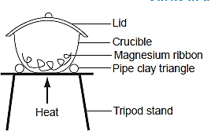Weigh about 1g clean magnesium ribbon in a crucible. Heat the crucible, occasionally lifting the lid to let air in. Do not allow any contents to escape from the crucible. When all the magnesium has burned, allow the crucible to cool. Weigh the cool crucible and its contents again.

Record your observations as follows:

Mass of crucible + Magnesium before burning = Xg

Mass of crucible + contents after burning        = Yg

Change in Mass                                               = (Y–X)g

**Side note**

When magnesium is burned in a closed crucible, most of the oxygen inside is consumed. It is therefore necessary to allow air in so that burning can continue.

**Discourse**

The mass of the product is more than the original mass of magnesium. This shows that as it burns, magnesium combines with air to form a new product.

### Competition for combined oxygen

A **more reactive metal removes combined oxygen from a metal oxide of a less reactive metal.** More reactive metals displace less reactive metals from their oxides.

For example, Magnesium combines with oxygen more readily than copper. Therefore, magnesium removes combined oxygen in copper (II) oxide to form magnesium oxide. Copper is said to have been **displaced** by magnesium.

Copper on the other hand **does not remove combined oxygen** from the oxides of magnesium, lead, zinc and iron. This is due to the fact that **copper reacts with oxygen less readily than these metals.** It is the **least** reactive.

Removal of oxygen from a substance is called **reduction.** When a metal oxide **loses oxygen**, it is said to have been **reduced.** The metal, which **gains oxygen** is said to have been **oxidised.**

Zinc + Copper (II) oxide  Zinc oxide + Copper

In the above equation, **zinc is oxidised** while **copper oxide is reduced.** Both reduction and oxidation take place **simultaneously**.

A reaction in which both reduction and oxidation occur simultaneously is called a **REDOX** reaction.

|  |  |  |  |  |  |
| --- | --- | --- | --- | --- | --- |
| Summary of the competition for combined oxygen by elements | | | | | |
|  | **Magnesium** | **Zinc** | **Lead** | **Iron** | **Copper** |
| Magnesium oxide (white) | No reaction | No reaction | No reaction | No reaction | No reaction |
| Copper (II) oxide (black) | Magnesium oxide and copper formed | Zinc oxide and copper formed | Lead oxide and copper formed | Iron (II) oxide and copper formed | No reaction |
| Lead (II) oxide (yellow) | Magnesium oxide and lead formed | Zinc oxide and lead formed | No reaction | Iron (III) oxide and lead formed | No reaction |
| Zinc oxide (white) | Magnesium oxide and zinc formed | No reaction | No reaction | No reaction | No reaction |
| Iron (III) oxide | Magnesium oxide and iron formed | Zinc oxide and iron formed | No reaction | No reaction | No reaction |

From the table, magnesium displaces four metals from their oxides. Zinc displaces three while lead and iron displaces two and one respectively. Copper displaces none. Therefore, magnesium is the most reactive while copper is the least reactive.

By considering the number of metals displaced, a **reactivity series** can be obtained.

Highest ability

Magnesium

Zinc increasing ability to

Iron take away combined oxygen

Lead

Copper Least ability

#### Application

The extraction of metals from their ores uses the concept of reduction. The ores that contain the metal oxides are reduced by more reactive metals. For example, Aluminium is used to reduce iron (III) oxide by the thermite process.

Carbon, a non-metal can remove combined oxygen from some metal oxides such as iron (III) oxide and copper (II) oxide.

Carbon + Copper (II) oxide  Carbon (IV) oxide + Copper

The ability of carbon to reduce some metal oxides is applied in the extraction of metals such as copper and zinc from their ores.

## Atmospheric Pollution

A pollutant is a substance (contaminant) or form of energy which has harmful effects to the environment.

Human activities have changed the composition of air in some places. Gases such as carbon (IV) oxide, carbon (II) oxide, sulphur (IV) oxide and phosphorous (V) oxide, are examples of harmful substances emitted into the atmosphere mainly from the combustion of fossil fuels. These gases cause pollution of the atmosphere. For example, sulphur (IV) oxide dissolves in rain water and is converted to sulphurous acid, which forms “acid rain”. Acid rain destroys plants and aquatic life. It also corrodes iron sheets, zinc roofing and buildings.

## Uses of Oxygen

1.    Air enriched with oxygen is used in hospitals by patients with breathing difficulties.

2.    When mixed with helium it is used by mountain climbers and deep-sea divers.

3.    Oxygen is used to burn fuels such as those used for propelling rockets.

4.    A mixture of oxygen and acetylene burns to produce a very hot flame used in welding and for cutting metals.

5.    During steel making, oxygen is used to remove iron impurities.

6.    Oxygen is used as one of the reactants in fuel cells.

## Review Exercises

1. (a) Complete the following table to show the components of air and their relative percentage abundance.

|  |  |
| --- | --- |
| Components | % Composition |
| Nitrogen  Oxygen  Carbon(IV)oxide  Noble gases |  |

(b) Name two noble gases that are likely to be found in air.

1. (a) Name three substances, other than oxygen and nitrogen, that are always present in the atmosphere.

(b) Outline an experiment that you could perform in the laboratory to identify one of the substances you listed in part (a).

1. Air is a mixture of several different gases. Identity the gas in air which

(a) puts off a burning split. __

(b) supports combustion. __

(c) makes up almost 80% of fair _

(d) condenses to form a colourless, odourless liquid at room temperature.

1. State the main uses of

(a) oxygen. (b) nitrogen

1. A burning candle was placed in a bell jar containing sodium hydroxide solution as follows.

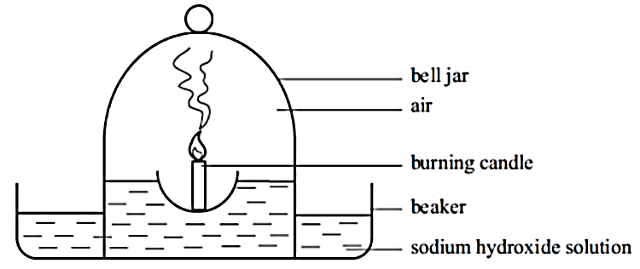

(a) Draw another diagram to show what you would expect after 10 minutes.

(b) Explain the observations in 6 a) above.

1. (a) State two conditions necessary for rusting.

(b) How is the rusting process accelerated in our daily life?

(c) State four ways that can be used to prevent rusting.

1. Iron rubbish bins coated with a complete layer of zinc do not rust easily

(a) What name is given to the coating of iron with zinc?

(b) Explain how the method works.

1. The set-up below was used In an experiment to determine the conditions necessary for rusting.

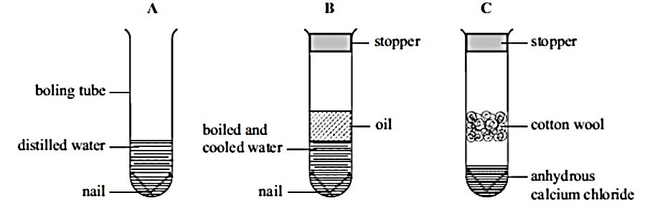

In which set up will the iron nails rust? Explain.

1. A large piece of magnesium buried in the ground and connected to an underground iron pipe prevents the corrosion of the iron pipes. Explain.
2. How does oiling of iron tools prevent rusting?
3. Common salt is often spread on roads cold countries.

(a) What is the purpose of adding common salt on roads in cold countries?

(b) In such countries, cars rust faster. Explain.

(c) Explain why iron objects are likely to rust slowly in a desert

1. When magnesium metal is burnt in air the product formed weighs more than the original magnesium. Explain.
2. When a substance combines with oxygen, the process is called (a)___________and the substance is said to be (b)__________
3. A mixture of copper(ii)oxide and zinc metal was heated strongly in a crucible.

(a) State and explain observations made at the end of the experiment.

(b) Write the equation for the reaction that takes place in the crucible.

(c) Suppose copper(ii)oxide was replaced with magnesium oxide, state and explain the observation that would be made.

1. Sodium metal on a deflagrating spoon was burnt in air as shown below

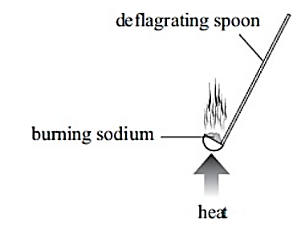

(a) What is the colour of the flame produced when sodium is burnt?

(b) Write a word equation for the reaction that takes place.

(c) The product formed in this process is dissolved in water. Blue and red litmus papers are dipped in the resultant solution. State the observations

1. The boiling points (at atmospheric pressure) of oxygen and nitrogen are -183°C and - 196°C respectively. Which of these two gases would you expect to be separated first?
2. (a) Given that oxygen gas is denser than air, draw a well labelled diagram to show how dry oxygen can be prepared and collected in the laboratory

(b) When elements burn in oxygen, they combine with it to form _

(c) State two physical properties of oxygen gas.

(d) Outline two uses of oxygen gas.

1. The following set up was used to prepare and collect a sample of oxygen gas

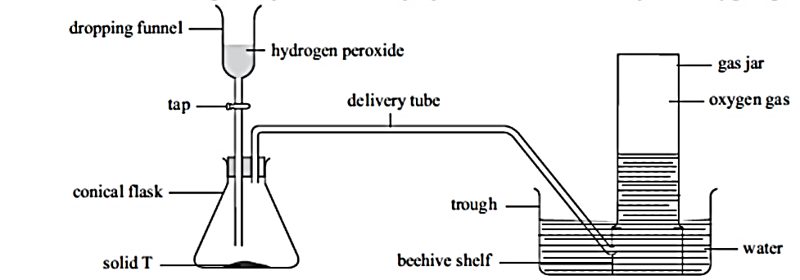

(a) (i) Identify solid T.

(ii) State the role of solid T in this reaction.

(b) Write a word equation for the reaction that produces oxygen.

(c) What property of oxygen makes it possible for its collection as indicated by the diagram?

(d) Explain why it is important not to collect any gas for the first few seconds of the experiment.

1. The following table gives three elements that were burnt by students in dry oxygen gas. Complete the table to show how the elements burnt and the name of the product

|  |  |  |
| --- | --- | --- |
| **Element** | **How it burnt** | **Name of product** |
| Sulphur  Magnesium  Carbon |  |  |

1. Oxygen can be prepared by dripping cold water on solid P.

(a) Name solid P.

(b) Write a word equation for the reaction that produces oxygen.

1. (a) Name two substances which when heated produce oxygen gas.

(b) Write the word equation for the reaction in (a) above.

1. Sodium metal was warmed until it began burning. The burning sodium was lowered in a gas jar of oxygen as shown below.

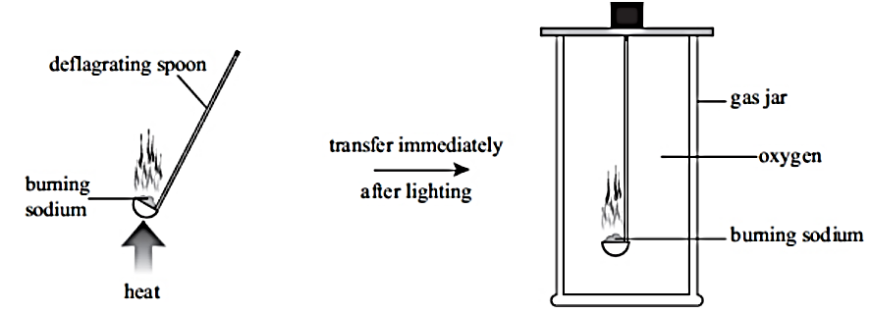

(a) State the expected observations.

(b) Some water was added to the product of this reaction and the resulting solution tested with blue and red litmus papers. State and explain the observations made.

(c) Write a word equation for the reaction of

(i) sodium with oxygen. _

(ii) product with water.

(d) What type of reaction takes place when sodium burns in oxygen?

1. Burning sulphur on a deflagrating spoon was lowered into a gas jar of oxygen gas.

(a) State the observations made.

(b) Write a word equation for the reaction that occurs. _

(c) A little water was used to dissolve the product of this experiment. What effect would the solution formed have on blue and red litmus papers? Explain using a word equation.

1. (a) Name the process used to obtain oxygen on large scale.

(b) During the process in 26 (a), dust particles are first removed from air How are the dust particles removed?

(c) Explain how the following substances are removed from air before liquefaction.

(i) Carbon (IV) oxide. (ii) Water vapour.

(d) Describe how air free of dust particles, carbon (IV)oxide and water vapour is liquefied.

(e) Which component of liquid air is obtained first? Explain.

(f) Nitrogen, oxygen and argon are obtained from liquid air by fractional distillation. State the physical property that makes it possible to separatethem.

(g) Arrange the gases in (f) in order of how they distil, starting with the first.

(h) State four uses of oxygen gas.

## In the papers….

1. 2006 Q 2 P1

The diagram below represents a set-up that was used to show that part of air is used during burning.

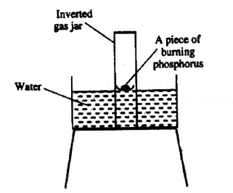

(a) Given that phosphorus used was in excess, draw a diagram of the set-up at the end of the experiment (when there was no further observable change).

(b) Suggest one modification that should be made on the apparatus if the percentage of the air used is to be determined.

1. 2007 Q 1a P1

State two factors that should be considered when choosing fuel for cooking.

1. 2009 Q 21 P1

Give the name of the product formed when magnesium reacts with phosphorus. (1 mark)

1. 2010 Q26 P1

A water trough, aqueous sodium hydroxide, burning candle, watch class and a graduated gas jar were used in an experimental set up to determine the percentage of active part of air. Draw a labelled diagram of the set up at the end of the experiment. (3 marks

1. 2012 Q1 P1

Charcoal is a fuel that is commonly used for cooking. When it burns it forms two oxides.

(a) Name the two oxides (2 marks)

(b) State one use of the two oxides (1 mark)

1. 2012 Q24 P1

The following set up of three-tubes was used to investigate rusting of iron. Study it and answer the questions that follow.

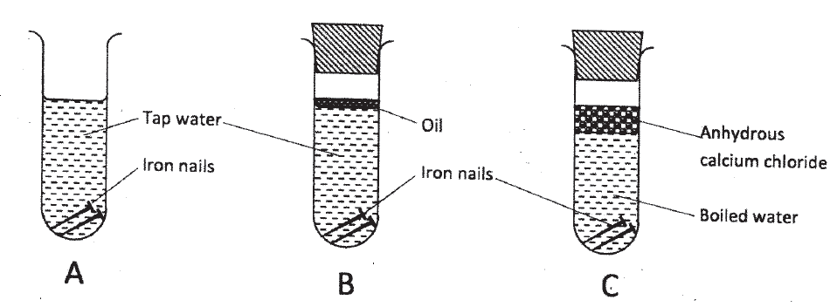

(a) Give a reason why rusting did not occur in test-tube C. (1 mark)

(b) Aluminium is used to protect iron sheets from rusting. Explain two ways in which aluminium protects iron from rusting. (2 marks)

1. 2013 Q1 P1

The set up below can be used to prepare oxygen gas. Study it and answer the questions that follow.

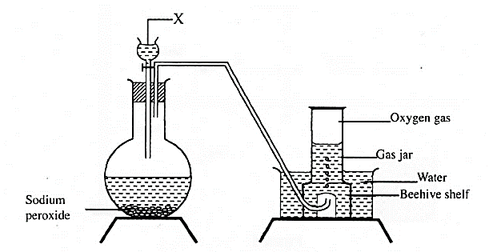

(a) Identify X (1 mark)

(b) What property of oxygen makes it possible for it to be collected as shown in the above set up? (1 mark)

(c) State two uses of oxygen. (1 mark)

1. 2014 Q16 P1

A measuring cylinder fitted with moist steel wool was inverted in a trough of water as shown in the diagram below.

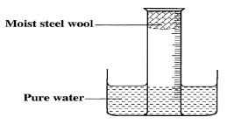

(a) State and explain the observations made on the:

(i) Moist steel wool after four days; (1 mark)

(ii) Water level in the measuring cylinder after four days. (1 mark)

(b) What would be the effect of using steel wool moistened with salty water? (1 mark)

1. 2016 Q18 P1

A water trough, aqueous sodium hydroxide, burning candle, watch glass and a graduated jar were used in an experimental set up to determine the percentage of active part of air. Draw a labelled diagram of the set up at the end of the experiment. (3 marks)

1. 2018 Q10 P1

Using iron filings, describe an experiment that can be conducted to show that oxygen is present in air. (3 marks)

1. 2019 Q14 P1

During laboratory preparation of oxygen, manganese (IV) oxide is added to reagent H.

(a) Name reagent H. (1 mark)

(b) State the role of manganese (IV) oxide in this experiment. (1 mark)

(c) Write the equation for the reaction that takes place. (1 mark)

**WATER AND HYDROGEN**

Table of Contents

Water - 2 -

Source of water: Burning of candle wax in air - 2 -

Reactions of Water with Metals - 3 -

Reactions of Metals with Steam - 4 -

Hydrogen - 5 -

Laboratory Preparation and properties of Hydrogen - 5 -

Reducing property of hydrogen - 7 -

Burning of hydrogen in air - 8 -

Uses of Hydrogen - 9 -

Review Exercises - 10 -

In the papers…. - 12 -

**Objectives**

**By the end of this chapter, the learner should be able to:**

1. Describe experiments to show that water is a product of burning organic matter and that it contains hydrogen.
2. State the products of reactions of metals with cold water and steam then derive the reactivity series of the metals.
3. Prepare hydrogen and investigate its properties and uses.

**WATER AND HYDROGEN**

# Water

Water is the most abundant substance on earth. About 71% of the earth’s surface is covered by water. The sources of water are seas, lakes, rivers and oceans.

## Source of water: Burning of candle wax in air

Carbon and hydrogen are the major components of organic matter. When organic matter burns in air, carbon (IV) oxide and water are produced. Candle wax is made up of organic matter.

Candle wax is a compound of carbon and hydrogen. It belongs to a group of compounds called **hydrocarbons.** It burns in air to form carbon (IV) oxide and water.

Other hydrocarbons include kerosene, petrol and diesel.

**⚗Practically Speaking🔊 📌**

To demonstrate what happens when candle wax burnsin air, the set up below can be used.

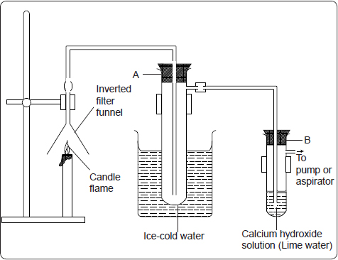

Light the candle and turn on the pump. Allow the candle to burn for about 15 minutes. Observe and record what happens in tube A and B.

Divide the contents of test-tube A into two portions. To one portion, add anhydrous copper (II) sulphate or blue cobalt (II) chloride paper. Record your observations.

**Side notes**

* Test-tube A is dipped in cold water so that the cold water condenses the vapor to a liquid.

**Observations and Discussion**

In test-tube A, a colourless liquid, which turns white anhydrous copper (II) sulphate to blue and blue cobalt(II) chloride paper to pink is observed.

In test-tube B, a white precipitate is observed.

Candle wax burns in air to form a colourless liquid, which turns white anhydrous copper(II)sulphate to blue and blue cobalt (II) chloride paper to pink. The liquid formed is water. A colourless gas that forms a white precipitate with lime water is also produced. Thisgas is carbon (IV) oxide.

## Reactions of Water with Metals

Water reacts with some metals to produce hydrogen gas.

**⚗Practically Speaking🔊 📌**

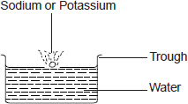The following experiments can be done to showcase the reaction between water and some metals

1. Cut a very small piece of sodium metal. Drop it into a trough containing cold water. Test the solution in the trough using pieces of red and blue litmus papers. Record your observations.
2. 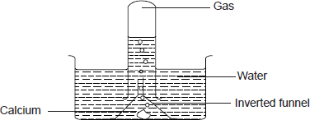Drop a piece of calcium metal into water in a trough. Invert a funnel over the calcium. Fill a test-tube with water and invert it over the funnel. Collect the gas given off. Cork the test-tube to prevent the gas from escaping. Lift the test-tube from water and turn it upright. As you remove the cork, bring a burning splint near the mouth of the test-tube. Observe what happens. Test the solution in the beaker using pieces of red and blue litmus paper. Record your observations.
3. Put a two-centimetre piece of clean magnesium ribbon into a test-tube containing water. Record your observations. Repeat the experiment using clean zinc granules and fresh iron filings respectively.

**Side notes**

* **It is necessary to clean the magnesium ribbon** before using because magnesium reacts with atmospheric oxygen to form a **coating of magnesium oxide.** The coating has to be removed so that the metal surface comes into contact with the water.
* The magnesium ribbon is coiled in order to increase the surface area in contact with the boiling tube.

**Observations and Discourse**

When a piece of **sodium** metal is placed in water, it melts into a silvery ball as it reacts vigorously darting on the surface of the water with a hissing sound. The resulting solution turns red litmus blue showing that it is basic.

Sodium + Water  Sodium hydroxide + Hydrogen.

When calcium is added to water it sinks and reacts moderately with water producing a steady stream of bubbles. When the gas is tested with a burning splint, it burns with a ‘pop’ sound indicating the gas is hydrogen. A basic solution of calcium hydroxide is formed.

A white suspension is observed because the calcium hydroxide is slightly soluble in water.

Calcium + Water  Calcium hydroxide + Hydrogen

Magnesium reacts very slowly with cold water while zinc and iron do not react.

The reaction of potassium with water is explosive. A small piece of potassium placed on water melts into a silvery ball and moves about rapidly on the surface. The reaction generates a lot of heat. As a result, hydrogen gas produced ignites spontaneously.

The flame produced is lilac (purple) due to the presence of potassium vapour produced during the reaction.

Potassium + Water  Potassium hydroxide + Hydrogen

The resulting solution turns red litmus blue showing that it is basic.

## Reactions of Metals with Steam

Some metals like magnesium and iron react slowly with cold water. However, with steam, the reaction is faster.

**⚗Practically Speaking🔊 📌**

**The experiment below can be used to demonstrate the reaction between steam and some metals.**

Place clean, wet sand in a boiling tube. Clean a piece of magnesium ribbon about 6cm long and make it into a spiral coil. Place it in the middle of the boiling tube and arrange the apparatus as shown below.

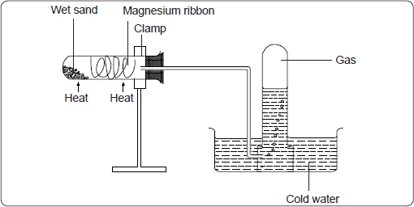Heat the magnesium strongly and warm the wet sand gently as you continue heating the magnesium. Observe what happens. Remove the delivery tube before you stop heating.

Test the gas produced using a burning splint. Record your observations. Repeat the experiment using zinc powder and iron filings.

**Side notes**

* The wet sand is warmed to generate steam, which reacts with the metal.
* The delivery tube is removed before heating stops to prevent water being sucked into the hot boiling tube as it cools.

**Observations and Discussion**

Magnesium burns brightly in steam to form white magnesium oxide powder and hydrogen gas.

Magnesium + Steam  Magnesium oxide + Hydrogen

Zinc and iron do not burn in steam, they glow. Zinc metal reacts with steam to form a yellow powder of zinc oxide, which turns white on cooling.

Zinc + Steam  Zinc oxide + Hydrogen gas

Iron forms a black residue of an oxide called tri-iron tetra oxide and hydrogen.

Iron + Steam  Tri-iron tetra oxide + Hydrogen gas

Aluminium reacts with steam but quickly forms a layer of aluminium oxide which prevents further reaction. Lead and copper do not react with either cold water or steam.

|  |  |  |
| --- | --- | --- |
| **Summary of reaction of metals with cold water and steam** | | |
| **Metal** | **Action of metal on water** | **Action of metal on steam** |
| Potassium | Violent | Explosive |
| Sodium | Violent | Explosive |
| Calcium | Moderate | Violent |
| Magnesium | Very slow | Rapid |
| Aluminium | No reaction | Slow |
| Zinc | No reaction | Slow |
| Iron | No reaction | Slow |
| Lead | No reaction | No reaction |
| Copper | No reaction | No reaction |

Metals can be arranged in order of their reactivity with water. The arrangement gives the Reactivity Series of metals, as shown below.

Potassium Most reactive

Sodium

Lithium

Calcium

Magnesium

Aluminium

Zinc

Iron

Lead

Copper Least reactive

# Hydrogen

Hydrogen is the simplest and lightest element. It does not occur as a free element on earth but exists in combined form. Examples of compounds containing hydrogen are water, hydrocarbons and and sugar.

## Laboratory Preparation and properties of Hydrogen

Hydrogen gas is prepared in the laboratory by the reaction between **dilute acids and some metals.** Dilute sulphuric acid and hydrochloric acid react with some metals to liberate hydrogen gas.Zinc is the **most suitable metal for the laboratory preparation of hydrogen gas****.**

**⚗Practically Speaking🔊 📌**

The set up below can be used to prepare hydrogen gas in the laboratory.

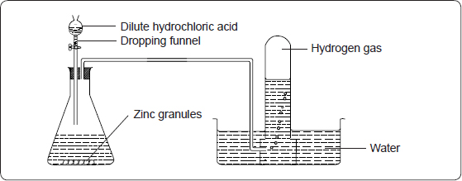If the reaction is slow, add a few crystals of copper (II) sulphate. If the gas is required dry, it should be bubbled through concentrated sulphuric acid and collected by upward delivery.

**Side notes**

* 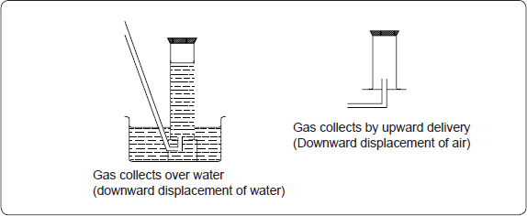Hydrogen is insoluble in water, so it is collected over water.
* Hydrogen is less dense than air and it can also be collected by **upward delivery.** This method is also called **downward displacement of air.**
* Copper (II) sulphate acts as a **catalyst** to speed up the reaction.

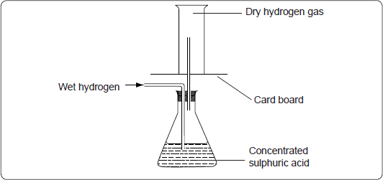

* Dry hydrogen gas can be obtained by passing wet hydrogen through **anhydrous calcium chloride** in a U-tube or passing it through concentrated sulphuric acid.

**Observations and Discussion**

When zinc granules are added to dilute hydrochloric acid there is effervescence and hydrogen gas is evolved.

Zinc + Hydrochloric acid  Zinc chloride + Hydrogen

Nitric acid is not used to prepare hydrogen gas because the **hydrogen formed is oxidised to water.** However, very dilute nitric acid liberates hydrogen with magnesium metal.

Zinc is preferably used because it reacts moderately with dilute acids.

Potassium, sodium, lithium and calcium react explosively with dilute acids hence **must** not be used. Magnesium could be used for the laboratory preparation of hydrogen but it is expensive. Aluminium forms a protective layer of aluminium oxide, which should be washed using concentrated hydrochloric acid before the metal can react with dilute acids. Impure iron gives a mixture of gases including the bad smelling hydrogen sulphide when it reacts with dilute acids.

**Physical Properties of Hydrogen**

Hydrogen is a colourless, odourless gas.

It is less dense than air and insoluble in water.

Hydrogen has no effect on litmus paper. It is neutral

**Test for hydrogen**

When mixed with air, hydrogen burns with a ‘pop’ sound. This is the test for hydrogen gas. The intensity of the pop sound diminishes as the purity of hydrogen increases. Pure hydrogen burns quietly with a blue flame. Hydrogen does not support combustion but it burns in air.

## Reducing property of hydrogen

Hydrogen is a strong reducing agent. It can reduce some metal oxides to their respective metals and is itself oxidised to water.

**⚗Practically Speaking🔊 📌**

**The experiment below can be done to demonstrate the reducing properties of hydrogen.**

Place a spatulaful of copper (II) oxide in a porcelain boat or on a piece of aluminium foil. Place the boat or aluminium foil in a combustion tube. Set the apparatus as shown.

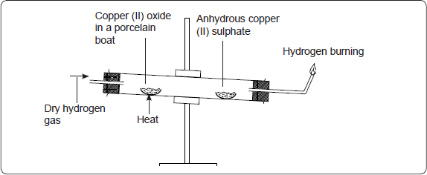

Pass dry hydrogen through the tube for some time to drive out the air from the apparatus. Collect a sample of the gas from the jet in a test-tube and test it with a burning splint. Continue collecting and testing until a sample of the gas burns silently (without a ‘pop’ sound)*.*

Light the gas at the jet and start heating copper (II) oxide as shown. Ensure a steady flow of hydrogen gas. Continue heating until there is no further change. Observe what happens. Allow the apparatus to cool as you continue passing the stream of hydrogen gas over the residue. Disconnect the apparatus and test the colourless liquid in the cooler parts of the combustion tube.

**Side notes: Precautions before and after the experiment**

* Air is driven out of the apparatus before heating the copper (II) oxide to ensure the hydrogen being burned at the jet is pure to avoid explosion.
* Excess hydrogen gas is burned because its mixture with oxygen (air) is explosive when ignited. The excess gas is therefore not allowed to escape into the air for safety reasons.
* The supply of hydrogen gas is continued while the apparatus cools to avoid the re-oxidation of the hot metal by oxygen from the air.

**Observations and Discussion**

* On passing a stream of dry hydrogen gas over hot copper (II) oxide the **black copper (II) oxide changes to red-brown.** At the same time a **colourless liquid condenses and collects on the cooler parts of the combustion tube.**

Hydrogen combines with oxygen from the copper (II) oxide to form water which is the colourless liquid. The red-brown solid is copper metal.

Copper (II) oxide + Hydrogen  Copper metal + Water

In this reaction copper (II) oxide is reduced to copper metal while hydrogen is oxidised to water.

**Hydrogen removes oxygen from copper (II) oxide and is therefore referred to as a reducing agent.** Copper (II) oxide loses oxygen to hydrogen hence it is an oxidising agent. Hydrogen will also reduce the oxides of lead and iron.

Removal of oxygen from a compound is known as **reduction** while the **addition of oxygen** is known as **oxidation**.

Lead (II) oxide + Hydrogen  Lead metal + Water

Iron (III) oxide + Hydrogen  Iron metal + Water

Hydrogen does not remove oxygen from oxides of more reactive metals.

## Burning of hydrogen in air

Hydrogen combines with oxygen from the air to form water. Water is therefore an oxide of hydrogen.

**⚗Practically Speaking🔊 📌**

To demonstrate the burning of hydrogen in air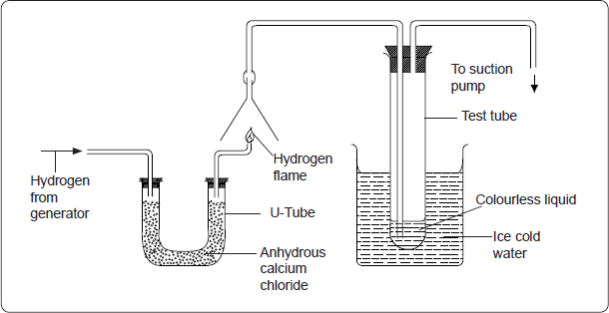, arrange the apparatus as shown below.

Pass a stream of hydrogen gas through anhydrous calcium chloride. Test the gas for purity by collecting samples over the jet and testing with a burning splint until the gas burns silently. Light the gas at the jet and turn on the pump. Draw in the products of the burning hydrogen using the pump for about 15 minutes. Test the liquid in the test-tube using white anhydrous copper (II) sulphate.

**Side notes**

* Anhydrous calcium chloride is used to dry the gas.
* The ice-cold water condenses the steam to form liquid water.

**Discourse**

When hydrogen burns in air a colourless liquid which turns white anhydrous copper (II) sulphate blue is formed. The liquid is water.

Hydrogen + Oxygen  Hydrogen oxide (water)

## Uses of Hydrogen

1.    Hydrogen is used in the large-scale manufacture of ammonia in a process known as the **Haber process.**

2.    The gas is also used during the hardening of oils to form fats. When hydrogen is passed through liquid oil in the presence of nickel catalyst, the oil takes up hydrogen and is converted into fat. This process is called **hydrogenation.** It is used in the manufacture of margarine.

3.    Hydrogen is used in balloons because it is lighter than air. A balloon filled with hydrogen floats in air. A light radio instrument can be connected to the balloon to collect information from the atmosphere by meteorologists who study weather conditions.*.*

4.    A mixture of hydrogen and oxygen burns to produce a very hot flame, the oxy-hydrogen flame, which has a temperature of up to 2000°C. The flame is used in welding and for cutting metals.

5.    Hydrogen is used in rocket as fuel.

6.    Hydrogen is used in the manufacture of hydrochloric acid.

7.    Hydrogen is used as a fuel in fuel cells.

## Review Exercises

1. Name two substances formed when a candle burns in air.
2. The following set up was used to investigate the products formed when a candle burns.

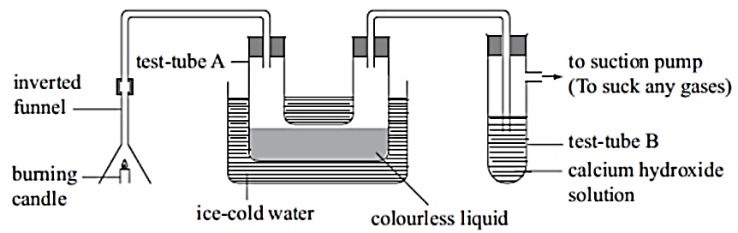

(a) State the observations made in

(i) Test tube A.______________

(ii) Test tube B_____________

(b) Explain the observations you stated in (a) (i) and (ii) above.

(c) State the effect of the contents of test tube A onanhydrous cobaltchloride paper

(d) Give one physical test for the contents of test tube A.

(e) Name two products formed when the candle burns.

(f) What elements are present in candle wax?

1. (a) You are provided with a colourless odourless liquid which you suspect to be pure water State how you would test for the purity of this liquid to confirm it is pure water.

b) A student left dry cobalt (II) chloride paper exposed overnight. The colour of the paper changed from blue to pink. Explain.

1. **(**a) Draw the set-up of apparatus you would use to burn dry hydrogen gas and collect the product.

(b) Write a word equation for the combustion of hydrogen.

(c) What type of reaction does hydrogen undergo during combustion?

(d) State the precaution you would take at the start and end of this combustion reaction

(e) State any four uses of hydrogen.

1. (a) Write a word equation for the reaction that takes place when dry hydrogen gas is passed over heated copper (II) oxide in a combustion tube.

(b) State the observations you would make in the combustion tube.

1. From the list of metals: lead, magnesium, iron, potassium, calcium, sodium and zinc, name the metal or metals that:

(a) react at a moderate rate with cold water;

(b) react with steam only when strongly heated;

(c) does not react with water or steam.

1. In an experiment, steam was passed over heated zinc metal using the following set-up of apparatus.

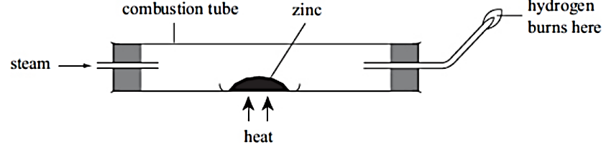

(b) Write a word equation for the reaction that occurs in the combustion tube.

(c) Write a word equation for the reaction that produces the flame.

1. State three physical properties and three chemical properties of hydrogen gas.
2. A student arranged apparatus as shown below to prepare and collect dry hydrogen gas.

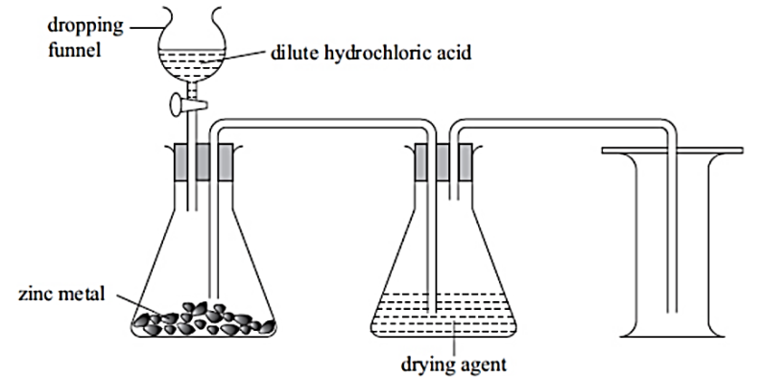

(a) Identify two mistakes in this set up.

(b) If the dropping funnel is replaced with thistle funnel, state the correction that should be made in the set-up.

(c) Name one metal that cannot be used in this experiment. Explain.

(d) Name a suitable drying agent that can be used in this experiment.

(e) Write a word equation for the reaction that takes place.

1. Steam is passed over heated magnesium as shown in the diagram below.

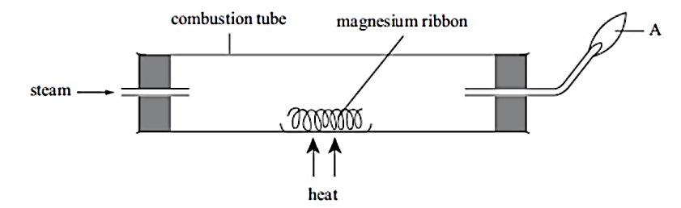

(a) Give two observations that will be made in the combustion tube during the experiment.

(b) Name the substance that was

(i) Burning at A (ii) Produced at A

(c) Write a word equation for the reaction in the combustion tube.

(d) Compare the initial mass of magnesium ribbon with that of the product. Explain.

## In the papers….

1. 2006 Q 18 P1

Study the diagram below and answer the question that follows.

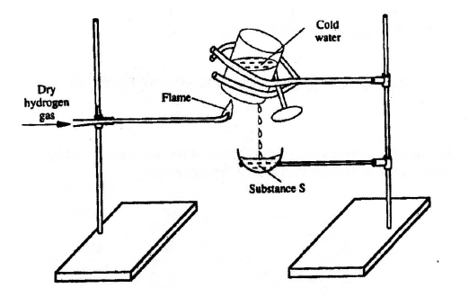  
Describe one chemical test that can be carried out to identify substance S. (2 marks)

1. 2006 Q 19 P1
2. Starting from solid magnesium hydroxide, describe how a solid sample of magnesium hydroxide can be prepared (2 marks)
3. Give one use of magnesium hydroxide. (1 mark)
4. 2007 Q 25a P1

The diagram below shows a student's set-up for the preparation and collection of hydrogen gas.

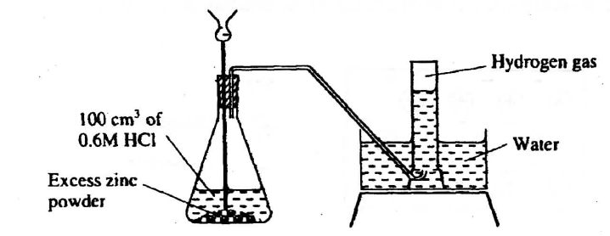

How would the final volume of hydrogen gas produced be affected if 80cm3 of 0.75 M hydrochloric acid was used? (1 mark)

1. 2008 Q 13 P1

In a laboratory experiment hydrogen gas was passed over heated copper (II) oxide as shown the diagram below.

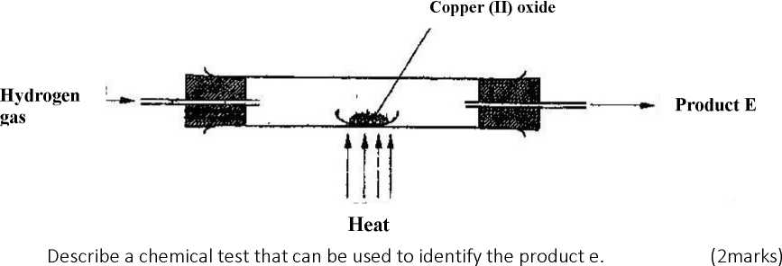

Describe a chemical test that can be used to identify the product E. (2 marks)

1. 2009 Q 4 P1

An experiment was set up shown in the diagram below.

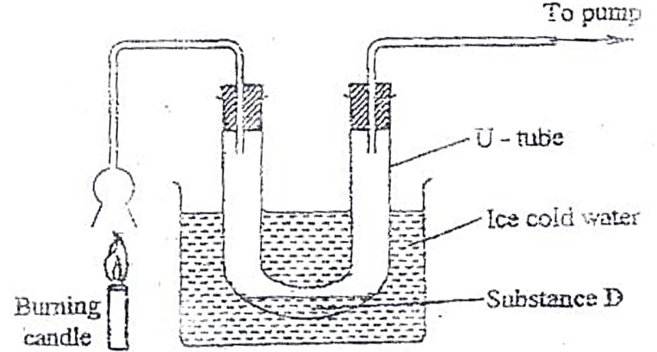

1. Identify substance D (1 mark)
2. Describe how the other product of the burning candle could be prevented from getting into the environment. (2 marks)
3. 2009 Q 15 P1

A student used the set up shown in the diagram below in order to study the reactions of some metals with steam. The experiment was carried out for ten minutes.

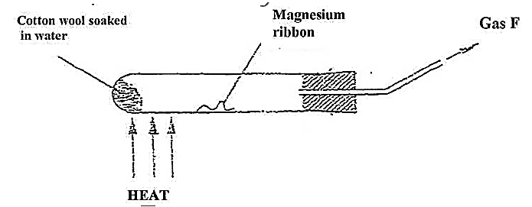

1. What observation would be made if gas F is ignited? (1 mark)
2. When the experiment was repeated using iron powder instead of magnesium ribbon, very little gas F was obtained.
3. Give a reason for this observation (1 mark)
4. What change in the conditions of the experiment should the student have made in order to increase the volume of gas F produces. (1 mark)
5. 2009 Q 5c P2

Coal, oil and natural gas are major sources of energy. They are known as fossil Hydrogen is also a source of energy.

1. State and explain two reasons why hydrogen is a very attractive fuel compared to fossil fuels (3 marks)
2. State one disadvantage of using hydrogen fuel instead of fossil fuel. (1 mark)
3. 2011 Q 9 P1

State two reasons why hydrogen is not commonly used as a fuel. (2 marks)

1. 2011 Q 12 P1

Sodium hydroxide can be prepared by the following methods;I and II.

1. Sodium metal $\underset{→}{cold water}$ Sodium hydroxide + Hydrogen
2. Concentrated $\underset{→}{process A }$ Sodium hydroxide + chlorine + hydrogen

Sodium chloride

1. Name one precaution that needs to be taken in method 1. (1 mark)
2. Give the name of process A. (1 mark)
3. Give one use of sodium hydroxide. (1 mark)
4. 2012 Q3 P1

In an experiment, dry hydrogen gas was passed over heated Lead (II) Oxide as shown in the diagram below.

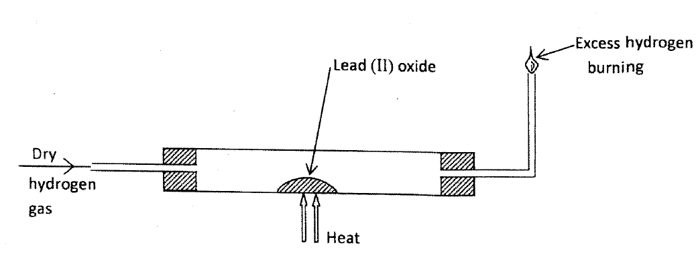

State and explain the observations made in the combustion tube (3 marks)

1. 2012 Q19 P1

The set up shown below was used to investigate a property of hydrogen gas.

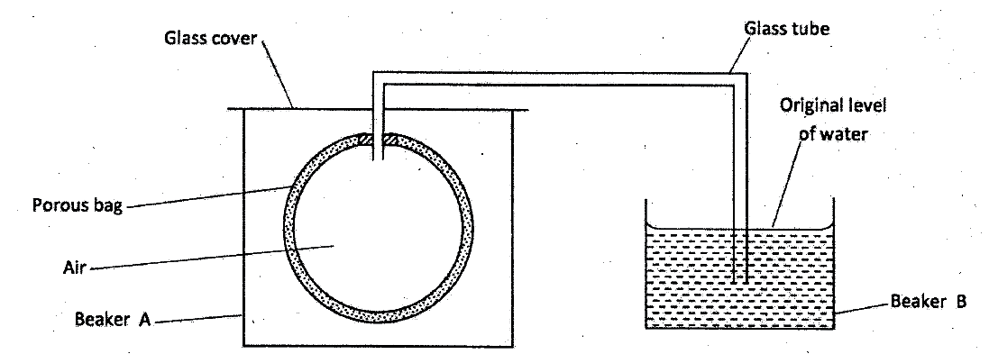

State and explain the observation that would be made in the glass tube if beaker A was filled with hydrogen gas. (3 marks)

1. 2013 Q18 P1

The set-up below was used to investigate the products of burning biogas (methane). Study it and answer the questions that follow.

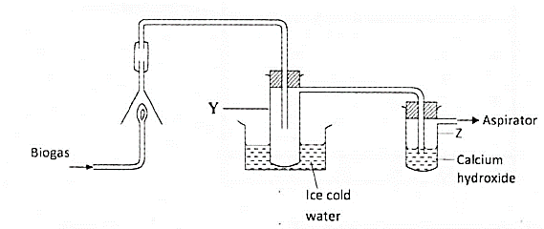

1. What product will be formed in test- tube Y?
2. State and explain the observations which would be made in Z?
3. 2015 Q9 P1, 2016 Q4 P1

The set up below was sued to investigate the reaction between dry hydrogen gas and copper (II) oxide

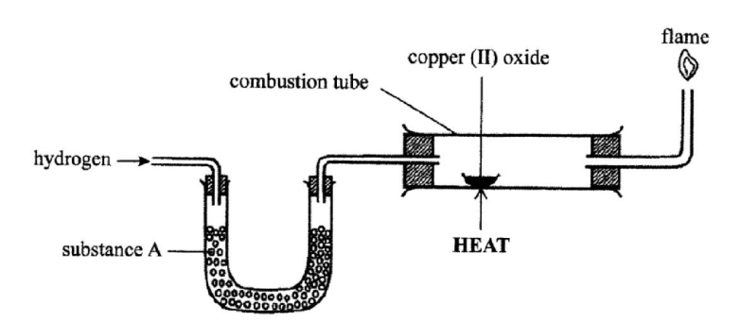

1. Name substance A. (1 mark)
2. State the observation made in the combustion tube. (1 mark)
3. Explain the observation made in (b) above. (1 mark)
4. 2017 Q3 (b) P2

**Figure 3** shows the apparatus used to burn hydrogen in air. Use it to answer the questions that follow.

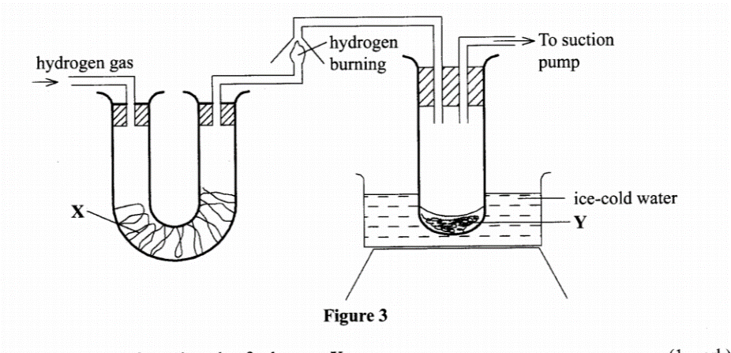

1. State the role of:
   * 1. substance X.
     2. ice-cold water Y (1 mark)
2. Give the name of the substance that could be used as X. (1 mark)
3. State the role of the suction pump. (1 mark)
4. Name the product Y formed. (1 mark)
5. Give a simple physical test to prove the identity of Y. (1 mark)
6. State the difference between 'dry' and 'anhydrous'. (2 marks)
7. 2018 Q 21 P1

Study the set-up in **Figure 6** and answer the questions that follow.

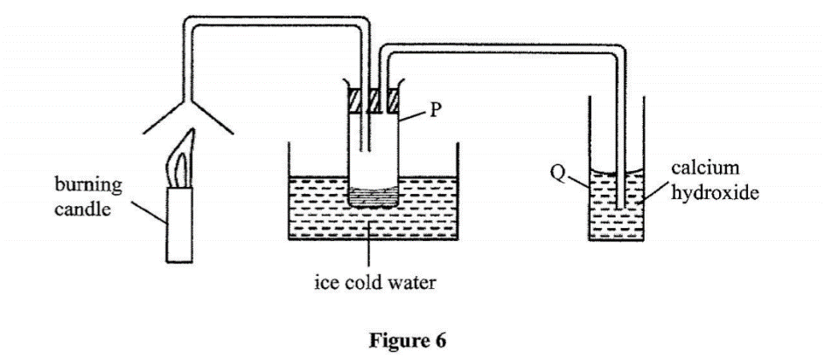

1. Name the substance that was collected in tube P. (1 mark)
2. Write an equation for the reaction which occurs in tube Q in the first few minutes of the experiment. (1 mark)
3. Give a suitable conclusion for the experiment in the set-up. (1 mark)
4. 2019 Q5 P1

Hydrogen has can be prepared by passing steam over heated magnesium ribbon as shown in the figure 2.

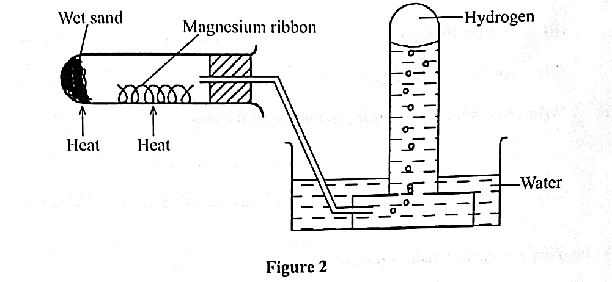

* 1. Write an equation for the reaction that produces hydrogen gas. (1 mark)
  2. Explain why the delivery tube must be removed from beneath the water before heating is stopped. (1 mark)
  3. Explain why sodium metal is not suitable for this experiment. (1 mark)

**END OF FORM ONE WORK**

**STRUCTURE OF THE ATOM**

**AND THE PERIODIC TABLE**

**Table of Contents**

1. Structure of the Atom - 2 -

(a) The sub-atomic particles - 2 -

Characteristics of the sub atomic particles - 3 -

(b) Energy Levels and Electron Arrangement - 5 -

2. The periodic table - 7 -

(a) Periods and Groups - 7 -

(b) Relative Atomic Mass and Isotopes - 8 -

(c) Ion Formation - 10 -

(d) Valency and Oxidation number - 12 -

3. Chemical Formulae - 14 -

4. Chemical Equations - 17 -

**Objectives**

**By the end of this topic, the learner should be able to:**

(a)   Describe the structure of the atom and write electron configuration.

(b)   Define atomic number, mass number, isotopes and relative atomic mass.

(c)   Determine relative atomic mass from isotopic composition.

(d)   Use electron configuration to determine the position of an element in the periodic table and predict the type of ion it forms.

(e)   Define valency and oxidation number of an element.

(f)   Use valency to derive chemical formulae of compounds.

(g)   Write balanced chemical equations.

**STRUCTURE OF THE ATOM AND THE PERIODIC TABLE**

The atom is the smallest particle of an element that can take part in a chemical reaction.

# 1. Structure of the Atom

## (a) The sub-atomic particles

An atom is made up of smaller particles called **sub-atomic particles**.

The sub-atomic particles are; **neutrons, protons and electrons.**

The atom is made up of two regions, a small central part called the **nucleus** and a larger region surrounding the nucleus.

The nucleus consists of protons and neutrons. The protons and neutrons are referred to as **nucleons** because they are found in the nucleus.

The larger region surrounding the nucleus consists of electrons. The general structure of an atom is as shown below.

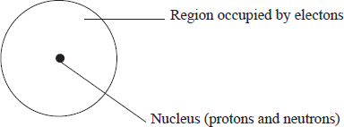

The hydrogen atom, which is the simplest in composition has one proton, one electron and has no neutron.

The atom of the next element, helium has two protons, two electrons and two neutrons. The structure of the atom of Helium is shown below.

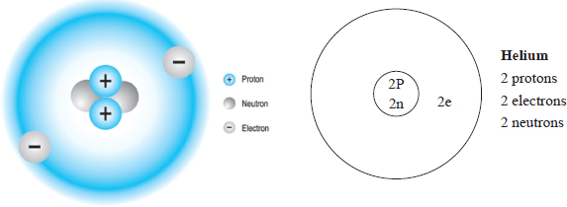

### **Characteristics of the sub atomic particles**

The proton is positively charged.

The electron is negatively charged.

The neutron has no charge.

|  |  |  |
| --- | --- | --- |
| **Sub atomic particle** | **Relative mass** | **Electrical charge** |
| Proton | 1 | + 1 (positive) |
| Neutron | 1 | 0 (neutral) |
| Electron | Image | – 1 (negative) |

The **number of protons is equal to the number of electrons** for any given atom. This makes the atom to be **electrically neutral.**

For example, a hydrogen atom has one proton and one electron while a helium atom has two protons and two electrons.

**The neutrons** in the nucleus contribute to the stability of the nucleus.

## Atomic Number and Mass Number

**Atomic number** *is the number of protons in the nucleus of an atom*.

For example, a hydrogen atom has 1 proton in the nucleus; therefore its atomic number is 1.

Likewise, an atom of helium has 2 protons and therefore its atomic number is 2. Sodium has 11 protons in the nucleus therefore it’s atomic number is 11.

**Mass number** *is the sum of the protons and neutrons in an atom of an element*. For example, an atom of hydrogen has 1 proton and no neutrons in it’s nucleus; therefore the mass number is 1.

1 proton + 0 neutrons = 1

A helium atom has 2 protons and 2 neutrons. Consequently, the mass number is 4.

2 protons + 2 neutrons = 4

Both mass and atomic number can be written along with the symbol of an element.

The conventional way of representing the mass number is to write the mass number as a **superscript** in front of the chemical symbol e.g. 23Na.

The atomic number is written as a subscript in front of the symbol e.g. 11Na.

Therefore, the element is represented as Na.

***A list of the first Twenty Elements***

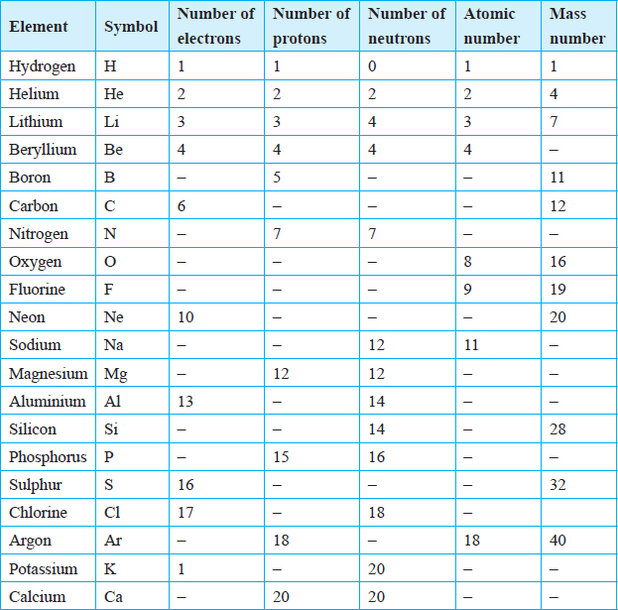

## Isotopes

**Isotopes** are atoms of the same element having the same atomic number but 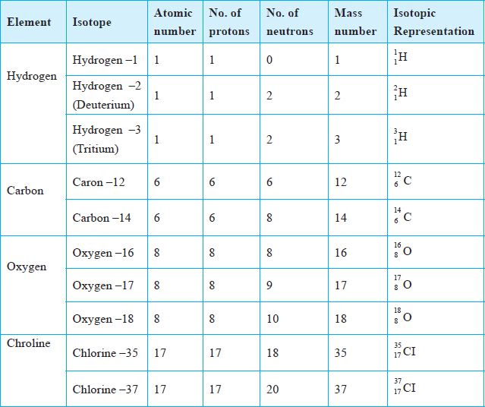different mass numbers.

**Examples of Isotopes**

## (b) Energy Levels and Electron Arrangement

Electrons occupy regions around the nucleus known as **energy levels**.

Electrons occupying the same energy level have approximately the same amount of energy. These energy levels are numbered 1, 2, 3, … starting with the one closest to the nucleus.

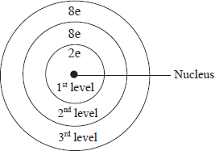Each energy level can only accommodate a given maximum number of electrons.

The first energy level can only hold a maximum of two electrons and the second energy level a maximum of eight electrons. For the first twenty elements, the third energy level accommodates a maximum of eight electrons.

The distribution of electrons in the energy levels of an atom is referred to as **electron arrangement** (**electron configuration**).

* Hydrogen has one electron in the first energy level. Helium with two electrons, has the two electrons in its first energy level. Helium therefore has one energy level which is filled up.

When an energy level is full, additional electrons occupy the next energy level until it is completely filled up.

* Thus, lithium with three electrons, has two electrons in its first energy level and one electron in its second energy level.
* This can be represented as: 1 for hydrogen, 2 for helium, 2.1 for lithium and 2.8 for neon.
* Electron arrangement may also be represented by a diagram in which electrons are represented by crosses (×) or dots (·) as shown below.

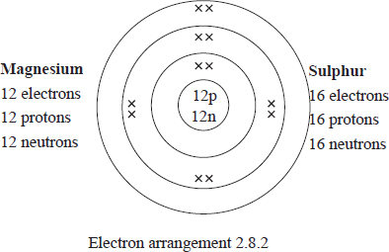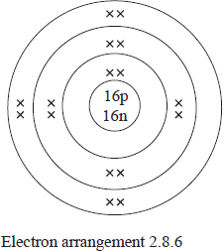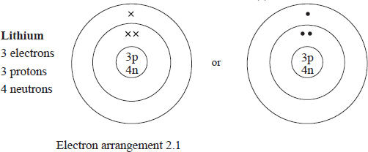

**Activity: Draw the electron arrangement of all the first 20 elements in the periodic table.**

# 2. The periodic table

## (a) Periods and Groups

* The elements with the same number of occupied energy levels belong to the same **period**.

Hydrogen and helium have one occupied energy level hence they belong to **Period 1.**

Lithium, beryllium, boron, carbon, nitrogen, oxygen, fluorine and neon have two occupied energy levels. These elements belong to **Period 2.**

Similarly, sodium, magnesium, aluminium, silicon, phosphorus, sulphur, chlorine and argon have three occupied energy levels and hence belong to **Period 3.**

* Those elements with the same number of occupied energy levels can be arranged in the same row, starting with the elements with the lowest atomic number.

|  |  |
| --- | --- |
| **First row** Period 1 | Hydrogen and helium. |
| **Second row** Period 2 | Lithium, beryllium, boron, carbon, nitrogen, oxygen, flourine and neon. |
| **Third row** Period 3 | Sodium, magnesium, aluminium, silicon, phosphorus, sulphur and argon. |
| **Fourth row** Period 4 | Potassium and calcium. |

* Elements with the same number of electrons in the outermost energy level form a **group**.

Hydrogen, lithium, sodium, potassium have**one** electron in the outermost energy level hence they belong to **group I**.

Similarly, beryllium, magnesium, calcium have**two** electrons in the outermost energy level, therefore they belong to **group II.**

* Elements with the same number of electrons in the outermost energy level can be arranged in the same vertical column. The columns represent members of a group.
* 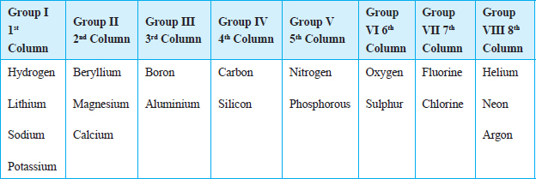There are eight groups numbered in Roman numerals.

Group 8 is also referred to as **group zero** because these elements have little tendency to lose or gain electrons during reactions.

* This information can be merged into a grid. The resulting figure is the **periodic table of elements**.
* The arrangement of elements in the periodic table is based on increasing atomic number.

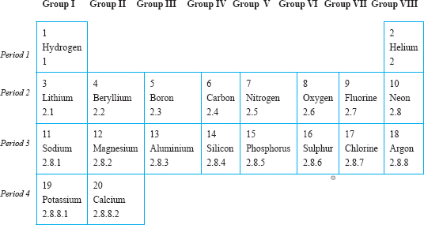

## (b) Relative Atomic Mass and Isotopes

The relative atomic mass (R.A.M) of an element is defined as the average mass of an atom of the element compared with an atom of carbon –12, the mass of which is 12.000 (a.m.u).

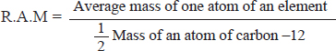

An instrument called the **Mass spectrometer** is used to accurately determine the relative atomic masses of elements.

It can also be used to obtain the relative abundance of isotopes of a given element. The relative atomic mass of an element can be a fraction because it is an average mass of the isotopes of the element.

The relative atomic mass is **closest in value to the mass of the most abundant isotope of the element.**

Relative atomic mass is a ratio and therefore **has no units.**

**Worked Examples**

***Example 1***

**Chlorine –35 forms 75% of the total mass of chlorine and chlorine –37 forms 25%. Calculate the relative atomic mass of chlorine.**

***Solution***

Consider a sample containing 100 atoms of chlorine. Therefore 75 atoms will each have a mass of 35.

Therefore, Total Mass = 35 × 75

25 atoms will have a mass of 37

Therefore, Total Mass = 37 × 25

The average mass of a chlorine atom would be;



Therefore, RAM of chlorine = 35.5

As can be seen, the relative atomic mass is nearer to the mass number of the most abundant isotope, that is chlorine –35. See mass spectrum of chlorine.

***Example 2***

**An element X, consists of three isotopes with mass number of 22, 24 and 25 with percentage abundance of 89.6%, 6.4% and 4.0% respectively. Find the relative atomic mass of element X.**

**Solution**

Consider a sample of 100 atoms of element X:

89.6 atoms of X have a mass of 22

Total mass = 89.6 × 22

6.4 atoms of X have a mass of 24

Total mass = 6.4 × 24

4.0 atoms of X have a mass of 25

Total mass = 4.0 × 25

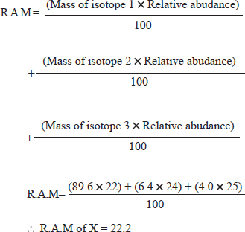

***More Questions***

1. An element P has two isotopes with relative abundance of 65% and 35%. If the mass number of the two isotopes is X and 31 respectively, find the mass number represented by X given that the relative atomic mass of element P is 30.
2. Lithium has two isotopes with mass number 6 and 7. If the relative atomic mass of lithium is 6.94, determine the percentage abundance of each isotope.

## (c) Ion Formation

Atoms with an electron configuration of 2, 2. 8 and 2.8.8 are said to be stable. Atoms without this electron configuration tend to attain this stability by either losing or gaining electrons.

* The charged particles formed when atoms gain or lose electrons are called **ions**.
* Positively charged ions are called **cations** and negatively charged ions are called **anions**.
* Metals mostly lose electrons to form positively charged ions while non-metals gain electrons to form negatively charged ions.

The examples below can be used to explain ion formation.

1. Sodium with atomic number 11 and an electron configuration 2.8.1 can acquire the stable electron configuration of 2.8 by losing one electron or 2.8.8 by gaining seven electrons. Since it requires less energy, it is easier to loose one electron than to gain seven electrons. The resulting sodium particle will have only ten electrons while the nucleus still has 11 protons. Ten negative charges and 11 positive charges give the resulting particles a net positive charge of 1(+1). The particle formed is a 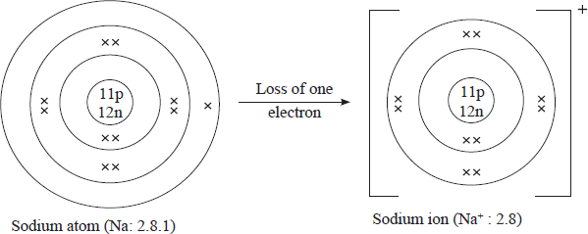sodium ion, written as Na+.
2. A chlorine ion can also be formed, Cl–. A chlorine atom with atomic number 17 and an electron configuration of 2.8.7 can acquire a configuration of 2.8 by losing seven electrons or a configuration of 2.8.8 by gaining one electron. It is easier for the chlorine 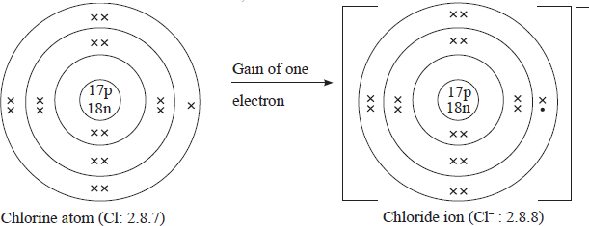atom to gain one electron than to lose seven.

Therefore, a chorine atom with 17 electrons and 7 protons will gain an electron and have 18 electrons. Since it still has 17 protons, a chlorine particle with a net negative charge of 1 is formed i.e a chlorine ion. The ion formed is written as Cl–It is also refered to as a chloride ion.

1. Magnesium has an atomic number of 12. The electron arrangement is 2.8.2. The magnesium atom can acquire the stable electron configuration of 2.8 by losing the two electrons in the outermost energy level. This means that the resulting particle will have a net positive charge of two. The ion formed is called a magnesium ion, and is written as Mg2+.

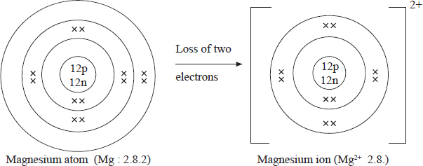

1. Oxygen atomic number 8 and electron arrangement of 2.6 can acquire a stable electron configuration of 2.8 by gaining two electrons. The resulting particle will have a net negative charge of two. The ion formed is an oxide ion and is written as O2–.

* 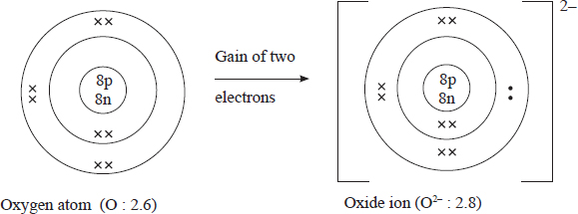Ion formation may be shown in a different format using chemical symbols. For example:

Sodium: Na  Na+ + e–

Chlorine: Cl + e– Cl–

Magnesium: Mg  Mg2+ + 2e–

Oxygen: O + 2e– O2–

* During chemical reactions atoms of metals react by losing electrons from their outermost energy level. On the other hand, non-metals generally gain electrons into their outermost energy level.

For example, a reaction between sodium and chlorine will involve the transfer of one electron from a sodium atom to a chlorine atom. In this reaction, sodium loses one electron. The chlorine atom gains one electron from sodium.

## (d) Valency and Oxidation number

The number of electrons an atom loses or gains during a chemical reaction is the **valency** of that atom. Valency is also refered to as the **combining power** of an element.

* All elements in Group I have a valency of one while Group II elements have a valency of two.
* Elements in Group VII have a valency of one, since they require one electron to acquire a stable electron configuration.
* Some elements have variable valencies. For example, iron can have a valency of 2 or 3, copper can have a valency of 1 or 2 while lead can have a valency of 2 or 4.

Electrons in the outer most energy level are called **valence electrons** because they can be used to predict valency. Valence should not be confused with valency.

### Radicals

**Radicals** are groups of atoms with a net charge that exist and react as a unit during chemical reactions.

* The valency of a radical is the same as the value of its charge.

For example, a sulphate ion (SO42+) has a valency of 2, a nitrate ion (NO–3) has a valency of 1, an ammonium ion (NH+4) has a valency of 1.

Table  (a) and (b) summaries the valency of some common elements and radicals.

1. Valencies of common Metals

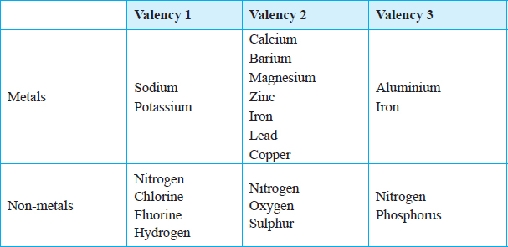

1. Valencies of common radicals Radicals

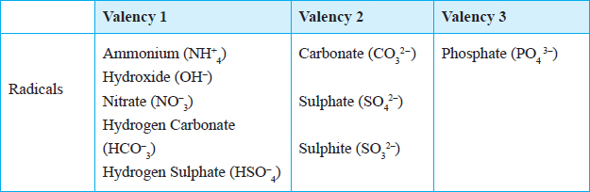

### Oxidation number

Elements react by either gaining or losing electrons, they are said to acquire a new state known as **oxidation state**.

***The oxidation number*** *of an element shows the number of electrons which have been removed or added to it to get the present state*.

There are positive oxidation numbers and negative oxidation numbers. Since atoms are electrically neutral, they are assigned an oxidation number of zero.

***Oxidation Numbers of Some Ions and Atoms***

|  |  |
| --- | --- |
| **Particle** | **Oxidation number** |
| Mg2+ | +2 |
| Fe2+ | +2 |
| Fe+3 | +3 |
| H+ | +1 |
| Cu+ | +1 |
| Cu2+ | +2 |
| Cl– | –1 |
| Cu | 0 |
| Mg | 0 |
| H | 0 |

**Oxidation state** should not be confused with charge. Oxidation states are written with the positive or negative sign coming before the number, e.g., – 2, + 3.

**Charge** on the other hand is written as a superscript with the number coming before the positive or negative sign e.g X2+ or X3+.

# 3. Chemical Formulae

***A chemical formula*** *is a representation of a chemical substance using chemical symbols. It shows the constituent elements and the proportions in which they are combined*.

When elements combine, they form compounds.

For example, Sodium and chlorine react to form sodium chloride. During the reaction, a sodium atom loses an electron to form a sodium ion, Na+. A chlorine atom then gains the electron lost by the sodium atom to form a chloride ion, Cl–. The ions then combine to form sodium chloride.

Na+ + Cl– NaCl

The product of the reaction between sodium and chlorine when represented in chemical symbols is called the chemical formula.

* In order to write a correct chemical formula, it is necessary to know the **symbols** and **valencies** of the elements which form the compounds.
* When writing the formula, always start with the element which is more likely to lose an electron or electrons then follow with the one that gains.

The chemical formula of a compound can be derived using the valencies of the combining elements.

**Worked examples**

***Example 1***

|  |  |  |
| --- | --- | --- |
| *Combining atoms* | *Mg* | *F* |
| *Combining power (valency)* | *2* | *1* |

For magnesium to combine with fluorine to form magnesium fluoride, each magnesium atom requires two fluorine atoms. Accordingly the formula for magnesium fluoride is:

Mg F2.

In the formula the valencies are interchanged and written as subscripts.

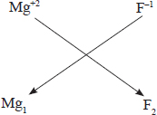For example

Therefore, the formula is Mg1F2

* When the subscript is 1, it is usually not written since the symbol represents 1 atom. Thus the formula of magnesium fluoride is MgF2.

***Example 2***

|  |  |  |
| --- | --- | --- |
| *Combining atoms* | *Mg* | *O* |
| *Combining power (valency)* | *2* | *2* |

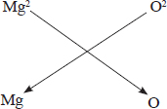

Formula Mg2O2

* When the subscripts are the same it indicates that the combining ratio is 1:1 and it is therefore omitted from the formula. Hence, the formula of magnesium oxide is: MgO

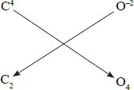***Example 3***

|  |  |  |
| --- | --- | --- |
| *Combining atoms* | *C* | *O* |
| *Combining power (valency)* | *4* | *2* |

Formula C2O4

The combining ratio is 2:4 which is simplified to 1:2 hence the formula for Carbon (IV) oxide is: CO2

***Example 4***

|  |  |  |
| --- | --- | --- |
| *Combining atoms* | *Al* | *O* |
| *Combining power (valency)* | *3* | *2* |

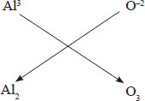

Formula Al2O3

***Example 5***

In deriving formula for compounds involving radicals, the net charge on the radical is taken to be equal to the valency of the radical.

|  |  |  |
| --- | --- | --- |
| Combining particles | Na+ | CO32- |
| Combining power (valency) | 1 | 2 |

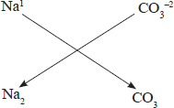Formula Na2CO3

***Example 6***

Where the formula of a compound contains more than one radical of the same type, the symbol of the radical is put in brackets and the number of radicals indicated as a subscript to the right outside the brackets.

|  |  |  |
| --- | --- | --- |
| Combining radicals | NH4+ | SO42- |
| Combining power | 1 | 2 |

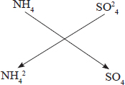

Formula (NH4)2SO4

When an element shows variable valency in its compounds, the valency exhibited is indicated in Roman numbers in brackets when naming its compounds as shown below

***Examples***

|  |  |
| --- | --- |
| ***Formula of compound*** | ***Conventional name*** |
| CuO | Copper (II) oxide |
| Cu2O | Copper (I) oxide |
| FeSO4 | Iron (II) Sulphate |
| FeCl2 | Iron (II) Chloride |
| FeCl3 | Iron (III) chloride |
| SO2 | Sulphur (IV) oxide |
| SO3 | Sulphur (IV) oxide |

# 4. Chemical Equations

A chemical equation represents a chemical change by use of **symbols and formula.**

The formulae of the **reactants are put on the left hand side and those of the products on the right hand side.**

To write a correct chemical equation one must write correct formula of the reactants and the products.

For example, copper metal reacts with oxygen to form copper (II) oxide. The chemical reaction is represented by a word equation as follows:

Copper metal + oxygen  copper (II) oxide

The equation which represents the reaction can be written in form of symbols as follows:

2Cu + O2 2CuO

## Balancing chemical equations

This is the process of making the number of each kind of atom on both sides of the equation equal.

A chemical equation is correct if it is balanced. *An equation is balanced when the number of atoms of each type of reactants is equal to that on the products side*. This is because atoms are neither created nor destroyed during a chemical reaction.

The following guidelines should be observed when balancing chemical equations:

(i)   Write the chemical reaction in words.

Copper metal + Oxygen gas  copper (II) oxide

(ii)   Write the correct chemical formulae for both reactants and products.

Cu + O2CuO (unbalanced)

(iii)  Check whether the number of atoms of each element on the reactants side is equal to that on the products side.

(iv)  If the number is not equal, multiply the chemical formula containing the unbalanced atoms with the lowest common multiple. In this case multiply the products side by two.

2Cu + O2 2CuO (balanced)

(v)   Check again to ensure that all the atoms are balanced.

The chemical formula of the reactants and products should never change during balancing of the equations.

(vi)   A chemical equation is correct and complete if the physical state of the reactants and products are indicated. The following symbols represent the physical states which are written in brackets after each reactant or product as solid (a), liquid (l), in solution/aqueous (aq), gas (g).

Thus

2Cu(s) + O2(g)  2 CuO (s)

showing that copper is a solid, oxygen is a gas and the product copper oxide is a solid.

***Example***

Zinc granules react with dilute hydrochloric acid liberating hydrogen gas and a solution of zinc chloride is formed.

The word equation for the reaction is:

Zinc + Hydrochloric acid  Zinc chloride + Hydrogen gas

The unbalanced chemical equation for the reaction is:

Zn + HCl  ZnCl2 + H2

There are two atoms of chlorine and two atoms of hydrogen on the products side while there is one atom of chlorine and one atom of hydrogen on the reactants’ side of the equation. The number of each of the atoms on both sides of the equation should be equal.

To balance the equation, two molecules of hydrochloric acid are used i.e. the number two is written before the formula of hydrochloric acid.

The balanced equation is:

Zn + 2HCl  ZnCl2 + H2

The equation is not yet complete as the state symbols are not in place. Thus to complete the equation these have to be placed.

Zn(s) + 2HCl(aq)  ZnCl2(aq) + H2(g)

***Review Questions***

Complete the following word equations. Write balanced chemical equations for the reactions listed below.

(a)   Sodium hydroxide + dilute hydrochloric acid

(b)   Zinc oxide + dilute sulphuric acid

(c)   Zinc metal + dilute nitric acid

(d)   Calcium carbonate + dilute sulphuric acid

(e)   Calcium hydrogen + carbon (IV) oxide

(f)    Sodium + water

1. 2006 Q 12 P1

The table below shows the relative atomic masses and the percentage abundance of the isotopes L1 of element L2.

|  |  |  |
| --- | --- | --- |
|  | **Relative atomic mass** | **% abundance** |
| L1 | 62.93 | 69.09 |
| L2 | 64.93 | 30.91 |

Calculate the relative atomic mass of element L. (3 marks)

1. 2007 Q 26 P1

The table below shows the number of valence electrons of the element P, Q and R.

|  |  |  |  |
| --- | --- | --- | --- |
| **Element** | P | Q | R |
| **Number of valence electrons** | 3 | 5 | 2 |

1. Explain why P and R would not be expected to form a compound. (1 mark)
2. Write an equation to show the effect of heat on the carbonate of R. (1 mark)
3. Write the formula for the most stable ion or Q. (1 mark)
4. 2008 Q 7 P1
   * 1. What are isotopes? (1 mark)
     2. Determine the number of neutrons in ${}_{8}^{18}O$ (2 marks)
5. 2009 Q6 P1

An isotope of element E has 34 neutrons and its mass number is 64. E forms a cation with 28 electrons. Write the formula of the cation indicating the mass and atomic numbers.

(1 mark)

1. 2010 Q2 P1

(a) What is meant by the terms: (2 marks)

1. Element;
2. Atomic number.

(b) The formula for a chloride of titanium is TiCl3. What is the formula of its sulphate? (1 mark)

1. 2011 Q 5a, b (i-iii) PP2
2. Other than their location in the atom, name two other differences between an electron and a proton. (2 marks)
3. The table below gives the number of electrons, protons and neutrons in particles A, B, C, D, E, F and G

|  |  |  |  |
| --- | --- | --- | --- |
| **Particle** | **Protons** | **Electrons** | **Neutrons** |
| A | 6 | 6 | 6 |
| B | 10 | 10 | 12 |
| C | 12 | 10 | 12 |
| D | 6 | 6 | 8 |
| E | 13 | 10 | 14 |
| F | 17 | 17 | 18 |
| G | 8 | 10 | 8 |

1. Which particle is likely to be a halogen? (1 mark)
2. What is the mass number of E? (1 mark)
3. Write the formula of the compound formed when E combines with G? (1mark)
4. 2011 Q 24

The table below gives the number of electrons, protons and neutrons in Substances X, Y and Z.

|  |  |  |  |
| --- | --- | --- | --- |
| **Substance** | **Electrons** | **Protons** | **Neutrons** |
| X | 10 | 10 | 10 |
| Y | 10 | 8 | 10 |
| Z | 8 | 8 | 8 |

1. Which letter represents an ion? (1 mark)
2. Which of the substances are isotopes? Give a reason. (2 marks)
3. 2013 Q29 P1

A sample of hydrogen gas was found to be a mixture of two isotopes 12 H and H. Determine the relative molecular masses of the molecules 11 formed, when each of these isotopes is burnt in oxygen. (O =16.0) (2 marks)

1. 2014 Q18 P1

Use the part of the periodic table given below to answer the questions that follow (Letters are not the actual symbols of the elements

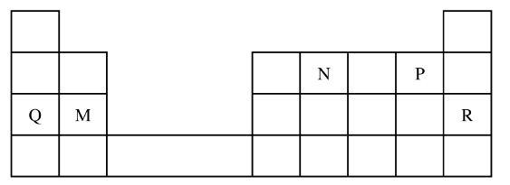

1. Identify the element that forms giant covalent structures. (1 mark)
2. Identify one element that does not form compounds. (1 mark)
3. Write the formula for the nitride of M. (1 mark)
4. 2014 Q29 P1
5. What is meant by the term radical?
6. The table below contains atoms that form common radicals. Complete the table to show radicals formed from various atoms. (2 marks)

|  |  |  |
| --- | --- | --- |
| Element | N | S |
| H | NH4+ |  |
| O |  |  |

1. 2015 Q10 P1

The atomic number of an element, T is 15.

1. Write the electronic configuration of the ion T (1 mark)
2. Write the formula of an oxide of T. (1 mark)
3. 2015 Q14 P1

The table below shows behaviour of metals R, X, Y and Z. Study it and

answer the questions that follow:

|  |  |  |  |
| --- | --- | --- | --- |
| **Metal** | **Appearance on exposure to air** | **Reaction in water** | **Reaction with dilute hydrochloric acid** |
| R | slowly tarnishes | Slow | Vigorous |
| X | Slowly turns white | Vigorous | Violent |
| Y | No change | Does not react | Does not react |
| Z | No change | No reaction | Reacts moderately |

1. Arrange the metals in the order of reactivity starting with the most reactive (2 marks)
2. Name a metal which is likely to be (1 mark)
3. X (ii) Y
4. 2015 Q7a P2

Naturally occurring magnesium consists of three isotopes. 78.6% 24Mg; 10% 25Mg and 26Mg. Calculate to one decimal place, the relative atomic mass of magnesium. (2 marks)

1. 2017 Q11 P1

An oxide of element K has the formula K2O5.

(a) Determine the oxidation number of K. (1 mark)

(b) To which group of the periodic table does K belong? (1 mark)

1. 2018 P1 Q17.

**Figure 5** represents a grid that is part of the periodic table. Study it and answer the questions that follow. The letters are not the actual symbols of the elements.

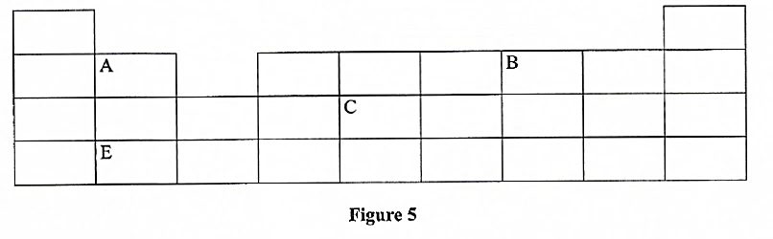

* + - 1. Write the electron arrangement of element **C**. (1 mark)
      2. On the grid provided, show with a tick (✓) the position of element **D** whose atomic number is 18. (1 mark)
      3. Element **E** is more reactive than **A**. Explain. (1 mark)

1. 2019 Q1 P1

An atom of element A has mass number 39 and 19 protons.

(a) Write the electron arrangements of the atom. (1 mark)

(b) State the period and group to which element A belongs

Group ........................................ (½ mark)

Period ......................................... (½ mark)

(c) State whether the element is a metal or a non-metal. (1 mark)

**CHEMICAL FAMILIES, PATTERNS AND PROPERTIES**

**Table of Contents**

1. The Alkali Metals - 2 -

Gradation in Size of the Atom and Ion - 3 -

Physical Properties of Alkali metals - 3 -

Chemical Properties of Alkali Metals - 4 -

Uses of Alkali metals and their compounds - 7 -

2. Alkaline Earth Metals - 7 -

Gradation in Size of Atom and Ion - 7 -

Physical Properties - 8 -

Chemical Properties of Alkaline Earth Metals - 9 -

Uses of some Alkaline Earth Metals and their Compounds - 13 -

3. Halogens - 13 -

Gradation in Size of Atoms and Ion…………- 13 -

Physical Properties of Halogens - 14 -

Chemical Properties of Halogens - 15 -

Uses of Halogens and their Compounds - 19 -

4. Noble gases - 19 -

Physical Properties of Noble gases - 20 -

Uses of Noble Gases - 20 -

5. Properties and Trends across A period - 21 -

(a) Trends in Physical Properties of Elements in Period 3 - 21 -

(b) Trends in Chemical Properties of the Elements in Period 3 - 23 -

**Objectives**

By the end of this topic, the learner should be able to:

(a)   Identify and write electron arrangement of alkali metals, alkaline earth metals, halogens and noble gases.

(b)   State and explain the trends in physical properties of elements in group I, II, VII and VIII.

(c)   State and explain the trends in reactivity of elements in group I, II, VII and VIII.

(d)   Explain the similarities in chemical formulae of compounds of the elements in a group.

(e)   Explain the unreactive nature of group VIII elements.

(f)    Identify and write electron arrangement of period 3 elements.

(g)   State and explain the trends in physical and chemical properties of the elements in period 3.

CHEMICAL FAMILIES, **PATTERNS AND PROPERTIES**

**Elements in the same group are said to belong to the same chemical family.**

Trends in physical and chemical properties provide useful information in predicting the physical and chemical behaviour of the elements within a family.

# 1. The Alkali Metals

The elements in **group I** of the periodic table are called **Alkali metals.**

These include, lithium, sodium, potassium, rubidium, caesium and francium. The electron arrangements of the first three alkali metals are as follows:

Lithium (L) : 2.1

Sodium (Na) : 2.8.1

Potassium (k) : 2.8.8.1

Each alkali metal atom has one electron in the outermost energy level. Down the group there is an increase in the number of occupied energy levels.

**Task: Draw the atomic structure of the first 3 Alkali Metals**.

## Gradation in Size of the Atom and Ion

It is not possible to measure the sizes of atoms and ions of elements in the laboratory due to their small size. The table below gives a summary of the atomic and ionic radii of the Alkali 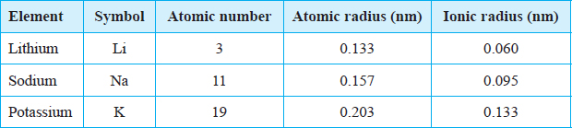Metals.

**Atomic radius***is the distance between the centre of the nucleus of an atom and the outermost energy level occupied by an electron or electrons*.

Discussion Questions

**1.   State and explain the trends in the atomic and ionic radiidown the group**

The atomic radii and ionic radii of the alkali metals increase down the group. This is because each alkali metal has one more occupied energy level than the preceding member in the group.

Lithium has two energy levels. Sodium has three while potassium has four. The outermost electron in a sodium atom is therefore further from the nucleus than the outermost electron in a lithium atom. This explains the increase in the atomic and ionic radii down the group.

1. **How does the ionic radius and atomic radius of an element compare?**

The ionic radius of an alkali metal is **less than its atomic radius.**

An alkali metal forms an ion by losing the single electron from the outermost energy level. The resulting ion (cation) has one occupied energy level less than the corresponding atom.

When an atom loses an electron to form a positively charged ion, the remaining electrons experience greater nuclear attraction. The remaining energy levels move closer to the nucleus resulting in a reduction in the radius.

## Physical Properties of Alkali metals

The table below shows some physical properties of alkali metals.

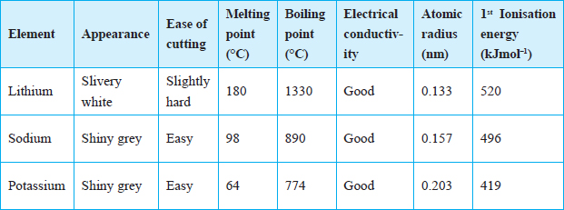

**Ionization energy***is the minimum energy required to remove an electron from the outermost energy level of an atom in the gaseous state*.

Discussion Questions

**State and explain the trends in the following properties down the group?**

1. **Appearance**

The alkali metals have a **shiny metallic lustre** when freshly cut. However, the surface quickly **tarnishes**. The surface tarnishes because of **reacting with air**.

1. **Ease of cutting**

The alkali metals are **soft and easy to cut.**

The softness and ease to cut **increases down the group** due to the **decrease** in the strength of the **forces holding the atoms** together as you move down the group.

1. **Melting and boiling points.**

The alkali metals have relatively **low melting and boiling** points.

The melting and boiling points **decrease down the group** due to the **weakening** of the forces holding the atoms together.

The strength of the forces holding atoms together depends on the **size of the atoms**. The **larger** the atoms, the **weaker** the force. Thus**as the atomic radius increases the forces of attraction between the atoms weaken**, hence the decrease in the melting and boiling points down the group.

1. **Electrical conductivity.**

Alkali metals are **good conductors of heat and electricity.** Conductivity in metals is due to the **presence of delocalisedelectrons** in the structure of the metal. Since they all have one electron in their outermost energy level, their conductivity is **similar**.

In metals, the electrons in the outermost energy level move randomly throughout the metallic structure. Since the electrons do **not remain in one fixed position**, they are said to be **delocalised**.

**(v)   1st ionization energy**

**Down the group** from lithium to potassium, the **1st ionization energy decreases.** This means that **less** energy is needed to remove the electron from the outermost energy level of a **potassium atom than a sodium atom** and a **lithium** atom. This is because the **effective force of attraction on the outermost electron** by the positive nucleus **decreases with increasing atomic size** and **distance from the nucleus.**

## Chemical Properties of Alkali Metals

Alkali metals react by **losing the one electron** from their **outermost** energy level to attain a **stable electron configuration**. Their reactivity **increases down the group**.

### Reaction with air and water

* Lithium, sodium and potassium **react vigorously** with both air and water. Potassium is the **most reactive** and lithium, the **least reactive.**
* When sodium is exposed, it reacts with moisture in the air to form sodium hydroxide. The sodium hydroxide further reacts with carbon (IV) oxide in the air to form sodium carbonate.

2Na(s) + 2H2O(l)  2NaOH(aq) + H2(g)

2NaOH(aq) + CO2 (g)  Na2CO3 · H2O(s)

* Sodium **burns in air with a yellow flame** to form a yellowish white solid which is mainly sodium oxide.

Sodium + Oxygen  Sodium Oxide

4Na(s) + O2(g) 2Na2O(s)

* When sodium burns in **air enriched with oxygen** it forms mainly **sodium peroxide.**

Sodium + Oxygen  Sodium peroxide

2Na(s) + O2(g)  Na2O2(s)

* Potassium **burns in air with a lilac flame** to form a white solid which is potassium oxide.

Potassium + oxygen  Potassium oxide

4K(s) + O2(g)  2K2O(s)

The observations made when alkali metals react with water are summarised in the table below.

|  |  |  |
| --- | --- | --- |
| Metal | Observation when metal reacts with water | Rate of reaction |
| Lithium | Lithium floats in water. A colourless gas is produced. The gas does not ignite spontaneously. The resulting solution turns red litmus paper blue. | Vigorous |
| Sodium | Sodium metal darts on the water surface as it melts into a silvery ball. A hissing sound is produced. A colourless gas is produced which may ignite spontaneously. The solution formed is alkaline. | More vigorous |
| Potassium | The metal darts about on the surface of the water and melts into a silvery ball. A colourless gas is produced which spontaneously bursts into a flame. Potassium vapour burns with a lilac flame. The resulting solution is alkaline. | Explosive |

* **Alkali metals react with water to form alkaline solutions and hydrogen gas.**

Metal + Water  Metal hydroxide + Hydrogen

Lithium + Water  Lithium hydroxide + hydrogen gas

2Li(s) + 2H2O(l)  2LiOH(aq) + H2(g)

Sodium + Water  Sodium hydroxide + Hydrogen gas

2Na(s) + 2H2O(l)  2NaOH(aq) + H2(g)

Potassium + water  Potassium hydroxide + Hydrogen gas

2K(s) + 2H2O(l)  2KOH(aq) + H2(g)

* Potassium is **the most reactive alkali metal**. This is because the **electron** in the outermost energy level is **loosely held by the nucleus** and is **easily removed during a reaction.**
* The ease of losing valence electrons **increases** down the group as the **atomic radius increases,** hence the **increase** in reactivity from lithium to potassium.

### Reaction with chlorine

Alkali metals react with chlorine gas to form the corresponding **metal chlorides.** The reactivity of alkali metals with chlorine ***increases down the group.*** This is because of the **increase in atomic radius** which leads to **increasing ease to lose the electron** in the outermost energy level.

**Task**: Cut a small piece of sodium and place it in a deflagrating spoon. Warm it and quickly lower it into a gas jar containing chlorine. Record your observations.

Discussion Questions

1. **What is observed when a hot piece of sodium metal is lowered into a gas jar containing chlorine?**

When hot sodium metal is lowered into chlorine gas, the metal **bursts into flame,** white fumes of sodium chloride are formed.

1. **What is formed when sodium metal reacts with chlorine?**

Sodium metal + chlorine gas  Sodium chloride

2Na(s) + Cl2(g)  2NaCl(s)

1. **Predict how lithium and potassium would react with chlorine.**

Lithium reacts **less vigorously** with chlorine while potassium **reacts much more violently** with chlorine than sodium.

Lithium + chlorine gas  Lithium chloride

2Li(s) + Cl2(g)  2LiCl(s)

Potassium + chlorine gas  Potassium chloride

2K(s) + Cl2(g)  2KCl (s)

### Similarity of Ions and formulae of some compounds of Alkali metals.

Formulae of hydroxides, oxides and Chlorides of Alkali metals

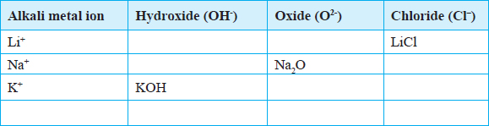

Discussion Question

Explain the similarity in the chemical formulae of the compounds formed between alkali metal ions and hydroxides, oxides and chloride ions.

**Each alkali metal ion** combines with a **single hydroxide ion** to form the respective hydroxide namely; Lithium hydroxide (LiOH), sodium hydroxide (NaOH) and potassium hydroxide (KOH). **This is because the valency of Group I elements is one**. The same applies in the formation of lithium chloride (LiCl), sodium chloride (NaCl) and potassium chloride (KCl)

**Two alkali metal ions** combine with **one oxide ion** to form the corresponding oxide namely; Lithium oxide (L2O), sodium oxide (Na2O) and potassium oxide (K2O).

This is because the valency of **oxygen is two.**Therefore**one oxygen ion requires two alkali metal ions** to combine with to form the corresponding oxide.

Due to their high reactivity, alkali metals are not found as free elements. They are normally found in the combined state in the earths’ crust.

## Uses of Alkali metals and their compounds

1.   Sodium is used in the manufacture of Sodium cyanide for use in the extraction of gold.

2.   Lithium is used in the manufacture of special high strength glasses and ceramics

3.   Lithium compounds are used in the manufacture of dry cells for use in mobile phones, laptops, stop watches and zero emission electric vehicles.

4.   A molten mixture of sodium and potassium is used as a coolant in nuclear reactors.

5.   Sodium vapour is used to produce the yellow glow in streetlights.

6.   Molten sodium is used as a reducing agent in the extraction of titanium from titanium (IV) chloride.

TiCl4(g) + 4Na(l) Ti(s) + 4NaCl(l)

7.   Sodium chloride is used as a food additive.

8.   A mixture of Sodium hydroxide (caustic soda) and carbon disulphide is used in the manufacture of artificial silk called rayon.

# 2. Alkaline Earth Metals

The elements in **group II** of the periodic table are called **alkaline earth metals.**

They consist of beryllium, magnesium, calcium, strontium, barium and radium. The electron arrangement of the first three alkaline earth metals is as follows:

Beryllium (Be) ; 2.2

Magnesium (Mg); 2.8.2

Calcium (Ca) ; 2.8.8.2

An atom of an alkaline earth metal has two electrons in the outermost energy level.

**Task: Draw the atomic structure of the first 3 Alkaline Earth Metals**

## Gradation in Size of Atom and Ion

The table below summaries the atomic and ionic sizes of the Alkaline Earth Metals.

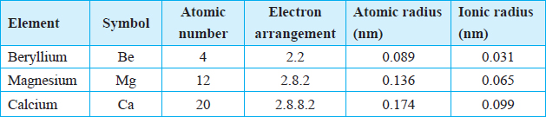

Discussion Question

State and explain the trends in atomic and ionic sizes down the group

Among the alkaline earth metals, the**atomic radius increases down** the group as **more energy levels are occupied.**

Beryllium has the **smallest** atomic radius among the alkaline earth metals because it has the **least number of occupied energy levels.**

Group II elements form ions by losing the two electrons in the outermost energy level in order to attain a stable electron arrangement. The loss of two electrons in the outermost energy level accounts for the smaller ionic radius compared to the atomic radius of the corresponding atom.

|  |  |
| --- | --- |
| Ion | Electron arrangement |
| Be2+ | 2 |
| Mg2+ | 2.8 |
| Ca2+ | 2.8.8 |

Beryllium ion with only one occupied energy level is therefore the smallest ion.

## Physical Properties of the Alkaline Earth Metals

***The table below summarises the Physical Properties of Alkaline Earth Metals***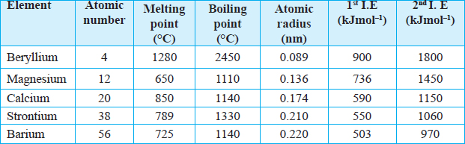

Discussion Questions

1. **What is the appearance of a polished surface of an alkaline earth metal?**

* When an alkaline earth metal is polished, it acquires a metallic lustre.
* Alkaline earth metals lose their metallic lustre when **exposed to air** because of **oxidation**.
* The purpose of **polishing the surface** of the alkaline earth metals before using them in experiments is to **remove the thin oxide layer** that usually forms on their surface. Both **magnesium and calcium have a metallic lustre.**

1. **What is observed when:**

**(a)   One cuts an alkaline earth metal?**

* Magnesium is hard to cut with a knife. However it is ductile and malleable. Calcium is brittle hence it cannot be cut with a knife.

A **ductile** material is one which can be drawn into a wire. Materials which **can be hammered into sheets** are said to be **malleable**. A **brittle** substance is one which is **hard and likely to break.**

1. **Magnesium and calcium are separately used to complete an electric circuit?**

Both magnesium and calcium are **good conductors of heat and electricity** due to the presence of **delocalised electrons.**

1. **How do the physical properties of alkaline earth metals compare with those of alkali metals?**
2. **State and explain the trend in:**
3. **Melting and boiling points**

The melting and boiling points of beryllium are **very high** compared to other alkaline earth metals. This is because the **beryllium atom is very small** and the forces of attraction between the atoms are **very strong.**

**Down the group** the melting point and boiling points **decrease**. This is because in metals atoms are held together by **forces of attraction between positive nuclei and delocalised electrons.** As the atomic radius increase this **attraction decreases** because of the **increasing distance from the positive nucleus** to the delocalised electrons. This explains why the melting point and boiling point decreases down the group.

1. **Ionization energy down the group.**

The first and second ionization energies decreases down the group. This is because the **effective force of attraction on the outermost electron** by the positive nucleus **decreases with increasing atomic size** and **distance from the nucleus.**

The first ionization energy for magnesium is the minimum amount of energy required to remove one electron from the outer most energy level.

Mg(g)  Mg+(g) + e– (1st I.E. = 736 kJmol–1)

The **second ionisation energy** of magnesium is the minimum amount of energy required to remove a **second electron** from a magnesium ion with a single positive charge.

Mg2+(g)  Mg2+(g) + e– (2nd I.E. = 1450 kJmol–)

**5. Explain why the second ionization energy is always higher than the first ionization energy.**

Once an electron has been lost from an atom, the overall positive charge holds the remaining electrons more firmly. This then means that removing a second electron form the ion requires more energy than the first electron.

## Chemical Properties of Alkaline Earth Metals

### **Reaction with air and water**

Discussion Questions

1. **What is observed when magnesium and calcium are heated in air?**

Magnesium burns in air with a **blinding brilliant white flame** forming a **white solid**. The white solid is a **mixture of magnesium oxide and magnesium nitride.**

Magnesium + Oxygen  Magnesium oxide

2Mg(s) + O2(g*)* 2MgO(s)

Magnesium + nitrogen  Magnesium nitride

3Mg(s) + N2(g)  Mg3N2(s)

Calcium on the other hand burns with a **faint orange-red flame** forming a **white solid,** which is a **mixture of calcium oxide and calcium nitride.**

Calcium + Oxygen  Calcium oxide

2Ca(s) + O2(g)  2CaO(s)

Calcium + Nitrogen  Calcium nitride

3Ca(s) + N2(g)  Ca3N2(s)

The trend in reactivity of the alkaline earth metals when burning in air is **not clear** due to the **oxide coating on calcium.**

1. **What is observed when magnesium and calcium are placed in water and solution tested with litmus paper?**

Magnesium **reacts slowly with cold water** to form magnesium hydroxide and hydrogen gas bubbles of which stick on the surface of the metal. Magnesium hydroxide **dissolves slightly** in water to form an **alkaline** solution.

Magnesium + Water  Magnesium hydroxide + Hydrogen gas

Mg(s) + 2H2O(I) Mg(OH)2(aq) + H2(g)

**A steady stream** of hydrogen gas is evolved when calcium reacts with cold water. **A white suspension** appears in the beaker due to the formation of calcium hydroxide which is **sparingly soluble** in water. The calcium hydroxide solution formed is **alkaline**.

Calcium + Water  Calcium hydroxide + Hydrogen gas

Ca(s) + 2H2O (s) Ca(OH)2(aq) + H2(g)

**2.   Which of the two metals is more reactive?**

The atomic radii increase from beryllium to calcium. Therefore, the two outer electrons in a calcium atom are more loosely held by the positive nucleus than the outer electrons in magnesium. This means that less energy is required to remove the outer electrons in calcium than in magnesium. Calcium is therefore more reactive than magnesium.

The order of reactivity of the alkaline earth metals increases down the group.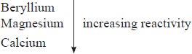

### Reaction with steam

Magnesium reacts slowly with cold water. However, it reacts faster with steam.

To react magnesium with steam, Put some wet sand at the bottom of a test tube. Insert a clean piece of magnesium ribbon (5 cm) into the middle of the test-tube ensure that the coil touches the sides of the tube. Set up the apparatus as shown in below.

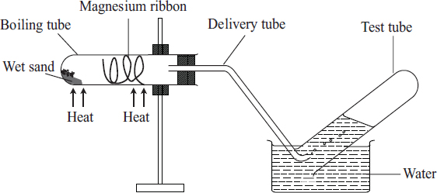

Heat the sand gently first, then heat the magnesium ribbon strongly until it glows, then continue to heat the wet sand to generate steam. Record your observations. Test any gas produced using a burning splint. Before the heating is discontinued, the delivery tube should be removed from the water.

Discussion Questions

1. **State and explain what is observed in the reaction tube.**

Magnesium burns in steam with a **white flame.** A **white solid** is formed and a **colourless gas** is produced. A pop sound is produced when a burning splint is introduced into a test-tube containing the gas. Therefore the colourless gas is hydrogen.

Magnesium + Steam  Magnesium oxide + Hydrogen

Mg(s) + H2O(g)  MgO(s) + H2(g)

1. **Why is the wet sand heated initially?**

The sand is heated initially to drive out the air that would otherwise react with magnesium by generating some steam.

1. **Why should the delivery tube be removed before heating is discontinued?**

The delivery tube is removed from the water before heating is stopped at the end of the experiment to prevent sucking back as the apparatus cools.

1. **Explain the observation made when a burning splint is lowered into a test tube of the gas collected.**

A pop sound is produced when a burning splint is introduced into a test-tube containing the gas. Therefore the colourless gas is hydrogen.

### Reaction with chlorine

Discussion Questions

1. **State and explain what is observed when chlorine gas reacts with:**
2. **A burning piece of magnesium**

When a burning piece of magnesium is lowered into a gas jar containing chlorine, the metal **continues to burn with a brilliant white flame to form a white powder.** The white ash formed is magnesium chloride.

Magnesium + Chlorine  Magnesium chloride

Mg(s) + Cl2(s)  MgCl2(s)

1. **A hot piece of calcium**

Calcium may not react steadily with chlorine. This is because a coating of **calcium oxide is formed first when the metal is heated.** However, under suitable conditions calcium may react with chlorine to form calcium chloride.

Calcium + Chlorine gas  Calcium chloride

Ca(s) + Cl2(g)  CaCl2(s)

### **Reaction with dilute acids**

Discussion Questions

**1.   State and explain what is observed when magnesium ribbon reacts with dilute hydrochloric and sulphuric acids.**

There is **effervescence** when a piece of magnesium is placed in hydrochloric acid. The gas produced during the reaction **produces a ‘pop’ sound** when a burning splint is introduced to the mouth of the test tube. This shows that the gas produced is **hydrogen**.

Magnesium + Hydrochloric acid  Magnesium chloride + Hydrogen gas

Mg(s) + 2HCl(aq)  MgCl2(aq)+ H2(g)

Magnesium + Sulphuric acid  Magnesium sulphate + hydrogen gas

Mg(s) + H2SO4(aq)  MgSO4(aq) + H2(g)

**2.   State and explain what is observed when calcium reacts with dilute hydrochloric and sulphuric acids.**

Calcium reacts with dilute hyrdrochloric acid to produce hydrogen gas and calcium chloride.

Calcium + Hydrochloric acid  calcium chloride + hydrogen gas

Ca(s) + 2HCl(aq)  CaCl2(aq) + H2(g)

When sulphuric (VI) acid is used, the **reaction quickly stops.** This is due to to the formation of **insoluble calcium sulphate** which **forms a coating on the surface of calcium metal preventing further reaction.**

Calcium + Sulphuric acid  Calcium sulphate + Hydrogen gas

Ca(s) + H2SO4 (aq)  CaSO4(s) + H2(g)

### Similarity of ions and formulae of some compounds of alkaline earth metals

All alkaline earth metals have a valency of two (2). Hence the chemical formulae of their compounds are similar.

Formation of hydroxides, oxides and chlorides of alkaline earth metals.

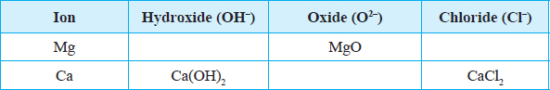

Both magnesium and calcium ions have a **valency of 2.** The hydroxide ion and chloride ion have a **valency of 1.** Therefore **two hydroxide ions combine with one magnesium** **ion to form magnesium hydroxide, Mg(OH)2.** Similarly, **two chloride ions will combine with one magnesium ion to form magnesium chloride, MgCl2.**

On the other hand, the **oxide ion has valency of 2.** therefore, **one calcium ion combines with one oxide ion to form calcium oxide, CaO.**

## (e) Uses of some Alkaline Earth Metals and their Compounds

1.   Magnesium is used in the manufacture of magnesium hydroxide which is used as anti-acid medicine. This is because magnesium hydroxide is a non-toxic base.

2.   A low-density alloy of magnesium and aluminium is used in aeroplane construction.

3.   Hydrated calcium sulphate (Plaster of Paris) is used in hospitals to set fractured bones.

4.   Cement is made by heating a mixture of calcium carbonate (limestone), clay and sand.

5.   Calcium carbonate is used in the extraction of iron.

6.   Calcium oxide (quicklime) is added to acid soils to raise pH for agriculture purposes.

7.   Calcium nitrate is used as a nitrogenous fertilizer.

8.   Magnesium oxide is used in the lining of furnances.

9.   Barium sulphate is used in diagnosis of ulcers.

10. Barium nitrate is used to produce the green flame in fireworks.

11. Calcium carbonate is mixed with oil to make putty.

# 3. Halogens

The word halogen is derived from the Greek word ‘halo’ meaning salt and ‘gen’ meaning producer. Halogen thus means salt producer. **Halogens** are non-**metals in Group VII of the periodic table.** Fluorine, chlorine, bromine and iodine are the first four members of the halogen group. The electron arrangement of fluorine and chlorine is as follows:

Fluorine 2.7

Chlorine 2.8.7

**Task: Draw the atomic structure of the first 2 Halogens**

## Gradation in Size of Atoms and Ion in halogens

The table below gives the atomic and ionic sizes of the Halogens.

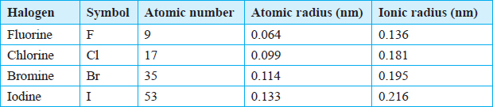

Discussion Questions

**1.   Explain the trends in the atomic and ionic radii of Halogens down the group:**

The atomic and ionic radii of the halogens **increase down the group.** This is because of the **increase** in the number of occupied energy levels.

**2.   How do the atomic radii of the halogens compare with their ionic radii?**

The **atomic radius of a halogen atom is less than the radius of its ion.**

For example, the **atomic radius of a chlorine atom is less than the ionic radius of a chloride ion.** This is because the **chlorine atom has 17 protons** in the nucleus **attracting 17 electrons** in the energy levels. The chloride **ion has 17 protons in the nucleus attracting 18 electrons.** The effect of the positive nucleus is thus **lower**. **The reduction in the nuclear attraction is due to repulsive effect between the existing electrons and the incoming electron.**

## Physical Properties of Halogens

Chlorine can be prepared by the action of concentrated hydrochloric acid on potassium manganate (VII) (KMnO4) or Manganese (IV) oxide (MnO2). Heat is required when manganese (IV) oxide is used.

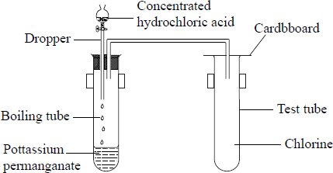***Set up for preparing chlorine gas***

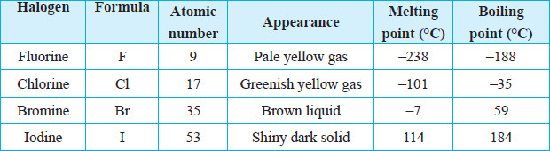The table below gives a summary of the physical properties of halogens.

Discussion Questions

1. **What is the physical state of chlorine, bromine and iodine at room temperature?**

**Fluorine** and **chlorine** are **gases at room temperature. Bromine** is a **volatile liquid** while **iodine is a solid.**

1. **What is the colour of chlorine, bromine and iodine?**

Fluorine is **pale yellow** while chlorine is **green-yellow.** Bromine is a **brown liquid** while iodine is a **shiny dark grey solid.**

1. **What is observed when chlorine and bromine are shaken withWater and Tetra chloromethane**

When a boiling tube containing chlorine gas or bromine vapour is inverted in water or tetrachloromethane, **the level of the solution rises in the boiling tube.**

The level of the solution rises more in tetrachloromethane than in water. The rise in water level is higher in the case of chlorine compared to bromine. This shows that **chlorine is more soluble in water than bromine. Solubility of halogens in water therefore decreases down the group. All halogens are soluble in tetrachloromethane.**

1. **Explain what is observed when iodine is heated.**

Iodine **sublimes when heated** to form a **purple vapour**. This is because the **particles are held by weak forces** which require **little energy** to break.

1. **Does iodine conduct electricity? Explain**.

Halogens are non conductors of heat and electricity. This is because there are no delocalised electrons in their structures.

1. **Explain the trends in the melting and boiling points of halogens down the group.**

The melting and boiling points of halogens increase down the group.

Halogens exists as diatomic molecules. The forces of attraction between molecules (intermolecular forces) increase with the increase in the size of the molecules. Hence, the forces of attraction between molecules among the four halogens are strongest in iodine and weakest in fluorine.

## Chemical Properties of Halogens

It is **not easy for non metals to lose electrons** because the amount of energy required (ionisation energy) is very large. Therefore non metals do not easily form positively charged ions. Non metals therefore **react by gaining electrons** to form negatively charged ions.

### Ion formation

Halogens have seven electrons in their outermost energy level. They react by gaining one electron to attain a stable electron configuration and form negatively charged ions. During ion formation, energy is released. The energy change for this process of electron gain is called electron affinity.

F + e– F– (Elctron affinity = –322 kJmol–1)

Cl + e– Cl– (Electron affinity = –349 kJmol–1)

Br + e– Br– (Electron affinity = –325 kJmol–1)

I + e– I– (Electron affinity = –295 kJmol–1)

Generally, **the electron affinity decreases as the size of the atoms increases** hence **reactivity decreases down the group.**

### Reaction with metals

The reaction between iron and a halogen results in the formation of a salt.

The procedure below can be used to react halogens with metals. Pass a stream of dry chlorine gas over heated iron wool as shown below. Record your observations.

For bromine and iodine, heat the iron wool in a test-tube in which bromine and iodine vapour is generated and passed over the wool as shown below. The test-tube should be held with a test-tube holder. Alternatively, using a defragrating spoon, place hot iron wool into a gas jar of chlorine.

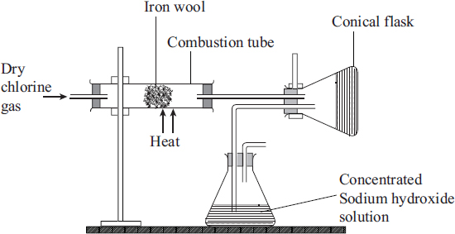

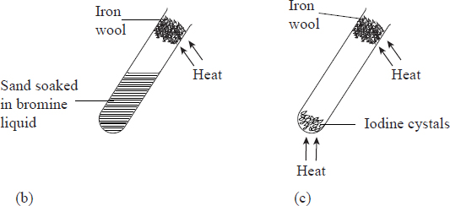

Discussion Questions

**1. What is observed when the hot iron wool reacts with the halogens?**

Chlorine reacts most vigorously with hot iron forming dark-brown crystals of iron (III) chloride. Hot iron glows in bromine vapour to form dark-red crystals of iron (III) bromide. Iodine vapour reacts slowly with hot iron to form grayish black crystals of iron (II) iodide. Iodine is not reactive enough to form a salt with iron.

The equations below represent the reactions which occur.

Iron + Chlorine  Iron (III) chloride

2Fe (s) + 3 Cl2(g)  2FeCl3(s)

Iron + Bromine  Iron (III) bromide

2Fe(s) + 3Br2(g)  2FeBr3(s)

Iron + Iodine  Iron (II) iodine

Fe(s) + I2(g)  Fel2(s)**.**

1. **State and explain the role of the concentrated sodium hydroxide.**

Concentrated sodium hydroxide is used to react with excess chlorine to avoid emitting poisonous chlorine gas into the air.

1. **Write chemical equations for the reactions between chlorine, bromine and iodine with**  **zinc.**

Halogens react with heated zinc to form zinc salts.

Zinc + Chlorine  Zinc chloride

Zn(s) + Cl2(g)  ZnCl2(s)

Zinc + Bromine  Zinc bromide

Zn (s) + Br (g)  ZnBr2(s)

Zinc + Iodine  Zinc iodide

Zn(s) + I2(g)  ZnI2(s)

Other salts formed in the same method are MgCl2, AlCl3 and NaCl.

1. **What is the order of reactivity of halogens? Explain**

The reaction between chlorine and metals is more vigorous than that of bromine. The order of reactivity of the halogens with metals **decreases down** the group.

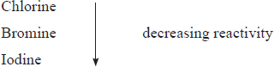

The ability of an atom to **gain an electron** in its outermost energy level **decreases as the size of the atoms increase,** hence the **decrease in reactivity of halogens down the group.**

### Reaction with water

To study the reaction between halogens and water, bubble chlorine through water in a conical flask for a few minutes using an experimental set-up as shown below.

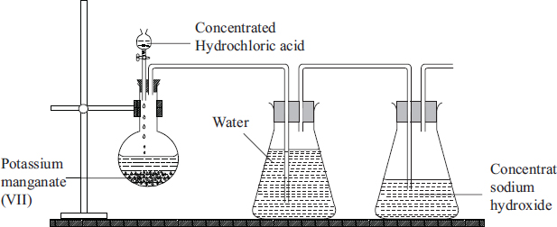Observe the colour of the resulting solution. Test the solution with litmus paper.

Discussion Questions

**1. What is observed when chlorine is passed through water for some time?**

Chlorine dissolves in water to form chlorine water which is a mixture of hydrochloric acid and chloric (I) acid.

Chlorine + water  Hydrochloric acid + Chloric (I) acid

Cl2(g) + H2O(g)  HCl(aq) + HClO (aq)

**2. What changes are observed on the litmus papers? Explain**

When the chlorine water is tested with litmus paper, the blue one turns red, showing that the solution is acidic. Then the litmus papers are **bleached (decolourised) immediately.**

The bleaching action is a **property of Chloric (I) acid**. Chloric (I) acid is **unstable** and **decomposes to form hydrochloric acid** and an **atom of oxygen**. The oxygen atom then combines with the natural dye in the litmus papers to form a colourless compound.

Chlorine **does not bleach dry litmus pape**r because **chloric (I) acid cannot be formed in the absence of water.** The bleaching action is only possible in the presence of water.

Chlorine water is y**ellow due to the presence of chloric (I) acid.**

In **sunlight**, the **chlorine water is decolourised** due to the decomposition of chloric (I) acid to oxygen gas and hydrochloric acid by the sunlight.

This reaction **does not take place in the dark**.

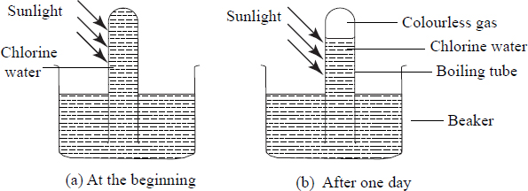

## Some uses of Halogens and their Compounds

1.   Fluorine is a raw material in the preparation of a synthetic fibre known as polytetraflouroethene.

2.   Some compounds of fluorine are added to water and some tooth pastes in small quantities to reduce tooth decay.

3.   Fluorine is used to manufacture hydrogen fluoride used to engrave words or pictures on glass.

4.   Chlorine is used to make bleaches used in paper pulp and textile industries.

5.   Chlorine is added to water to kill micro-organisms in water treatment works.

6.   Chlorine is used in the manufacture of a plastic known as polyvinylchloride (PVC).

7.   Chlorine is used in the large-scale manufacture of hydrochloric acid.

8.   Bromine is used in the manufacture of silver bromide which is used to make the light sensitive photographic paper and films.

9.   A solution of iodine in alcohol (tincture of iodine) is used as a disinfectant.

# 4. Noble gases

The **elements in group (VIII)** of the periodic table are called **noble gases.** Noble gases are found as free atoms in nature and form about 1% of air. They include helium, neon, argon, krypton, xenon and radon. Argon is the most abundant and forms about 0.9% of air by volume.

Noble gases were initially called **inert gases** because they were thought to be unreactive.

**Task: Draw the atomic structure of the first 3 noble gases**

Electron Arrangements of the first three Noble Gases

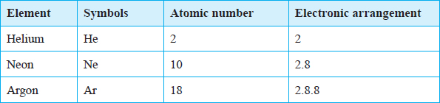Helium with only two electrons has one occupied energy level which is full. Hence it has a **duplet**. The rest have eight electrons in their outermost occupied energy level. Thus they have the **octet**.

Under normal conditions noble gases neither gain nor lose electrons. They are therefore stable and non reactive.

## Physical Properties of Noble gases

Group VIII elements are colourless monoatomic gases.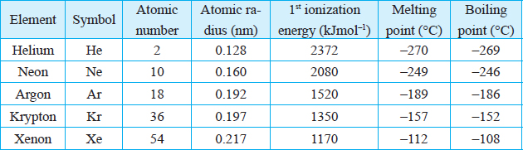

Discussion Questions

**1.What happens to each of the following properties down the group?**

1. **Atomic radius.**

Atomic radii increase down the group due to the increase in the number of energy levels. The increase in atomic radii down the group explains why the first ionization energy of the gases decreases down the group.

1. **Melting point and boiling point.**

Noble gases have low melting and boiling points. This is because of the weak inter atomic forces of attraction between the atoms. However, as the atomic size increases down the group there is increase in strength of inter atomic forces of attraction between atoms. Hence the rise in melting and boiling points down the group.

1. **Ionization energies.**

Helium has a duplet electron arrangement while the others have an octet in their outermost energy level. Therefore they all have a stable electron arrangement. This explains the high ionization energies for all the elements.

**2.Xenon takes part in some reactions. Explain.**

Xenon has a **large atomic radius.** In xenon an electron in the outermost energy level is **relatively far** from the positive nucleus. It therefore has a **low ionization energy compared to the other noble gases.** For this reason, xenon takes part in some reactions.

## Uses of Noble Gases

The inert nature of the noble gases enables them to have a wide range of uses.

1.   Argon is used in light bulbs to provide an inert environment to prevent oxidation.

2.   Argon is used as an insulator in arch-welding.

3.   Neon gas is used in street and advertisement lights.

4.   Helium mixed with oxygen is used in deep sea diving and mountaineering. The mixture is also used in hospitals for patients with respiratory problems and those undergoing certain forms of surgery.

5.   Helium can be used instead of hydrogen in balloons for meteorological research.

6.   Helium is used in thermometers for the measurement of very low temperatures.

7.   Liquid helium is used to keep certain metal alloys at temperatures low enough for them to become super conductors.

# 5. Properties and Trends across A period

Elements in the same period have the same number of occupied energy levels. As you move across the period, the number of electrons in the outermost energy level increases by one. While the elements in the same group exhibit similar properties, those across a period show a gradual change in properties. This can be illustrated by considering elements in Period 3 from left to right.

## (a) Trends in Physical Properties of Elements in Period 3

The table below gives a summary of the physical properties of Elements in Period 3.

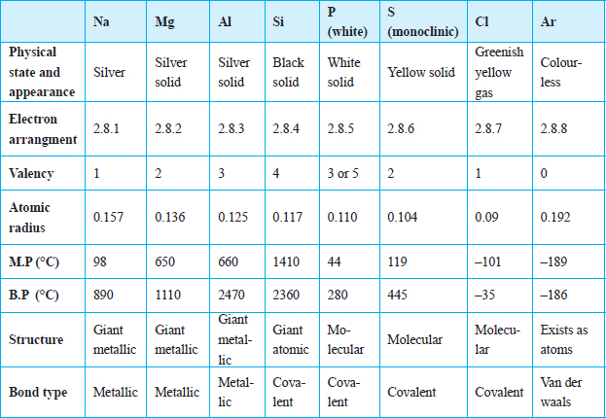

### (i)   Trends in Electrical conductivity

Discussion Questions

**1. List the elements in period 3 that conduct electricity.**

**S**odium, magnesium and aluminium are good conductors of electricity.

**2.Explain the trends in the electrical conductivity of the elements in period 3.**

Sodium, magnesium and aluminium **have delocalised electrons** in their structures. These delocalised electrons are responsible for the conduction of electricity. **Conductivity increases with increase in the number of delocalised electrons.** Therefore, **aluminium** with three delocalised electrons from each atom in the structure **has** the **highest electrical conductivity**.

Phosphorus, sulphur, chlorine and argon **are all made up of molecules** and therefore are **non-conductors** of electricity.

**Silicon** is unique among the elements because it is a **semi-conductor**. Its electrical conductivity **increases with increase in temperature.**

### (ii**) Other physical properties**

Discussion Questions

1. **Explain the trends in atomic radii across the period**

The atomic radii of the elements **gradually decrease across the period** from left to right. This is explained by the **increase in the nuclear charge across the period** due to an increase in the number of protons. Although there is an additional number of electrons, they enter the same energy level. This means that the shielding effect remains the same as the nuclear charge increases. The forces of attraction between the nuclei of these elements and the electrons in the outermost energy levels progressively increase across the period. As a result, the electrons in the outermost energy level are pulled closer to the nucleus, thereby decreasing the size of the atoms across the period from sodium to chlorine.

1. **Explain the trends in melting points and boiling points across the period.**

Sodium, magnesium and aluminium have giant metallic structures. Therefore, they have strong metallic bonds. These bonds require a lot of energy to break hence high melting and boiling points. Silicon has giant atomic structure hence high melting and boiling points. The rest of the non-metals have molecular structures held together by weak Van der Waals forces which require little energy to break hence low melting and boiling points.

1. **Why is the melting point of aluminium higher than that of sodium?**

Aluminium contributes three electrons to the metallic lattice whereas sodium contributes only one. Also, due to the small size of the aluminium atom, the packing of the atoms is close. Therefore, the metallic bonds in aluminium are stronger than in sodium and magnesium, hence the higher melting and boiling points of aluminium.

1. **Silicon, a non-metal, has a much higher melting point than all the other elements in the period. Explain.**

Silicon has a **giant atomic structure** in which **all the atoms are held together by strong covalent bonds.** These need **a lot of heat energy to break, hence the high melting and boiling points of silicon.** In contrast, **phosphorus and chlorine are molecular.** The atoms in the molecules are held together by strong covalent bonds while **the molecules themselves are held together by van der Waals forces** which require **little energy to break**. Melting involves breaking the van der Waals forces.

1. **Why are boiling points of chlorine and argon very low?**

Chlorine and argon exist as gases at room temperature. They have low melting and boiling points due to the presence of weak van der Waals forces. Chlorine is diatomic while argon is monoatomic.

## (b) Trends in Chemical Properties of the Elements in Period 3

**Summary of reaction of period 3 elements with air, water and dilute acids**.

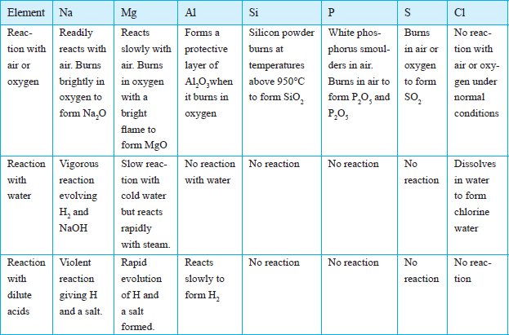

### **Reaction with oxygen**

Discussion Questions

**1.   Describehow elements in Period 3 react with oxygen. Explain the nature of the resulting solutions whenthe products are dissolved in water.**

* Sodium **reacts vigorously with oxygen** to form a white solid, sodium oxide.

Sodium + Oxygen  Sodium oxide

4Na(s) + O2 (g)  2Na2O (s)

The sodium oxide produced in the reaction readily dissolves in water to form an alkaline solution

Sodium oxide + Water  Sodium hydroxide

Na2O(s) + H2O(l)  2NaOH(aq)

* Magnesium **burns with a bright white light** to give a white solid, magnesium oxide.

Magnesium + Oxygen  Magnesium oxide

2Mg (s) + O2(g)  2MgO(s)

The magnesium oxide produced in the reaction is slightly soluble in water. The solution formed is alkaline.

Magnesium oxide + water  Magnesium hydroxide

MgO(s) + H2O(l) Mg(OH)2(aq)

* Aluminium foil is usually coated with **a layer of aluminium oxide, Al2O3.** This **prevents the reaction with oxygen.** When polished,**aluminum reacts slowly** with oxygen to form the white solid, aluminium oxide.

Aluminium + Oxygen  Aluminium oxide

4Al(s) + 3O2(g)  2Al2 O3(s)

The aluminium oxide is insoluble in water.

* Silicon powder **can only burn in oxygen at high temperatures (about 450°C)** to form solid silicon (IV) oxide.

Silicon + Oxygen  Silicon (IV) oxide

Si(s) + O2(g)  SiO2(s)

Silicon (IV) oxide is insoluble in water.

* Phosphorus **readily burns in oxygen with a bright orange flame** to form a white solid, phosphorus (V) oxide.

Phosphorus + Oxygen  Phosphorus (V) oxide

P4(s) + 5O2(g)  2P2O5(s)

Phosphorus (V) oxide readily dissolves in water to form an acidic solution.

Phosphorus (V) oxide + Water  Phosphorus (V) acid

P2O5(s) + 3H2O(l)  2H3PO4(aq)

* Sulphur **burns in oxygen with a blue fame** to form a gas sulphur (IV) oxide.

Sulphur + Oxygen  Sulphur (IV) oxide

S(s) + O2(g)  SO2(g)

The sulphur (IV) oxide gas readily dissolves in water to give an acidic solution of sulphuric (IV) acid, H2SO3, which is easily oxidized to sulphuric (VI) acid H2SO4.

Sulphur (IV) oxide + Water  Sulphuric (IV) acid

SO2(g) + H2O(l)  H2SO3(aq)

Sulphuric (IV) acid + Oxygen Sulphuric(VI) acid

2H2SO3(aq) + O2(g)  2H2SO4(aq)

* Chlorine burns in oxygen under certain conditions to form **acidic oxides** while argon is not reactive.

**2.   State the trend in how elements in period 3 react with oxygen**

**T**he following trends in the elements of period 3 can be identified.

•    **All** the elements across period 3**,** with the **exception of argon**, **burn** in oxygen to form oxides.

•    The **reactivity of the metals with oxygen decreases from left to right** across the period. Sodium is the most reactive of the three metals in the period and aluminium the least. The order of reactivity with oxygen is therefore Na > Mg > Al. This is **because of the increase in nuclear charge from sodium to aluminium, which makes it easier to remove an electron from a sodium atom than from an aluminium atom.**

•    **Metallic elements** burn in oxygen to form **basic oxides.Soluble** metallic oxides dissolve in water to form **alkaline solutions.**

•    The **reactivity of the non-metallic elements with oxygen increases from left to right across the third period.** This is **because the ease of gaining electrons increases from left to right.** Phosphorus is the least reactive and chlorine the most reactive. The order of reactivity with oxygen, starting with the most reactive is therefore: Cl > S > P. **Non-metals react by gaining electrons.**

•    The **non-metallic elements** burn in oxygen to form **acidic oxides** which dissolve in water to form **acidic solutions**.

### Reaction with Water

Discussion Questions

1. **Describe how each of the elements in period 3 react with water.**

* Sodium **reacts violently with cold water** to form sodium hydroxide and hydrogen gas.

Sodium + Water  Sodium hydroxide + Hydrogen

2Na(s) + H2O(l)  2NaOH(aq) + H2(g)

* Magnesium **reacts very slowly with cold water** to form magnesium hydroxide and hydrogen gas.

Magnesium + water  Magnesium hydroxide + Hydrogen

Mg(s) + 2H2O(l) Mg(OH)2(aq) + H2(g)

* Aluminium **does not normally react with cold water or steam** due to the presence of a **coating of aluminium oxide, which prevents any reaction.** However, **at temperatures above 700 °C steam can react with aluminium.** Due to its apparent inability to react with water, aluminium was prefered for making cooking vessels such as ***pans***and***sufurias*.**

1. **Explain why the reactivity varies across the period.**

* In general, the reactivity of the metals with water **decreases** from sodium to aluminium, Na > Mg > Al. sodium is **more reactive** becaus**e it loses its valence electron more readily** than magnesium and aluminium.
* Non-metals **do not displace hydrogen from water**. Therefore, silicon, phosphorus and sulphur **do not react with either cold water or steam.**
* Chlorine is an exception since **it dissolves in water** to form **chlorine water**, which is a **mixture of hydrochloric acid and chloric (I) acid.**

Chlorine + water  Hydrochloric acid + Hypochlorous acid

Cl2(g) + H2O(l)  HCl(aq) + HOCl(aq)

### **Reaction with Acids**

Discussion Questions

**Explain the trend in reactivity of the period 3 elements with dilute acids.**

* Magnesium reacts with both dilute hydrochloric acid and dilute sulphuric (VI) acid to form a salt and hydrogen gas.

Magnesium + hydrochloric acid  Magnesium chloride + Hydrogen gas

Mg(s) + 2HCl(aq)  MgCl2(aq) + H2(g)

Magnesium + Sulphuric (VI) acid  Magnesium sulphate + Hydrogen gas.

Mg(s) + H2SO4(aq)  MgSO4(aq) + H2(g)

* Aluminium does not readily react with dilute acid due to the **presence of an aluminium oxide coating.** However, on removing the oxide coating, the metal reacts.

Aluminium + Hydrochloric acid  Aluminium chloride + Hydrogen gas

2Al(s) + 6HCl(aq)  2AlCl3(aq) + 3H2(g)

2Al(s) + 3H2SO4(aq)  Al2(SO)4 (aq) + 3H2(g).

* The reaction between sodium and acids is explosive and should NEVER be tried. The order of reactivity with acid is Na > Mg > Al.
* Silicon, phosphorus, sulphur and chlorine **do not react with dilute acids.**

1. 2006 Q19 P1
   1. Starting from solid magnesium oxide, describe how a solid sample of magnesium hydroxide can be prepared. (2 marks)
   2. Give one use of magnesium hydroxide. (1 mark)
2. 2006 Q 3a,b P2
3. Distinguish between isotopes and allotropes.
4. The chart below is part of the periodic table. Study it and answer the questions that follow. (The letters are not the actual symbols of the elements).

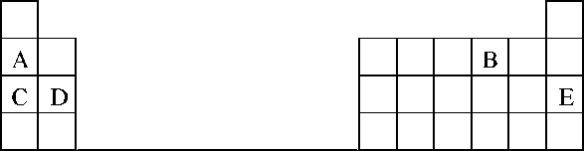

1. Select the element in period three which has the shortest atomic radius. Give a reason for you answer. (2 marks)
2. Element F has the electronic structure, 2.8.18.4. On the chart above; indicate the position of element F. (1 mark)
3. State one use of the elements of which E is a member. (1 mark)
4. 2007 Q3a P1

Both chlorine and iodine are halogens. What are halogens? (1 mark)

1. 2007 Q 8 P1

Explain why there is general increase in the first ionization energies of the elements in period 3 of the periodic table from left to right. (2 marks)

1. 2007 Q 25b

Give a reason why helium is increasingly being preferred to hydrogen in weather balloons. (1 mark)

1. 2008 Q 18 P1

The grid below is part of the periodic table. Use it to answer the questions that follow, (the letters are not the actual symbols of the elements).

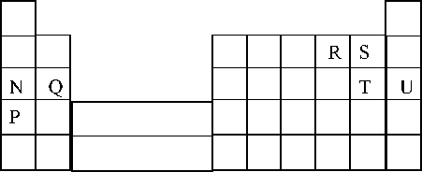

1. Indicate on the grid the position of an element represented by letter V whose atomic number is 14. (1 mark)
2. Select a letter which represents a monoatomic gas. (1 mark)
3. 2009 Q 1 P1

The ionization energies for three elements A, B and C are shown in the table below.

|  |  |  |  |
| --- | --- | --- | --- |
| **Element** | **A** | **B** | **C** |
| Ionisation energy (kJ /mole) | 519 | 418 | 494 |

1. What is meant by ionization energy? (1 mark)
2. Which element is the strongest reducing agent? Give a reason (2 marks)
3. 2009 Q 21 P1,2011 Q 5 P1

Give the name of the product formed when magnesium reacts with phosphorus. (1 mark)

1. 2011 Q5 P1

The diagram below represents part of the periodic table. Use it to answer the questions that follow.

|  |  |  |  |  |  |  |  |  |
| --- | --- | --- | --- | --- | --- | --- | --- | --- |
|  |  | |  | | | | |  |
| M |  |  |  |  | Q |  |  |  |
| T | V | W |  |  |  |  |  |
|  |  |  |  |  |  |  |  |  |
|  |  |  |  |  |  |  |  |  |

1. Write the electron arrangement for the stable ion formed by W (1 mark)
2. Write an equation for the reaction between V and Q (1 mark)
3. How do the ionization energies of the elements M and T compare? (1 mark)
4. 2011 Q 22 P1

The table below gives some properties of three elements in group (VII) of the periodic table. Study it and answer the questions that follow.

|  |  |  |  |
| --- | --- | --- | --- |
| **Element** | **Atomic No.** | **Melting Point (°C)** | **Boiling Point (°C)** |
| Chlorine | 17 | -101 | -34.7 |
| Bromine | 35 | -7 | 58.8 |
| Iodine | 53 | 114 | 184 |

1. Which element is in liquid form at room temperature? Give a reason. (1 mark)
2. Explain why the boiling point of iodine is much higher than that of chlorine. (2 marks)
3. 2011 Q 31 P1

What name is given to elements which appear in group (II) of the periodic table? (1 mark)

1. 2012 Q14 P1

Distinguish between ionisation energy and electron affinity of an element. (2 marks)

1. 2012 Q2 P2

The grid below is part of the periodic table. Use it to answer the questions that follow. (the letters are not the actual symbols of the elements).

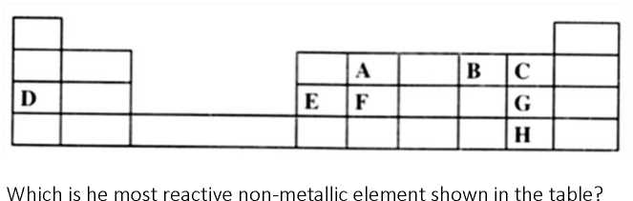

1. Which is the most reactive non-metallic element shown in the table? Explain. (2 marks)
2. (i) Write the formula of the compound formed when element A reacts with element B (1 mark)

(ii) Name the bond type in the compound formed in b (i) above (1 mark)

1. (i) What is the name given to the group of elements where, C, G and H belong?

(ii) Write an equation for the reaction that occurs when C in gaseous form is passed through a solution containing ions of element H (1 mark)

1. The melting points of elements F and G are 14100C and -101 respectively. In terms of structure and bonding, explain why there is a large difference in the melting points of F and G. (2 marks)
2. D forms two oxides. Write the formula of each of the two oxides. (1 mark)
3. J is an element that belongs to the 3rd period of the periodic table and a member of the alkaline earth elements. Show the position of j in the grid (1 mark)
4. 2012 Q4 P1

The table below shows properties of some elements A, B, C and D which belong to the same period of the periodic table. The letters are not the actual symbols of the elements.

|  |  |  |  |  |
| --- | --- | --- | --- | --- |
| **Element** | **A** | **B** | **C** | **D** |
| MP (°C) | 1410 | 98 | -101 | 660 |
| Atomic radii (nm) | 0.117 | 0.186 | 0.099 | 0.143 |
| Electrical conductivity | Poor | Good | Non-conductor | Good |

1. Arrange the elements in the order they would appear in the period. Give a reason (2 marks)
2. Select the metallic element which is the better conductor of electricity. Give a Reason. (1 mark)
3. 2012 Q27 P1
4. The electronic arrangement of the ion of element Q is 2.8.8. If the Formula of the ion is Q3-, state the group and period to which Q belongs,

Group: (½ mark)

Period: (½mark)

1. Helium, neon and argon belong to group 8 of the periodic table. Give:

(i) The general name of these elements; (1 mark)

(ii) One use of these elements (1 mark)

1. 2013 Q20 P1

The plots below were obtained when the atomic radii of some elements in groups I and II were plotted against atomic numbers.

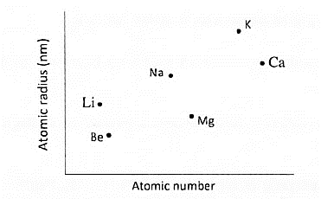

Explain:

1. The trend shown by Li, Na and K. (1 mark)
2. Why the atomic radii of elements Be, Mg, and Ca are lower than those of Li, Na and K. (2 marks)
3. 2013 Q1 P2
4. The grid below represents part of the periodic table. Study it and answer the questions that follow. The letters do not represent the actual symbols of the elements.

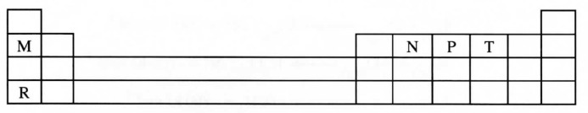

* + 1. Select a letter which represents an element that losses electrons most readily. Give a reason for your answer. (2 marks)
    2. Explain why the atomic radius of P is found to be smaller than that of N. (2 marks)
    3. Element M reacts with water at room temperature to produce 0.2 dm3 of gas. Determine the mass of M which was reacted with water. (molar gas volume at r.t.p is 24 dm3, relative atomic mass of M = 7). (3 marks)

1. Use the information in the table below to answer the questions that follow. (The letters are not the actual symbols of the elements).

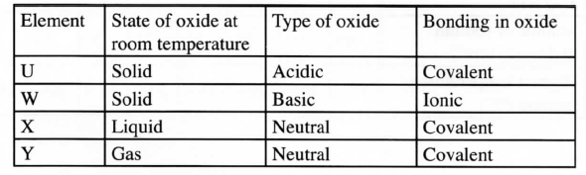

Identify a letter which represents an element in the table that could be calcium, carbon or sulphur. Give a reason in each case.

1. Calcium____________ (½ mark)

Reason____________ (½ mark)

1. Carbon ____________ (½ mark)

Reason_____________ (½ mark)

1. Sulphur ____________ (½ mark)

Reason_____________ (½ mark)

1. 2014 Q2 P1
2. The grid below represents part of the periodic table. Study it and answer the questions that follow. The letters are not the actual symbols of the elements

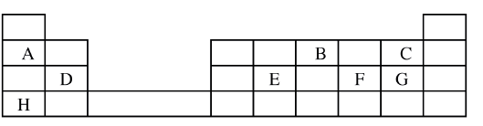

1. Select the most reactive metal. Explain (2 marks)
2. Select an element that can form an ion with a charge of 3- (1 mark)
3. Select an alkaline earth metal (1 mark)
4. Which group 1 element has the highest first ionization energy? Explain (2 marks)
5. Element A combines with chlorine to form a chloride of A. State the most likely pH value of a solution of a chloride of A. Explain (2 marks)
6. (i) Explain why molten calcium chloride and magnesium chloride conduct electricity while carbon tetrachloride and silicon tetrachloride do not. (2 marks)

(ii)Under the same conditions, gaseous neon was found to diffuse faster than gaseous fluorine. Explain this observation. (F=19.0; Ne=20.0) (2 marks)

1. 2015 Q23 P1

The table below is part of the periodic table. The letters are not the actual symbols of the elements. Study it and answer the questions that follows. 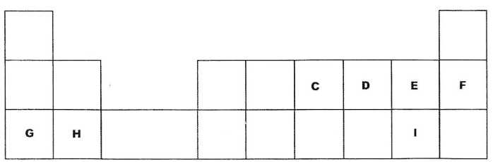

* + 1. Select an element which is stored in paraffin in the laboratory. (1 mark)
    2. How do the ionic radii of E and I compare? Explain (2 marks)

1. 2015 Q3c-d P2
2. The diagram below shows part of a periodic table. The letters do not represent the actual symbols of elements. Use the diagram to answer the questions that follow.

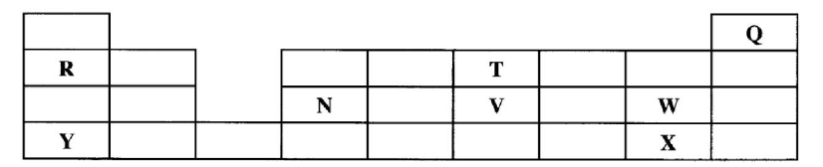

1. Explain why the oxidizing power of W is more than that of X. (1 mark)
2. How do the melting points of R and T compare? Explain. (2 marks)
3. Sketch an element that could be used
   1. In weather balloons (1 mark)
   2. For making a cooking pot (1 mark)
4. (i) Classify the substances water, iodine, diamond and candle wax into elements and compounds (2 marks)

|  |  |
| --- | --- |
| Elements | Compounds |
|  |  |

1. Give one use of diamond. (1 mark)
2. 2015 Q20 P1

A crystal of iodine, heated gently in a test tube gave off a purple vapour.

1. Write the formula of the substance responsible for the purple vapour. (1 mark)
2. What type of bond is broken when the iodine crystal is heated gently? (1 mark)
3. State one use of iodine. (1 mark)
4. 2016 Q1 P2

Use the information in the table below to answer the questions that follow. The letters do not represent the actual symbols of the elements.

|  |  |  |
| --- | --- | --- |
| Element | Atomic Number | Melting Point (°C) |
| R | 11 | 97.8 |
| S | 12 | 650.0 |
| T | 15 | 44.0 |
| U | 17 | -102 |
| V | 18 | -189 |
| w | 19 | 64.0 |

* + - 1. Give reasons why the melting point of:

(i) S is higher than that of R; (1 mark)

(ii) V is lower than that of U. (2 marks)

* + - 1. How does the reactivity of W with Chlorine compare with that of R with chlorine? Explain. (2 marks)
      2. Write an equation for the reaction between T and excess oxygen.

(1 mark)

* + - 1. When 1.15g of R were reacted with water, 600cm3 of gas was produced. Determine the relative atomic mass of R. (Molar gas volume = 24 000 cm3). (3 marks)
      2. Give one use of element V. (1 mark)

1. 2017 Q1 P1

Table 1 shows the atomic numbers and the first ionisation energies of three elements. The letters are not actual symbols of the elements. Use it to answer the questions that follow.

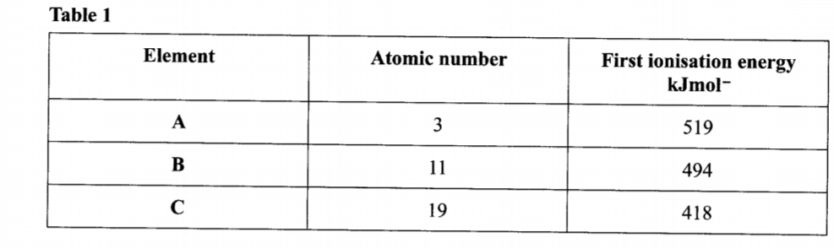

* 1. Explain the trend in first ionisation energy from A to C. (2 mark)
  2. Write the electronic configuration for the ion of C. (1 mark)

1. 2018 P1 Q5.

Describe an experiment to show that group one elements react with cold water to form alkaline solutions. (3 marks)

1. 2018 Q2 P2

Figure 2 is a section of the periodic table. Study it and answer the questions that follow. The letters do not represent the actual symbols of elements

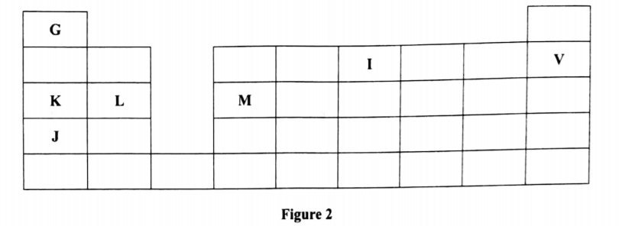

1. (i) Select elements which belong to the same chemical family. (1 mark)

(ii) Write the formulae of ions for elements in the same period. (1 mark)

1. The first ionisation energies of two elements K and M at random are 577 kJ/mol and 494 kJ/mol. (1 mark)
2. Write equations for the 1ˢᵗ ionisation energies for elements K and M and indicate their energies. (1 mark)
3. Explain the answer in b(i). (1 mark)
4. Write the formula of the compound formed when **L** and **I** react. (1 mark)
5. Give one use of element **V.** (1 mark)
6. (i) State another group that **G** can be placed in **Figure 1**. Explain. (2 marks)

(ii) How do the reactivity of elements **J** and **K** compare? Explain. (2 marks)

1. (i) Elements **L** and **M** form chlorides. Complete the following table by writing the formulae of each chloride and state the nature of the solutions. (2 marks)

|  |  |  |
| --- | --- | --- |
| **Element** | **Formula of chloride** | **Nature of chloride solution** |
| **L** |  |  |
| **M** |  |  |

(ii) The chloride of element M vaporises easily while its oxide has a high melting point. Explain. (2 marks)

**STRUCTURE AND BONDING**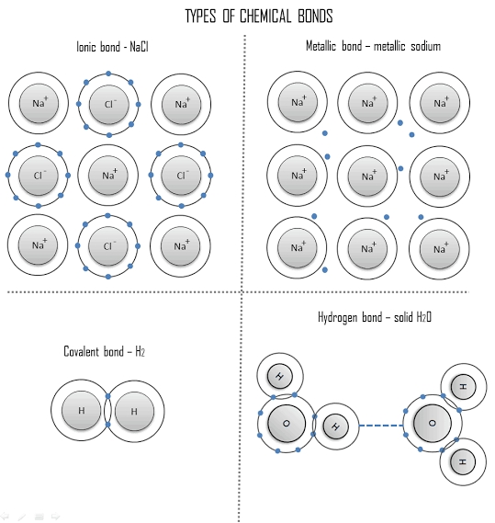

**Table of Contents**

Ionic Bond (electrovalent bond) 2

Giant Ionic Structures 3

Physical Properties of Ionic Compounds 4

2. Covalent and Co-ordinate Bond 5

Covalent bond 5

Co-ordinate Bond (Dative bond) 7

Molecular Structures 9

Physical Properties of Substances with Molecular Structures. 10

Giant Covalent Structure (Giant Atomic structures ) 11

The Metallic Bond 12

Physical Properties of Metals 12

Types of Bonds Across a Period 13

Oxides of Elements in Period 3 13

Chlorides of Elements in Period 3 14

Summary of Characteristics of Bonds 16

Objectives

By the end of the chapter the learner should be able to:

(a)   State the significance of valence electrons in bonding.

(b)   Explain qualitatively the formation of ionic, covalent and metallic bonds.

(c)   Diagrammatically illustrate ionic, covalent, dative, hydrogen bonds and van der Waals forces.

(d)   Predict the bond type and structure of a given substance from its physical properties.

(e)   Explain the changes in bond type across period 3.

(f)   Select materials for use based on bond types and structure.

(g)   Predict the properties of a given substance on the basis of the bonds present.

STRUCTURE AND BONDING

When atoms of the same or different elements combine during a chemical reaction, a mutual force of attraction develops between them.

A **Chemical Bond**is the mutual force of attraction that holds the particles of atoms of the same or different elements together.

**Structure**is a regular pattern in which chemical bonds hold the particles of a substance together.

Atoms of other elements achieve the stable electron arrangement of noble gases by gaining, losing or sharing the valence electrons.

The attraction between unlike charges and repulsion forces between like charges forms an important basis in bonding.

# Ionic Bond (electrovalent bond)

An **ionic bond** is the **electrostatic force of attraction** between **ions with opposite charges.**

**An ionic bond***is formed when there is* ***complete transfer of valence electrons from one atom to another resulting in two ions with opposite charges***which mutually attract one another. The resulting compound is known as an **ionic compound**.

Generally, the reaction between metals and non-metals results in the formation of ionic compounds.

For example, sodium reacts with chlorine to form sodium chloride as shown below.

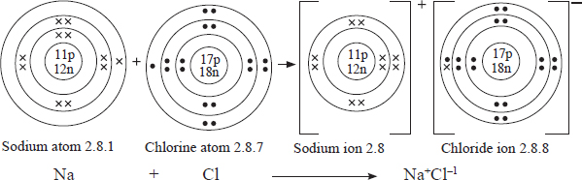

The sodium atom reacts by losing its single valence electron to the chlorine atom. The resulting sodium particle has 10 electrons and 11 protons. This results in the formation of a sodium ion with a net positive charge, Na+. The chlorine atom on the other hand, accepts the electron donated by the sodium atom into its outermost energy level. The resulting particle (a chloride ion) has 18 electrons and 17 protons. Thus the chloride ion formed has net negative charge, Cl–.

The sodium ion with a net positive charge and the chloride ion with a net negative charge attract each other in an ionic bond and the resulting compound is referred to as an ionic compound.

Other examples of ionic compounds include potassium fluoride, magnesium oxide and magnesium chloride.

1. **Potassium flouride**
2. 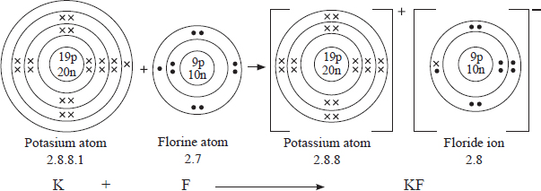**Magnesium chloride**

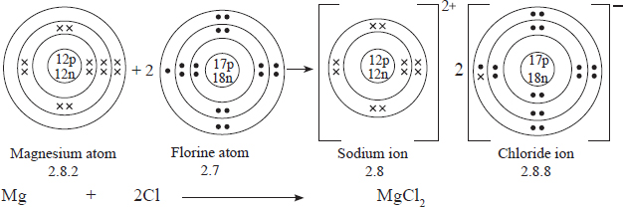

1. **Magnesium oxide**.

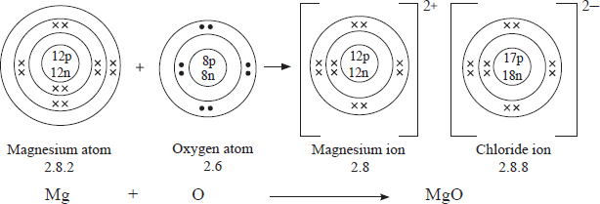

## Giant Ionic Structures

Substances with ionic bonds are **crystals** with **giant ionic structures.**

A **crystal** is a solid form of a substance in which the particles are arranged in a definite pattern repeated regularly in three dimensions.

Most ionic substances are crystalline in nature.

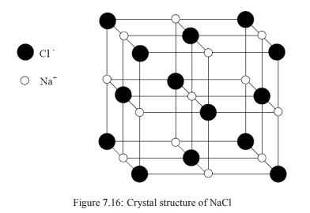For example, the sodium chloride structure shownalongside consists of many sodium ions and chloride ions that are arranged and packed in a regular pattern. Each sodium ion is surrounded by six chloride ions that are equidistant from it. Similarly, each chloride ion is surrounded by six sodium ions. This pattern repeats itself many times in all directions. The result is the formation of a giant ionic structure.

Other examples of ionic substances with giant ionic structures include **potassium nitrate, sodium iodide, potassium bromide and calcium nitrate.**

## Physical Properties of Ionic Compounds

Below is a summary of some physical properties of ionic compounds.

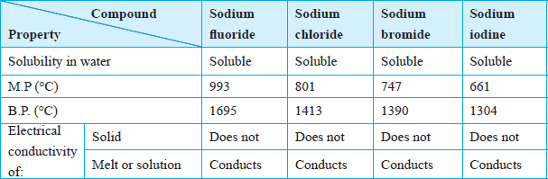

Discussion Questions

1. **Comment on the solubility of ionic substances in water.**

Most ionic substances **dissolve in water** because **they are made up of oppositely charged ions which are attracted by the polar water molecules.**

1. **Explain why the melting and boiling points of ionic compounds are generally high.**

Ionic substances have high melting and boiling points. This is because **ionic bonds are strong**. Melting and boiling involve breaking these ionic bonds. A lot of heat energy is required to break the bonds.

**3.   Explain why ionic compounds conduct electricity in the molten state and in aqueous solution but not in the solid state.**

Ionic compounds **do not conduct electricity in the solid state**. This is because **the ions forming the structure are not mobile but occupy fixed positions in the structure**. In the **molten state or aqueous solutions,** the ions are **mobile within the molten liquid** or solution and therefore **conduct** electricity.

Ionic substances conduct electricity by use of **molten ions.**

# 2. Covalent and Co-ordinate Bond

## Covalent bond

**A covalent bond** is a bond formed when the combining atoms **share a pair (or pairs) of electrons between them**, **each donating an electron** to the shared pair.

Covalent bonding occurs when atoms of non-metals combine. The combining atoms could be of the same element or from different elements. It is commonin **molecules**. Substances with covalent bonds either have **molecular or giant atomic structures.**

***A molecule****is a group of atoms (two or more) of the same or different elements that are held together by strong covalent bonds*.

Substances consisting of molecules include **water, most gases, sugar, oils, fats, naphthalene, paraffin wax and sulphur.**

Substances consisting of molecules are referred to as **molecular substances.**

For example, two hydrogen atoms can combine to form a hydrogen molecule.

Each hydrogen atom has only one electron in its occupied energy level. It therefore needs to gain one electron to attain the stable electron arrangement of 2 helium (duplet state).

Since the combing atoms are of the same element, none would readily lose an electron to the other. The atoms therefore end up sharing a pair of electrons, each atom contributing an electron to the shared pair.

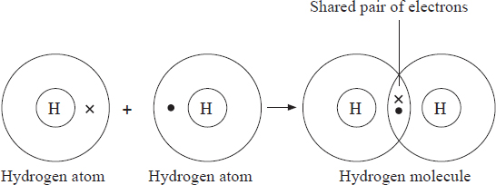

The covalent bond formed by the two hydrogen atoms in a hydrogen molecule can also be represented as follows.



The **single line ( – )** between the hydrogen atoms represents a **covalent bond** consisting of a shared pair of electrons.

A **single shared pair of electrons is represented by a single line (–)** and is called a **single covalent bond e.g. H – H.**

**Two** shared pairs of electrons are represented by **two lines (=)** and are called a **double covalent bond e.g. O=O**

**Three** shared pairs of electrons are represented by **three lines thus: (≡)** and are referred to as a **triple covalent bond e.g. N≡N.**

When drawing the structures, only the valence electrons are shown.

Other examples of substanceswhich are covalently bonded include:

1. Water molecule, H2O

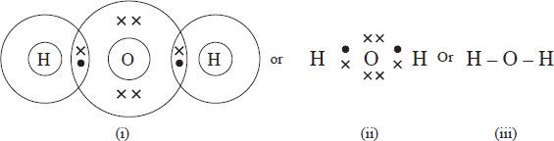

1. Chlorine molecule, Cl2

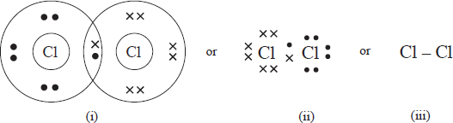

1. Oxygen molecule, O2

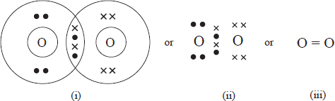

1. Nitrogen molecule, N2

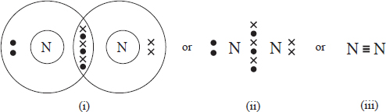

1. Ammonia,NH3

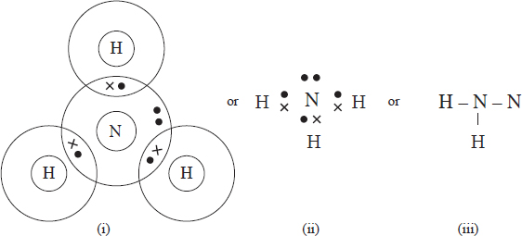

1. Carbon (IV) oxide,CO2

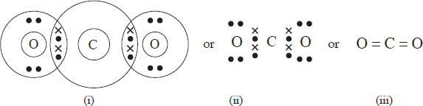

## Co-ordinate Bond (Dative bond)

A co-ordinate bondis a type of a covalent bond in which the shared pair of electrons forming the bond is contributed by only one of the atoms forming the bond.

Examples of substances which have coordinate bonds include ammonium ion (NH4+) ;carbon (II) oxide, CO, ;hydroxonium ion, H3O+;Ozone,O3, aluminum chloride dimer, Al2Cl6 and nitric (v) acid, HNO3

1. **Ammonium ion (NH4+).**

In the case of ammonium ion, the pair of electrons forming the co-ordinate bond is contributed by the ammonia molecule.

A hydrogen ion (H+) and an ammonia molecule (NH3) combine to form an ammonium ion (NH4+).

The hydrogen ion has no electron around its nucleus. On the other hand, the ammonia molecule has an unshared pair of valence electrons that has not been used in bonding.

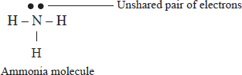When the hydrogen ion combines with the ammonia molecule, the hydrogen ion accepts the pair 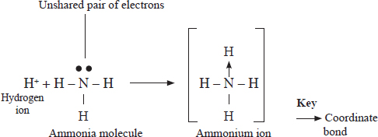of electrons into its empty first energy level.

The total number of protons in the ammonium ion is more than the total number of electrons resulting in a net positive charge.

1. **Carbon (II) oxide**

In carbon (II) oxide, Oxygen donates one of its two unshared pairs of electrons to form a co-ordinate bond with the carbon atom.

A carbon atom has four valence electrons and therefore needs to gain four electrons to fill its outermost energy level. Oxygen on the other hand has six valence electrons and needs two electrons to attain the stable configuration of 2.8.

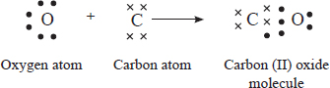The oxygen atom and the carbon atom in carbon (II) oxide form two covalent bonds and a co-ordinate bond.

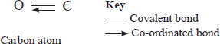

1. **Hydroxonium ion (H3O+)**

In hydroxonium ion, a water molecule donates one of its unshared pair of electrons to form a coordinate bond with the hydrogen ion. The resulting ion has a net positive charge as shown below.

1. 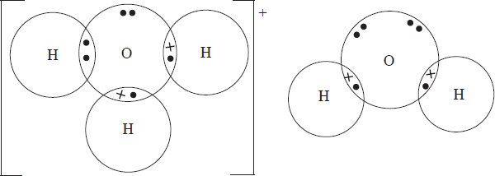**Aluminium chloride dimer**.

Aluminium combines with chlorine by forming covalent bonds to form a molecule of aluminium chloride (Al2Cl3). Two aluminium chloride molecules then combine through coordinate bonds to form a dimer as 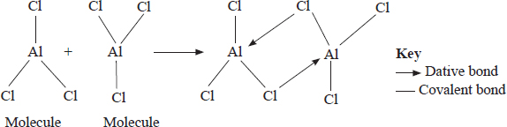shown below.

1. **Ozone, O3**

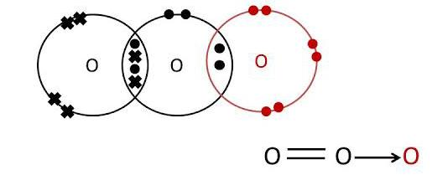

1. 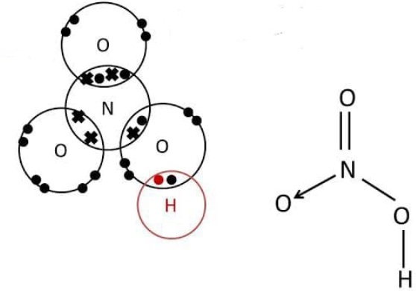**Nitric (V) acid**, **HNO**3

## Molecular Structures

Most molecular substances are **gases or liquids at room temperature.** Some molecular substances include sulphur, sugar, iodine, fats, paraffin wax and naphthalene.

**Discussion Question:**

**Using the structure of iodine, differentiate between a covalent bond and Van der waals forces.**

**Van der Waals forces** are **weak forces of attraction** between **molecules or atoms** which exist **only when the particles are close together.**

In molecules such as iodine, the atoms forming the molecules are held together by strong covalent bonds. The molecules in the solid substance are in turn held together in a regular pattern by weak van der Waals forces. The regular pattern repeats itself many times resulting to a molecular structure as shown below.

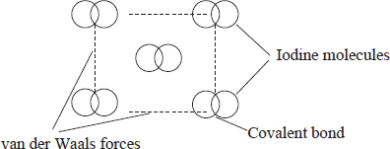The van der Waals forces hold the iodine molecules together in layers. This arrangement explains the flaky nature of iodine crystals.

### 

### **Physical Properties of Substances with Molecular Structures.**

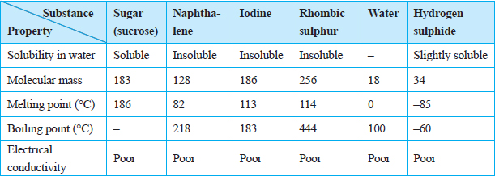The table below gives the physical properties of molecular substances.

Discussion Questions

1. **Give the reasons why molecular substances are poor conductors of electricity?**

Molecular substances are **poor conductors of both heat and electricity.** This is because they have structures composed of molecules. There are n**o ions or delocalised electrons in the structures to enable them to conduct electricity.**

1. **What is the general trend in the melting and boiling points in relation to the molecular masses?**

Molecular substances **have low melting and boiling points**. Although the atoms forming a molecule are held by strong covalent bonds, the **intermolecular forces are usually the weak van der Waals forces.** As melting and boiling involves breaking the weak van der Waals forces, the melting and boiling points are low. Melting and boiling points of molecular substances increase with the increase in relative molecular mass.

1. **Explain the effect of hydrogen bonds on melting and boiling points of molecular substances**

Although the melting point and boiling point of molecular substances increases with increase in molecular mass, some substances however, display a disparity.

For example, water (H2O) with relative molecular mass of 18 has a higher melting point of (°C) than hydrogen sulphide with a relative molecular mass 34 and a melting point of –85°C. In water the molecules are held together by hydrogen bonds while molecules in H2S are held by the weak van der Waals forces.

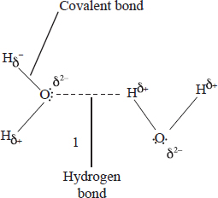***A hydrogen bond****is an intermolecular force in which the electropositive hydrogen atom of one molecule is attracted to an electronegative atom of another molecule*.

In water, the electropositive hydrogen of one molecule is attracted to the electronegative oxygen of another molecule.

A hydrogen bond is **stronger than the van der Waals** forces but **weaker than a covalent bond.**

The influence of hydrogen bonding on the physical properties of molecular substances is also illustrated by **ethanol (C2H5OH) and dimethyl ether (C2H6O).** Both substances have the same relative mass, 46. However, dimethyl ether boils at –24°C while ethanol boils at 78.4°C. This is because ethanol has hydrogen bonds as the intermolecular forces while dimethyl ether has the weaker van der Waals forces.

**4. State and explain the differences in the solubility of molecular substances?**

Most molecular substances are insoluble in water. However, some such as sugar, ethanol and ethanoic acid are soluble due to the presence of hydrogen bonding.

## Giant Covalent Structure (Giant Atomicstructures )

**A giant covalent structure is a structure that consists of an indefinite number of atoms which are all covalently bonded together. The pattern repeats itself and extends in all directions**.

Substances with giant atomic structures include **diamond, graphite and silicon (IV) oxide.**

### Diamond

Diamond is an allotrope of carbon. **Allotropes are different forms of an element in the 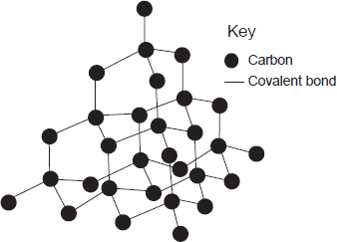same physical state.**

In the structure of diamond each carbon atom is bonded to other carbon atoms by strong covalent bonds. The carbon atoms in diamond form an octahedral structure as shown below.

The pattern repeats itself in all directions resulting in a giant atomic structure.

In diamond, all the valence electrons of each carbon atom are used in bonding. There are therefore **no delocalised electrons** in the structure.Thus, diamond is a **poor conductor of heat and electricity.**

Diamond is the **hardest known substance**. This is because **all the bonds in diamond are strong covalent bonds and the atoms in the structure are closely packed**. For this reasons its melting point is **very high (3700°C)**

**Graphite**

Each carbon atom in graphite is bonded to three other carbon atoms. Because only three of the four valence electrons in each atom are used in bonding, the forth valence electron is **delocalized** in the structure.

The structure of graphite consists of layers in which the carbon atoms are held together by strong covalent bonds forming hexagonal arrangement as shown below. Each layer is held to the other by van der Waals forces.

The **presence of delocalised electrons** in the structure of graphite explains its electrical **conductivity**.

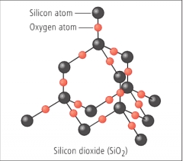Layers of graphite are **held together by van der Waals forces, therefore easily slide over each other when pressed and this gives graphite its slippery feel**.

### Silicon (IV) Oxide

Silicon has four electrons in its outer occupied energy level. Each silicon atom is bonded covalently to four oxygen atoms forming a giant covalent structure as below. .

# The Metallic Bond

**Metallic bond** is the **electrostatic force of attraction** between the **positive nuclei** and the **delocalised valence electrons** in the metallic structure.

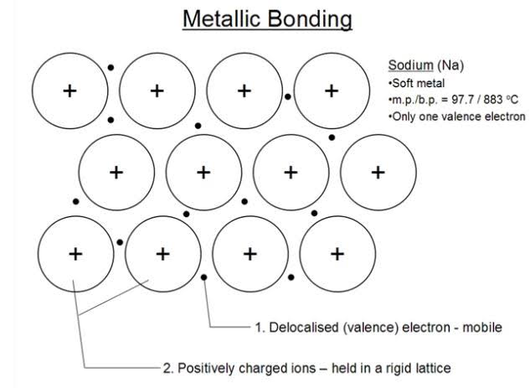In a metallic structure there are many atoms surrounding any one atom. The valence electrons are therefore mutually attracted to many nuclei. This gives rise to a situation where the positive nuclei appear to be immersed in a sea of mobile electrons. The mobile electrons in the structure are said to be delocalised.

Metallic bonds are strong bonds. The pattern is repeated many times resulting in a giant metallic structure.

## Physical Properties of Metals

The table below gives a summary of some physical properties of metals.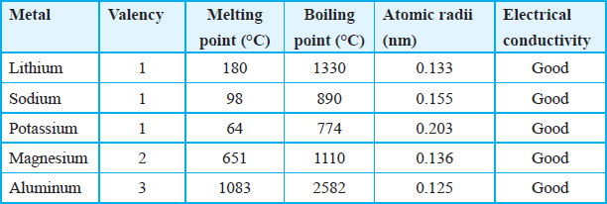

Discussion Questions

1. **Why are metals good conductors of electricity?**

All metals are good conductors of both heat and electricity. This is because there are **delocalised electrons** in the metallic structure. Thermal and electrical conductivity increases with the increased number of delocalised electrons from each atom in the structure. This explains why aluminium is a better conductor than magnesium.

1. **Explain why Metals have high melting points.**

Metals have relatively high melting and boiling points. This is because the metallic bond is a strong bond.

1. **Explain why potassium has a lower melting point than lithium.**

The melting point of lithium is higher than that of potassium because lithium has a **smaller atomic size** than potassium, therefore it has a stronger metallic bond.

1. **Magnesium has lower melting point than aluminium. Explain.**

Aluminium has a higher melting point and boiling point than magnesium. This is because aluminium has a **smaller atomic size than magnesium** therefore it has stronger metallic bonds. Aluminium also has **more delocalized electrons** than magnesium which also contribute to the strength of the metallic bond.

1. **Aluminium is a better electrical and thermal conductor than magnesium. Explain.**

Thermal and electrical conductivity increases with the increased number of delocalised electrons from each atom in the structure. This explains why aluminium is a better conductor than magnesium.

# Types of Bonds Across a Period

Bond types vary from metallic to covalent across a period. The structures also vary from giant metallic, giant covalent to molecular. It is expected that similar compounds of the elements in period 3 will exhibit variation in bond types, structure and properties. This can be illustrated by studying the bond types and properties of oxides and chlorides of elements in period 3.

## Oxides of Elements in Period 3

* The elements in period 3 form oxides when they react with oxygen.
* The oxides of sodium and magnesium **dissolve** in water to form **alkaline solutions.**
* Aluminum oxide **does not dissolve** in water.
* The oxides of the **non-metals** dissolve in water to form acidic solutions, however 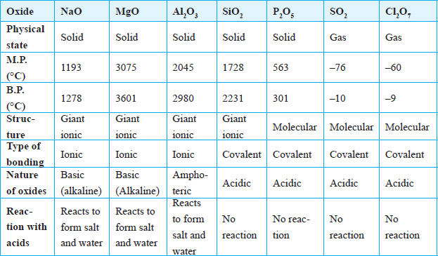**silicon (IV) oxide does not dissolve in water.**
* Oxides of sodium and magnesium react with acids to form a salt and water.
* Aluminium oxide reacts with both acids and alkalis and therefore it is an amphoteric oxide.
* Oxides of the non-metals do not react with acids but react with alkalis.
* All the oxides of elements in period 3 **except** those of **sulphur and chlorine** are **solids**. Sulphur (IV) oxide is a **gas** at room temperature. Several gaseous oxides of chlorine do exist, however they cannot be prepared in the laboratory.

Discussion Questions

1. **Explain why sulphur (IV) oxide is a gas at room temperature.**

The atoms of sulphur and oxygen are held together by covalent bonds but the molecules of sulphur (IV) oxide are attracted to each other by weak van der Waals forces.

1. **Why is the melting point of magnesium oxide higher than that of sodium oxide?**

Both sodium oxide and magnesium oxide have a giant ionic structure. However, the melting point of magnesium oxide is higher because the electrostatic forces of attraction between magnesium ions and oxide ions are stronger. This is due to the fact that the magnesium ion has a charge of +2 and is smaller in size than the sodium ion.

1. **Explain the high melting and boiling points of silicon (IV) oxide.**

Silicon (IV) oxide has a giant covalent structure. Each silicon atom is attached to four oxygen atoms and each oxygen atom is attached to two silicon atoms. Silicon uses all its valency electrons to form strong covalent bonds with oxygen. The covalent bonds in silicon are extra ordinarily strong. This explains the high melting point of silicon (2231°C).

**4.   What is the general trend in the bond types of the oxides of elements across period 3?**

In general the bond types change from ionic to covalent across the period. The structure of the oxides changes from giant ionic, to giant atomic and finally to molecular. This explains the trends in properties of the oxides.

## Chlorides of Elements in Period 3

Most elements of period 3 form stable chlorides.

The trend in bond types, structure and properties of chlorides of period 3 elements show variation across the period as shown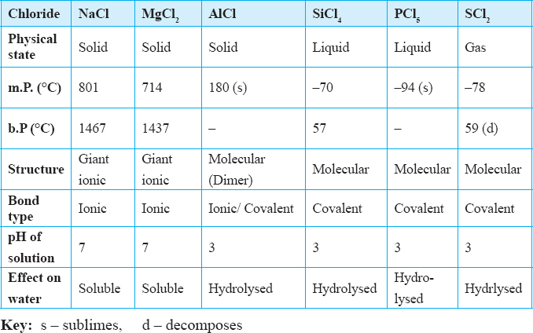in the table below.

Discussion Questions

**Explain how the chlorides of elements in Period 3 dissolve in water.**

* Sodium chloride dissolves in water resulting in a **slight drop in temperature.**

Magnesium chloride dissolves readily with a **small increase in temperature.** Both chlorides form **neutral solutions. These chlorides are ionic and therefore fully dissociate into ions.**

* **Anhydrous aluminium chloride** differs from the other metallic chlorides because **it exists in molecular form.** Aluminium combines with chlorine by forming covalent bonds to form a molecule of aluminium chloride (Al2Cl3). Two aluminium chloride molecules then combine through coordinate bonds to form a **dimer** as shown below.

** *Formation of a dimer in aluminium chloride*

Aluminium chloride **is hydrolysed** by water to form an **acidic solution** and therefore **behaves as a covalent rather than an ionic chloride.**

Hydrolysis is a reaction that involves breaking down a substance by water.

**Molecular chlorides undergo hydrolysis**.

* Silicon (IV) chloride is also hydrolysed by water to form a solution which is acidic. Alot **of heat is given out** and fumes of hydrogen chloride gas are given out.

Silicon (IV) chloride + Water  Silicon (IV) Oxide + Hydrogen chloride

SiCl4(l) + 2H2O (l)  SiO2(s) + 4HCl(aq)

* Phosphorus (III) chloride or phosphorus (V) chloride react vigorously with water to form an acidic solution. A lot of **heat is also evolved** and this makes the temperature of the water to rise.

Phosphorus (III) chloride + Water  Phosphorous acid + Hydrogen chloride

PCl3(s) + 3H2O(l)  H3PO3(s) + 3HCl(g)

Phosphorus (V) chloride + Water  Phosphoric acid + hydrogen chloride

PCl5(s) + 4H2O(l)  H3PO4(aq) + 5HCl(aq)

### Summary of Characteristics of Bonds

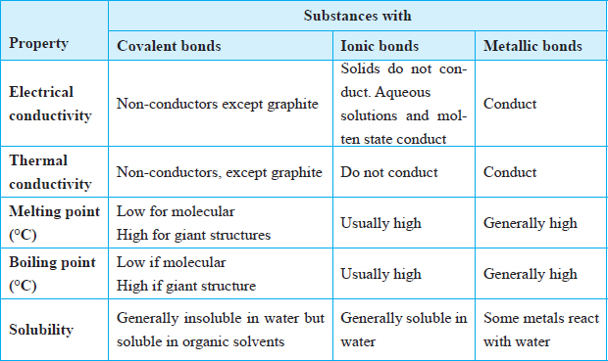

* 1. 2006 Q 5 P1

The atomic numbers of elements C and D are 19 and 9 respectively. State and explain the electrical conductivity of the compound CD in:

1. Solid state (1½marks)
2. aqueous state. (1½ marks)
   1. 2006 Q 20 P1
   2. Distinguish between a covalent bond and a co-ordinate bond. (2 marks)
   3. Draw a diagram to show bonding in an ammonium ion. (1 mark)
   4. 2006 Q21 P1
      * 1. Explain why the metals magnesium and aluminium are good conductors of electricity. (1 mark)
        2. Other than cost, give two reasons why aluminium is used for making electric cables while magnesium is not. (2 marks)
   5. 2007 Q 3b P2

Both chlorine and iodine are halogens.

* 1. What are halogens? (1mark)
  2. In terms of structure and bonding, explain why the boiling point of chlorine is lower than that of iodine. (2 marks)
  3. 2007 Q 29 P1

The diagram below is a section of a model of the structure of element T.

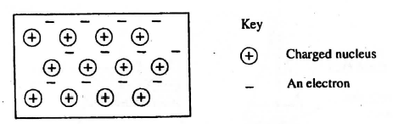

1. State the type of bonding that exists in T. (1 mark)
2. In which group of the period table does element T belong? Give a reason. (2 marks)
   1. 2007 Q 5a-c P2
3. The diagram below represents part of the structure of a sodium chloride crystal. The position of one of the sodium ions in the crystal is shown as **⌖**

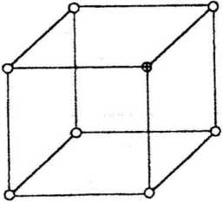

1. On the diagram, mark the position of the other three sodium ions (2 marks)
2. The melting and boiling points of sodium chloride are 801°C and 1413°C respectively. Explain why sodium chloride does not conduct electricity at 25°C, but does so at temperatures between 801° C and 1413°C (2 marks)
3. Give a reason why ammonia gas is highly soluble in water (2 marks)
4. The structure of an ammonia ion is shown below:

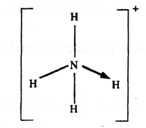

Name the type of bond represented in the diagram by N→ H (1 mark)

* 1. 2008 Q 11 P1

The table below gives atomic numbers of elements represented by the letters A, B, C and D.

|  |  |  |  |  |
| --- | --- | --- | --- | --- |
| **Element** | **A** | **B** | **C** | **D** |
| **Atomic number** | 15 | 16 | 17 | 20 |

Use the information to answer the questions that follow.

1. Name the type of bonding that exists in the compound formed when A and D react (1 mark)
2. Select the letter which represents the best oxidizing agent. Give a reason for your answer. (2 marks)
   1. 2008 Q 2b P2

The table below gives information about elements A1, A2, A3 and A4

|  |  |  |  |
| --- | --- | --- | --- |
| **Element** | **Atomic**  **Number** | **Atomic**  **Radius (nm)** | **Ionic radius (nm)** |
| A1 | 3 | 0.134 | 0.074 |
| A2 | 5 | 0.090 | 0.012 |
| A3 | 13 | 0.143 | 0.050 |
| A4 | 17 | 0.099 | 0.181 |

1. In which period of the periodic table is element A2? Give a reason. (2 marks)
2. Explain why the atomic radius of:
3. A1 is greater than that of A2;
4. A4 is smaller than its ionic radius (2 marks)
5. Select the element which is in the same group as A3 (1 mark)
6. Using dots (.) and crosses(x) to represent outermost electrons, draw a diagram to show the bonding in the compound formed when A1 reacts with A4 (1 mark)
   1. 2009 Q 3 P1

The atomic number of sulphur is 16. Write the electron arrangement of sulphur in the following (2 marks)

(a) H2S

(b) SO32-

* 1. 2009 Q 5 P1

In terms of structure and bonding, explain why the melting point of oxygen is much lower than that of sodium. (3 marks)

* 1. 2009 Q 8 P1

Using dots (.) and crosses (X), show bonding in:

1. The compound formed when nitrogen reacts with fluorine. (Atomic numbers F= 9, N=7) (2 marks)
2. Sodium oxide. (Atomic numbers Na = 11, O= 8) (1 mark)
   1. 2009 Q17 P1

The structure of methanoic acid is

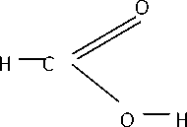

What is the total number of electrons used for bonding in a molecule

of methanoic acid? Give reasons. (2 marks)

* 1. 2009 Q 24 P1

The boiling points of some compounds of hydrogen with some elements in groups 4 and 6 of the periodic table are given below.

|  |  |  |  |
| --- | --- | --- | --- |
| **Compound** | **Boiling point(°C)** | **Compound** | **Boiling point(°C)** |
| CH4 | -164.0 | H2O | 100.0 |
| SiH4 | -112.0 | H2S | -61.0 |

* 1. Which of the compounds CH4and SiH4 has the stronger intermolecular forces? (1 mark)
  2. Explain why the boiling point of H2O and H2S show different trends from that of CH4 and SiH4. (2 marks)
  3. 2009 Q 6a, c P2

1. Study the table below and complete it.(W- and X4+ are not the actual symbols of the ions)

|  |  |  |  |  |
| --- | --- | --- | --- | --- |
| Ion | Number of  Protons | Number of neutrons | Mass Number | Electron Arrangement |
| W- |  | 20 |  | 2.8.8 |
| X4+ | 14 |  | 28 |  |

1. The atomic numbers of Na and Mg are 11 and 12 respectively. Which of the element has higher ionization energy? Explain. (2 marks)
   1. 2010 Q 14 P1
2. Using electrons in the outermost energy level, draw the dot (.) and cross (x) diagram for the molecules H2O and C2H4. (H = 1, C = 6, O = 8) (2 marks)
   1. H2O
   2. C2H4
3. The formula of a complex ion is [Zn(NH3)4]2+. Name the type of bond that is likely to exist between zinc and ammonia in the complex ion. (1 mark)
   1. 2010 Q 27 P1

The atomic numbers of phosphorus, sulphur and potassium are 15, 16 and 19 respectively. The formulae of their ions are P3-, S2- and K+. These ions have the same number of electrons.

1. Write the electron arrangement for the ions. (1 mark)
2. Arrange the ions in the order of increasing ionic radius starting with the smallest. Give a reason for the order. (2 marks)
   1. 2010 Q 3 P2

Use the information in the table below to answer the questions that follow.

The letters do not represent the actual symbols of the elements.

|  |  |  |
| --- | --- | --- |
| **Element** | **Atomic number** | **Melting point (°C)** |
| R | 11 | 97.8 |
| S | 12 | 650.0 |
| T | 15 | 44.0 |
| U | 17 | -102 |
| V | 18 | -189 |
| W | 19 | 64.0 |

* 1. Give the reasons why the melting point of:

1. S is higher than that of R (1 mark)
2. V is lower than that of U (1 mark)
   1. How does the reactivity of W with chlorine compare with that of R with chlorine? Explain (2 marks)
   2. Write an equation for the reaction between T and excess oxygen (1 mark)
   3. When 1.15g of R was reacted with water, 600cm3 of gas was produced. Determine the relative atomic mass of R. (Molar gas volume = 24000 cm3) (3 marks)
   4. Give one use of element V (1 mark)
   5. 2011 Q 5b(iii-vii) P2

The table below gives the number of electrons, protons and neutrons in particles A, B, C, D, E, F and G.

|  |  |  |  |
| --- | --- | --- | --- |
| **Particle** | **Protons** | **Electrons** | **Neutrons** |
| A | 6 | 6 | 6 |
| B | 10 | 10 | 12 |
| C | 12 | 10 | 12 |
| D | 6 | 6 | 8 |
| E | 13 | 10 | 14 |
| F | 17 | 17 | 18 |
| G | 8 | 10 | 8 |

1. Which particle is likely to be a halogen? (1 mark)
2. What is the mass number of E? (1 mark)
3. Write the formula of the compound formed when E combines with G. (1 mark)
4. Name the type of bond formed in (iii) above (1 mark)
5. How does the radii of C and E compare? Give a reason. (2 marks)
6. Draw a dot (.) and cross (x) diagram for the compound formed between A and F. (1 mark)
7. Why would particle B not react with particle D? (1 mark)
   1. 2011 Q 28 P1

The diagram below shows the bonding between aluminium chloride and ammonia.

1. Name the types of bonds that exist in the molecule. (1 mark)
2. How many electrons are used for bonding in the molecule? (1 mark)
   1. 2012 Q7 P1, 2016 Q6 P1

Ammonium ion has the following structure:

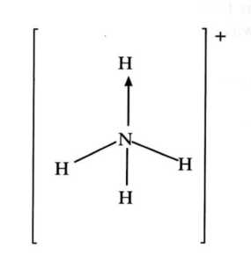

Label on the structure:

* 1. Covalent bond; (1 mark)
  2. Coordinate (dative) bond. (1 mark)
  3. 2012 Q 16 P1

Use the following information on substances S, T and hydrogen to answer the questions that follow:

* + 1. T displaces V from a solution containing V ions
    2. hydrogen reacts with the heated oxide of S but has no effects on heated oxide of V.

1. Arrange substances S, t, V and hydrogen in the order of increasing reactivity. (2 marks)
2. If T and V are divalent metals, write an ionic equation for the reaction in (i) above. (1 mark)

* 1. 2012 Q 2 P2

The grid below is part of the periodic table. Use it to answer the questions that follow. (the letters are not the actual symbols of the elements).

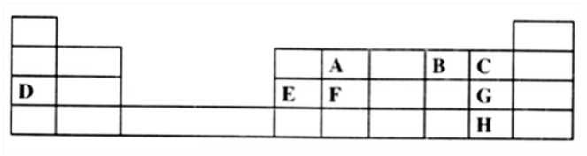

1. Which is the most reactive non-metallic element shown in the table? Explain . (2 marks)
2. (i) Write the formula of the compound formed when element **A** reacts with element **B** (1 mark)

(ii) Name the bond type in the compound formed in b(i) above (1 mark)

1. (i) What is the name given to the group of elements where, **C**, **G** and **H** belong?

(ii) Write an equation for the reaction that occurs when C in gaseous form is passed through a solution containing ions of element H. (1 mark)

1. The melting points of elements **F** and **G** are 1410 °C and -101 °C respectively. In terms of structure and bonding, explain why there is a large difference in the melting points of **F** and **G**. (2 marks)
2. **D** forms two oxides. Write the formula of each of the two oxides. (1 mark)
3. **J** is an element that belongs to the 3rd period of the periodic table and a member of the alkaline earth elements. Show the position of **J** in the grid (1 mark)
   1. 2013 Q 4 P1

In terms of structure and bonding, explain the following observations:

1. The melting point of aluminium is higher than that of sodium. (1½mark)
2. Melting point of chlorine is lower than that of sulphur (1½ mark)
   1. 2014 Q21 P1

Given that the atomic number of Y is 13 and that of Z is 9:

1. Write the electronic arrangement of Y and Z; (1 mark)
2. Draw the dot (.) and cross(x) diagram for the compound formed by Y and Z. (1 mark)
   1. 2016 Q16 P1

The atomic number of sulphur is 16. Write the electron arrangement of sulphur in the following:

(a) H2S (1 mark)

(b) SO32- (1 mark)

* 1. 2017 Q21 P1.

The atomic numbers of some elements **P**, **Q**, **R** and **S** are 6, 8, 12 and 17 respectively.

(a) Draw the dot (•) and cross (X) diagrams for the compounds formed when:

(i) **R** and **Q** react (1 mark)

(ii) **P** and **S** react. (1 mark)

(b) Explain why the melting point of the compound formed by **P** and **S** is lower than that formed by **R** and **Q**. (1 mark)

* 1. 2018 P1

In terms of structure and bonding, explain why graphite is used as a lubricant in machines. (3 marks)

* 1. 2018 Q11 P1

Element U has atomic number 12 while element V has atomic number 16. How do the melting points of their oxides compare? Explain. (3 marks)

* 1. 2019 P1 Q8.

Table 1 shows the properties of two chlorides, D and E.

Table 1

|  |  |  |
| --- | --- | --- |
| Chloride | Melting Points(°C) | Electrical Conductivity(liquid) |
| D | 1074 | Good |
| E | 203 | Poor |

(a) State the type of bond present in:

(i) D....................... (1 mark)

(ii) E....................... (1 mark)

(b) Explain in terms of structure and bonding, the difference in electrical activity of the chlorides D and E. (1 mark)

**SALTS**

**Table of Contents**

Types of Salts - 2 -

Solubility of Salts and Bases in Water - 3 -

Solubility of Salts in Water - 3 -

Solubility of Bases in Water - 3 -

How to obtain crystals of a salt from a solution - 4 -

3. Methods of Preparing Salts - 5 -

Preparation of Soluble salts - 6 -

Preparation of insoluble salts - 10 -

Effects of exposing salts to the atmosphere - 12 -

Uses of Salts - 12 -

6. Action of heat on salts - 13 -

Action of Heat on Carbonates - 13 -

Action of Heat on Nitrates - 14 -

Effect of heat on sulphates. - 16 -

Review Exercises - 17 -

**Chapter objectives**

**By the end of this chapter, the learner should be able to:**

(a)   Define a salt.

(b)   State and describe the types of salts.

(c)   Identify soluble and insoluble salts.

(d)   State the methods of preparing soluble and insoluble salts.

(e)   Define the terms: saturated solution, crystallisation, neutralisation and precipitation.

(f)   Write ionic equations for the preparation of insoluble salts.

(g)   State the effect of heat on salts.

(h)   State the uses of some salts.

**SALTS**

A **salt** is *a substance that is formed when* ***the hydrogen ions in an acid arewholly or partially*** *replaced by* ***a positive ion*.**

# Types of Salts

There are four types of salts namely; normal salts, acid salts, basic salts and double salts.

### Normal salts

A **normal salt** *is a salt that* ***does not*** *contain any* ***replaceable hydrogen atom*.**

Some examples of normal salts are sodium chloride (NaCl), potassium sulphate (K2SO4) sodium carbonate (Na2CO3) and calcium nitrate (Ca(NO3)2). These salts are **neutral** in aqueous state.

### **Acid salts**

**Acid salts** *are salts that* ***contain a replaceable hydrogen atom*.**

Some examples are sodium hydrogen carbonate (NaHCO3), potassium hydrogen sulphate (KHSO4) and sodium dihydrogen phosphate (NaH2PO4). They have **acidic** properties due to the presence of **replaceable hydrogen**.

### **Basic salts**

**Basic salts** *are salts that contain* ***hydroxyl (OH–) i****ons*.

It is the presence of hydroxyl ions in these salts that is responsible for the basic properties. Examples are basic magnesium chloride(Mg(OH)Cl, basic lead (II) carbonate (Pb(OH)2.PbCO3), basic zinc chloride (Zn(OH)Cl) and basic copper (II) carbonate (CuCO3).Cu(OH)2).

### **Double salts**

**Double salts** *are salts in which there are* ***two different anions or cations*.**

Examples are hydrated potassium aluminium sulphate (KAl(SO4)2.12H2O) hydrated ammonium iron (II) sulphate (Fe(NH4)(SO4).6(H2O) and trona (Na2CO3. NaHCO3.2H2O).

# Solubility of Salts and Bases in Water

## Solubility of Salts in Water

***Discussion Questions***

1. **Which cations form salts that are soluble in water?**

•    All potassium, sodium and ammonium salts are soluble in water.

**2. Comment on the solubility of sulphate, chlorides, nitrates and carbonates**

•    All nitrates are soluble.

•    All sulphates are soluble except those of barium and lead. Calcium sulphate is slightly soluble.

•    All chlorides are soluble except lead (II) chloride and silver chloride. Lead (II) chloride is insoluble in cold water but soluble when hot.

•    All carbonates are **insoluble** except those of Group I metals and ammonium. Carbonates of aluminium and iron do not exist.

***Summary of Solubility of Common Salts***

|  |  |
| --- | --- |
| **SALTS** | **SOLUBILITY IN WATER** |
| **Carbonates** | **All are insoluble except potassium sodium and ammonium carbonate.** |
| **Chlorides** | **All are soluble except silver and lead (II) chloride. Lead (II) chloride is soluble in hot water.** |
| **Nitrates** | **All are soluble** |
| **Sulphates** | **All are soluble except barium sulphate and lead(II) sulphate. Calcium sulphate is slightly soluble.** |
|  | **All potassium, sodium and ammonium salts are soluble in water** |

## Solubility of Bases in Water

***Discussion Questions***

1. **Which oxides areSoluble? What is the nature of the bases formed?**

* The oxides potassium and sodium are **soluble** in water.
* The oxides of calcium and magnesium are **slightly soluble**.
* The solution formed is alkaline and turns red litmus paper blue.

Calcium oxide + water  Calcium hydroxide

CaO(s) + 2H2O(l) Ca(OH)2 (aq)

Magnesium oxide + water  Magnesium hydroxide

MgO(s) + H2O(l) Mg(OH)2 (aq).

1. **Which Oxides are Insoluble?**

* The oxides of zinc , aluminium, lead, iron and copper are insoluble in water.

**Ammonium oxide does not exist.**

1. **Which hydroxides are Soluble? What is the nature of the solutions formed?**

* Potassium and sodium hydroxides are soluble in water.
* The hydroxides of calcium and magnesium are slightly soluble.
* The resulting solutions are**alkaline** and **turn red litmus blue**.

Potassium hydroxide + water  Potassium hydroxide solution

KOH(s) + water  KOH (aq)

Sodium hydroxide + water  Sodium hydroxide solution

NaOH(s) + water  NaOH(aq)

**4. Which hydroxides are Insoluble?**

* The **hydroxides** of **zinc, aluminium, iron, lead and copper are insoluble in water**.
* Ammonia is a base and dissolves in water to form aqueous ammonia.

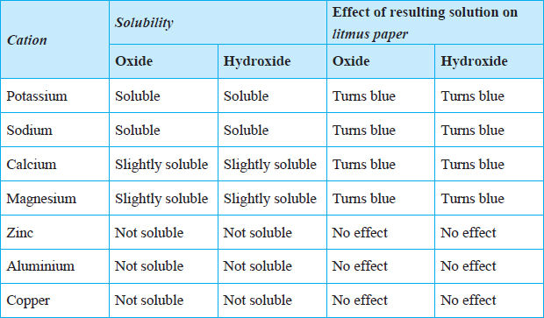

### **How to obtain crystals of a salt from a solution**

It is possible to obtain crystals of a salt from a solution by evaporating the solvent.

For example, toobtain crystals of copper (II) sulphate obtained from a solution of copper (II) sulphate, the following procedure is used:

Measure about 20 cm3 of water in a beaker. Add a spatulaful of copper (II) sulphate crystals in the beaker and stir. Continue adding until it does not dissolve anymore. Decant a portion of the solution into an evaporating dish. Place the evaporating dish on a water bath and heat.

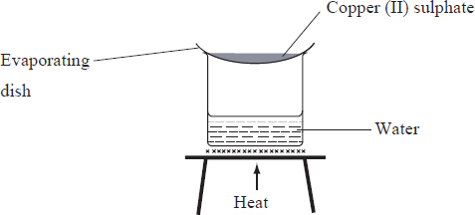Evaporate the solution until it is about to form crystals. To find out if this point has been reached, dip a clean glass rod into the solution and hold it up in the air to cool. Examine the rod to find out whether the crystals have formed on it. Continue heating until crystals are seen on the glass rod when the rod is dipped in the solution. Allow the solution to cool slowly to form crystals. Observe the crystals with a hand lens.

To obtain larger crystals, cover the evaporating dish with a perforated paper. Leave the set-up undisturbed and observe after 12 hours. Filter off the crystals and dry them between filter papers.

***Discussion Questions***

**1.   How can you tell whether a solution has dissolved as much copper (II) sulphate as possible?**

When the blue solution becomes **saturated** such that no more of thesalt can dissolve and some crystals remain at the bottom of the beaker.

A **saturated solution** *is one that cannot dissolve any more solute at a given temperature*.

1. **What happens as the saturated solution cools?**

As the hot saturated solution cools, it forms **solid particles with a regular shape.** These solid particles are called **crystals** and the process is referred to as **crystallisation**.

1. **Explain why the solution is not evaporated to dryness.**

Evaporation is not done to dryness so that larger crystals may form. Slow cooling allows the salt to form large crystals. Otherwise the crystals formed would be small.

1. **Why are the crystals not dried by heating?**

Crystals of copper (II) sulphate are not dried by heating because heating would drive out water of crystallisation to leave behind a powder, anhydrous copper (II) sulphate.

1. **What is water of crystallization? How important is it?**

*The fixed amount of water incorporated within the crystal structure of a salt* is called **water of crystallisaton**.

Water of crystallisation is important in the formation of crystals for hydrated salts.

**Hydrated salts** are salts which contain water of crystallization.

Examples of hydrated salts include; sodium carbonate decahydrate (Na2CO3.10H2O), Iron (II) sulphate heptahydrate (FeSO4.7H2O).

# 3. Methods of Preparing Salts

The method chosen for preparation a specific salt may depend on the solubility of the salt in water.

## Preparation of Soluble salts

Soluble salts can be prepared in many ways.

### Reaction of an acid and a metal.

**The reaction of an acid and a metal is** suitable for the preparation of soluble salts such as zinc sulphate, magnesium nitrate, zinc chloride and calcium chloride.The metals are reacted with suitable acids.

**Equations**

Zinc + Sulphuric (VI) acid  Zinc sulphate + Hydrogen gas

Zn(s) + H2SO4(aq)  ZnSO4(aq) + H2(g)

Magnesium + Nitric acid  Magnesium nitrate + Hydrogen gas

Mg(s) + 2HNO3(aq) Mg(NO3)2 (aq) + H2 (g)

Zinc + Hydrochloric acid  Zinc chloride + Hydrogen gas

Zn(s) + 2HCl(aq)  ZnCl2(aq) + H2(g)

Calcium + Hydrochloric acid  Calcium chloride + Hydrogen gas

Ca(s) + 2HCl(aq)  CaCl2(aq) + H2(g)

The procedure below can be used to prepare **zinc (II) sulphate.**

Measure about 20 cm3 of dilute sulphuric acid (VI) acid and transfer it into a beaker. Add zinc powder a little at a time as you stir with a glass rod. Continue adding zinc powder until it is in excess. Filter the solution and pour the filtrate into an evaporating basin.

Evaporate the filtrate to saturation. To find out if this point has been reached, dip a glass rod into the solution and hold it up in air to cool. If cystals form on the tip of the rod, the solution is ready to form crystals and heating can be stopped to allow the now saturated solution to cool and evaporate slowly.

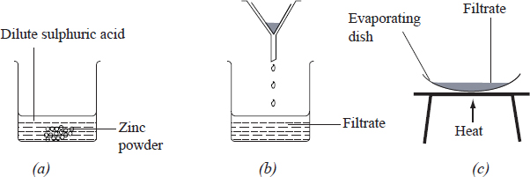

***Questions***

1. **Explain why zinc powder is added in excess.**

Excess zinc is used to ensure all the acid reacts completely.

1. **Why is filtration necessary in this experiment?**

The unreacted zinc is removed by filtration.

1. **Write an equation for the reaction between zinc powder and dilute sulphuric acid.**

Zinc reacts with dilute sulphuric (VI) acid to produce zinc sulphate and hydrogen gas. Effervescence stops when all the sulphuric acid has completely reacted with zinc powder.

Zinc + Sulphuric (VI) acid  Zinc sulphate + Hydrogen gas

Zn(s) + H2SO4(aq)  ZnSO4(aq) + H2(g)

The saturated salt solution is allowed to cool for zinc sulphate crystals to form. The process of obtaining salt crystals from a saturated solution by cooling is called **crystallisation**.

### Reaction of acids on insoluble bases

**The reaction of acids on insoluble bases** is another method of preparation of salts, ideal for preparation of soluble salts such as copper (II) sulphate. Other salts that can be prepared in a similar way are lead (II) nitrate, magnesium sulphate and calcium chloride.

Copper (II) oxide + Sulphuric (VI) acid  Copper sulphate + water

CuO(s) + H2SO4(aq)  CuSO4(aq) + H2O(l)

Lead (II) oxide + dilute nitric (V) acid  Lead nitrate + water

PbO(s) + 2HNO3(aq) Pb(NO3)2(aq) + H2O(l)

Magnesium oxide + dil. sulphuric (VI) acid  Magnesium sulphate + water

MgO(s) + H2SO4(aq)  MgSO4(aq) + H2O(l)

Calcium oxide + dil. hydrochloric acid  Calcium chloride + water

Ca(s) + 2HCl(aq)  CaCl2(aq) + H2O(l)

The **procedure below can be used to prepare copper (II) sulphate.**

Measure about 20 cm3 of dilute sulphuric (VI) acid and pour it into a glass beaker. Warm the acid in the beaker. Using a spatula, add copper (II) oxide to the warm acid a little at a time while stirring with a glass rod until no more oxide can dissolve. Filter and collect the filtrate. Transfer the filtrate to the evaporating basin. Evaporate the filtrate over a water bath to saturation. Stop heating and allow the saturated solution to cool to form crystals. Dry the crystals between filter papers.

***Questions***

1. **Why was copper (II) oxide added in excess?**

Excess copper (II) oxide is used to ensure that all the acid has reacted.

1. **Explain why the acid was warmed before adding copper (II) oxide?**

Since the reaction between the acid and the oxide is slow, warming speeds up the reaction.

1. **Besides the salt, what is the other product?**

The reaction between copper (II) oxide and dilute sulphuric (VI) acid produces a salt and water only. This type of reaction is called **neutralisation**.

**4.   Why was evaporation done over a water bath?**

Evaporation of the filtrate is carried out over a water bath to ensure slow evaporation and formation of large crystals.

**5.   Write an equation for the reaction between copper (II) oxide and dilute sulphuric acid.**

Copper (II) oxide + Sulphuric (VI) acid  Copper sulphate + water

CuO(s) + H2SO4(aq)  CuSO4(aq) + H2O(l)

### Neutralization: Reaction of acids on soluble bases

**A Neutralisationreaction is a** *reaction in which only a salt and water is formed*.

The action of acids on soluble bases is an example of a neutralization reaction and is used to prepare some soluble salts. Sodium chloride, potassium nitrate, ammonium chloride, ammonium sulphate and sodium sulphate are prepared by thismethod.

The equations given are for the reactions between various acids and bases to produce salts.

Sodium hydroxide + hydrochloric acid  Sodium chloride + water

NaOH(aq) + HCl(aq)  NaCl(aq) + H2O(l)

Potassium hydroxide + Nitric acid  Potassium nitrate + water

KOH(aq) + HNO3(aq)  KNO3(aq) + H2O(l)

Ammonium hydroxide + Hydrochloric acid  Ammonium chloride + water

NH4OH (aq) + HCl(aq)  NH4Cl(aq) + H2O(l)

Sodium hydroxide + Sulphuric (VI) acid  Sodium sulphate + water

2NaOH(aq) + H2SO4(aq)  Na2SO4(aq) + 2H2O(l)

**The procedure below can be used to prepare sodium chloride.**

Measure 25 cm3 of dilute hydrochloric acid and pour it in a beaker. Dip universal indicator paper into the beaker. Record the pH. Measure 25 cm3 of sodium hydroxide and pour it in another beaker. Record its pH also. Add 2–3 drops of phenolphthalein into the sodium hydroxide. Pour the hydrochloric acid slowly into the beaker containing sodium hydroxide until the pink colour just disappears. Test the resultant solution with universal indicator paper. Pour about 25 cm3 of the resultant solution into a clean evaporating basin, evaporate the solution until it is saturated. Allow the saturated solution to cool for crystals to form.

***Questions***

1. **Explain the role of phenolphthalein in this experiment.**

Phenolphthalein indicator is pink in alkaline solutions and colourless in acidic solutions. It is used in this reaction to determine when the reaction is over, the point at which just enough of the acid has been added to exactly neutralise the alkali. This point is known as the **end point**.

Universal indicator paper **shows a range of colours** in alkaline and acidic solutions. It is blue in sodium hydroxide and red in hydrochloric acid. It is not very suitable for determining the end point of an acid base reaction.

1. **Write an equation for the reaction that takes place between sodium hydroxide and hydrochloric acid.**

Sodium hydroxide + hydrochloric acid  Sodium chloride + water

NaOH(aq) + HCl(aq)  NaCl(aq) + H2O(l)

### **Reaction of acids with carbonates**

**The reaction of acids with carbonates** is another suitable method for preparing soluble salts such as lead nitrate, which can be prepared by reacting lead carbonate with dilute nitric (V) acid.

Lead(II) carbonate + Nitric (IV) acid  Lead nitrate + Carbon(IV) oxide + Water

PbCO3(a) + 2HNO3(aq) Pb(NO3)2 + CO2(g) *+* H2O (l)

Other salts such as calciumchloride, sodium nitrate, zinc nitrate and ammonium sulphate can also be prepared by reacting suitable acids with their corresponding carbonates.

The **procedure below can be used to prepare lead nitrate.**

Measure about 25 cm3 of dilute nitric (V) acid and pour it into a glass beaker. Warm the acid in the beaker gently. Add lead (II) carbonate to the warm acid, a little at a time and stir. Continue adding the carbonate while stirring until effervescence stops. Stop warming and filter off the unreacted carbonate. Evaporate the filtrate to saturation and allow it to form crystals.

***Questions***

1. **What are the products of the reaction? Write an equation for the reaction between lead (II) carbonate and nitric acid.**

When lead (II) carbonate is added to the warm nitric acid, there is immediate effervescence. The effervescence is due to production of carbon (IV) oxide gas.

Lead(II) carbonate + Nitric (IV) acid  Lead nitrate + Carbon(IV) oxide + Water

PbCO3(a) + 2HNO3(aq) Pb(NO3)2 + CO2(g) *+* H2O (l)

**2. Write equations to show how the following salts may be prepared from their corresponding carbonates.**

**(i)    Zinc nitrate.**

Zinc carbonate + Nitric (IV) acid  Zinc nitrate + carbon (IV) oxide + Water

ZnCO3(s) + 2HNO3(aq) Zn(NO3)2 (aq) + CO2(g) + H2O(l)

**(ii)   Calcium chloride.**

Calcium carbonate+ Hydrochloric acid  Calcium chloride + carbon (IV) oxide + water

CaCO3(s) + 2HCl(aq)  CaCl2(aq) + CO2(g) + H2O(l)

**(iii)   Ammonium sulphate.**

Ammonium carbonate + Sulphuric (VI)acid  Ammonium sulphate + Carbon (IV) oxide + Water

(NH4)2CO3(s) + H2SO4(aq)  (NH4)2SO4(aq) + CO2(g) + H2O(l)

1. **Sodium nitrate.**

Sodium carbonate + Nitric (IV) acid  Sodium nitrate + Carbon (IV) oxide + Water

Na2CO3(s) + 2HNO3(aq)  2NaNO3(aq) + CO2(g) + H2O(l)

### Preparation of salts by Direct Combination of Elements

Salts can also be prepared by reacting a metal with a non-metal. This method is called **direct synthesis**and is suitable for preparing **both soluble and insoluble salts**.

Iron (III) sulphide can be prepared this way by reacting iron with sulphur.

Iron + Sulphur  Iron (II) sulphide

Fe (s) + S(s) FeS(s)

Other salts that can be prepared by this method are sodium chloride and iron (III) chloride.

Sodium + Chlorine  Sodium chloride

2Na(s) + Cl2(g)  2NaCl(s)

Iron + Chlorine  Iron (III) chloride

2Fe(s) + 3 CL2(g)  2FeCl3(s)

***The procedure below can be used to prepare iron (II) sulphide.***

Put a spatulaful of iron filling in a crucible. To the same crucible add a spatulaful of sulphur. Mix them well. Heat the mixture strongly. When the reaction is complete, allow the products to cool.

***Questions***

**1.   What is the colour of:**

**(i)    Iron filings?**

The colour of iron is grey

**(ii)   Sulphur?**

The colour of sulphur is yellow

**(iii)   The product?**

The colour of the product is black. The black solid formed is iron (II) sulphide.

**2.   What was observed when the mixture was being heated?**

When a mixture of sulphur and iron fillings is strongly heated, it glows red even when the source of heat is removed. This shows that the reaction between iron and sulphur produces heat.

**3.   Write an equation between iron filings and sulphur.**

Iron + Sulphur  Iron (II) sulphide

Fe (s) + S(s) FeS(s)

## Preparation of insoluble salts

**Precipitation reactions** are suitable for preparing insoluble salts.

Reactions in which solids are formed from aqueous solutions are called **precipitation reactions.** The solids formed are referred to as **precipitates.**

In a precipitation reaction, the two reactants must be **soluble salts** and **one of the products must be insoluble.**

In these reactions, the metal ions of the salts simply exchange their anions. This type of reaction is called **double decomposition.**

In precipitation reactions, some ions undergo changes in their physical state ie from solid to aqueous or aqueous to solid. However, the state of other ions remain unchanged.

The ions that remain unchanged during a chemical reaction are called **spectator ions** and are omitted when writing **ionic equations.**

*The equation obtained by writing only those ions that undergo change during a chemical reaction is called an***ionic equation.**

**Examples of precipitation reactions are:**

**Barium nitrate + Zinc sulphate  Barium sulphate + Zinc nitrate**

Ba(NO3)2(Aq) + ZnSO4(aq)  BaSO4(s) + Zn(NO3)2(aq)

Ba2+(aq) + 2NO–3(aq) + Zn2+(aq) +SO2–4 BaSO4(s) + Zn2+(aq) + 2NO–3(g)

***Ionic equation:*** Ba2+(aq) + SO2–4 (aq)  BaSO4(s)

**Lead nitrate + Potassium iodide  Lead iodide + Potassium nitrate.**

Pb(NO3)2(aq) + 2KI(aq)  PbI2(s) + 2KNO3(aq)

Pb2+(aq) + 2NO–3(aq) + 2K+(aq) + 2I–(aq)  PbI2(s) + 2K+(aq) + 2NO–3(aq)

*Ionic equation:* Pb2+(aq) + 2I–(aq)  PbI2(s)

**Silver nitrate + Sodium chloride  Silver chloride + Sodium nitrate**

AgNO3(aq) + NaCl(aq)  AgCl(s) + NaNO3(aq)

Ag+(aq) + NO–3(aq) + Na+ + Cl–(aq)  AgCl(s) + Na+ (aq) + NO–3(aq)

*Ionic equation:* Ag+(aq) + Cl–(aq)  AgCl(s)

**Copper chloride + Sodium carbonate  Copper carbonate + Sodium chloride**

CuCl2(aq) + Na2CO3(aq)  CuCO3(s) + 2NaCl(aq)

Cu2+(aq) + 2Cl–(aq) + 2Na+(aq) +CO32–(aq)  CuCO3(s) + 2Cl–(aq) + 2Na+(aq)

*Ionic equation:* Cu2+(aq) + CO2–3(aq) CuCO(s)

### **The procedure below can be used to prepare lead (II) sulphate**

Put 10 cm3 of lead (II) nitrate in a beaker. To the same beaker, add excess magnesium sulphate solution. Stir the solution using a glass rod. Let the solid settle then decant the liquid. Wash the solid with distilled water. Filter and dry the solid between filter papers.

***Questions***

1. **Which ions are present in the reactants?**

The ions present in the reactants are lead (Pb2+), and nitrate (NO3–) ions from lead (II) nitrate; magnesium (Mg2+) and sulphate (SO42–) ions from magnesium sulphate.

1. **What observations are made when lead (II) nitrate and magnesium sulphate solutions are mixed?**

When lead (II) nitrate and magnesium sulphate solutions are mixed, a white solid is formed. When the two salt solutions react, lead sulphate and magnesium nitrate salts are formed.

In this reaction, the metal ions of the salts simply exchange their anions. Lead sulphate is formed as a white solid (precipitate).

1. **Write an equation for the reaction between lead (II) nitrate and magnesium sulphate.**

Lead (II) nitrate + Magnesium sulphate  Lead (II) sulphate + Magnesium nitrate

Pb(NO3)2(aq) + MgSO4(aq)  PbSO4(s) + Mg(NO3)2(aq)

Pb2+(aq) + 2NO–3(aq) + Mg2+(aq) + SO2–4(aq)  PbSO4(s) + Mg2+(aq) + 2NO–3(aq)

**4.   (i)    Name the solid formed in 3 above.**

Lead sulphate

**(ii)   Which ions react to form the solid.**

The ions in the salt solutions that react to form lead sulphate are lead ions (Pb2+) and sulphate ions (SO42–).

These ions are in aqueous state in the begining of the reaction and end up in the solid state at the end of the reaction. The ions undergo a change in their physical state.

**(iii)   Write an equation using the ions that form the solid.**

Pb2+(aq) + SO2–4(aq)  PbSO4(s)

Magnesium ions (Mg2+) and nitrate ions (NO–3) are thespectator ions since they are in aqueous state in the begining and at the end of the reaction, they remain unchanged through out the reaction.

# Effects of exposing salts to the atmosphere

Salts undergo some changes after some time when left in the open.

1. Saltsthat **absorbwater from the atmosphere and form solutions**are said to be **deliquescent** and the process is called **deliquescence.**

When **anhydrous calcium chloride** is exposed to the atmosphere overnight, it forms a colourless solution. The **shiny black crystals of iron (III) chloride** also form a **yellow solution.** This is because theyabsorb so much water from the atmosphere that they form solutions. Other deliquescent substances are **sodium hydroxide, calcium chloride, iron (II) chloride, potassium hydroxide and zinc chloride.**

1. Salts that **absorb water from the atmosphere but do not form solutions** are said to be **hygroscopic** and the process is called **hygroscopy**.

When **anhydrous copper (II) sulphate** is exposed to the atmosphere, the **white solid turns blue and becomes damp.** This is because it absorbs water from the atmosphere but does not dissolve. Examples of **hygroscopic salts** are **anhydrous cobalt (II) chloride, potassium nitrate** and **common table salt.**

NB: Pure sodium chloride **is not hygroscopic**, but common table salt is hygroscopic **because it contains other salts** such as **magnesium chloride** which makes it behave like a hygroscopic salt. It is the magnesium chloride, that absorbs water and makes the salt damp.

1. Salts which **lose some of their water of crystallisation**when exposed to the atmosphere are said to be **efflorescent**. The process is called **efflorescence**.

When crystals of **hydrated sodium carbonate (Na2CO3.10H2O)** are exposed to the atmosphere over-night a white powder is formed. This, is because the crystals lose some water of crystallisation to form a white powder, **sodium carbonate monohydrate. (Na2CO3.H2O)**. Other examples of efflorescent salts include **iron(II) sulphate heptahydrate, (FeSO4.7H2O) and Sodium sulphate deca-hydrate (Na2SO4.10H2O)**

# Uses of Salts

Salts are widely used. Some of the uses are:

1.   Fertilizers contain sodium nitrate, potassium sulphate and ammonium salts such as ammonium nitrate, ammonium sulphate and ammonium phosphate.

2.   Sodium chloride is used as a food additive while sodium hydrogen carbonate is used in baking powder.

3.   Calcium sulphate (Plaster of Paris) is used in hospitals on people with fractures or dislocations.

4.   Calcium chloride is used in road surfacing to keep the road moist due to its deliquescent nature, moisture absorbs dust.

5.   Calcium chloride is used in the extraction of sodium metal by electrolysis.

6.   Potassium nitrate is used for making fireworks and gunpowder.

7.   Sodium carbonate is used in the softening of hard water, making of glass and detergents.

8.   Many salts are used for de-frosting snow in cold countries during winter by lowering its freezing point. Calcium chloride is applied on roads to melt snow.

# 6. Action of heat on salts

Heat energy can bring about changes in substances when applied to them. Some salts undergo thermal decomposition when they are heated.

All ammonium salts decompose on heating.

## Action of Heat on Carbonates

***Discussion Questions***

1. **Which carbonates are not affected by heat? Explain.**

Pure **carbonates of sodium and potassium** are not affected by heat. Carbonates of these metals are **stable because of the high position of the metals in the reactivity series**.

If hydrated, the salts only lose their water of crystallisation. The water vapour condenses on the sides of the test tube as a colourless liquid. The residue is a white solid.

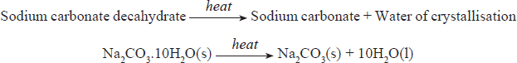

1. **Write equations for the reactions which occur when some carbonates are heated.**

The other metal carbonates decompose on heating to give off a colourless gas and the corresponding metal oxide. On testing the gas with calcium hydroxide, a white precipitate is formed confirming the gas to be carbon (IV) oxide.

The general equation is;



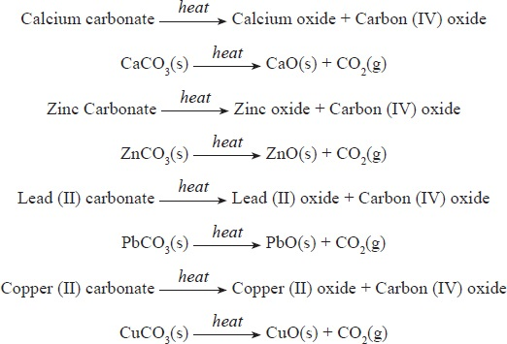

**3.   What is the relationship between ease of decomposition of a metallic carbonate and the position of the metal in the reactivity series?**

The **position of a metal i**n the reactivity series **determines the ease of decomposition of its carbonate.**

Ammonium carbonate decomposes to form ammonia gas, carbon (IV) oxide and steam. Presence of ammonia is confirmed by the turning of moist red litmus paper to blue.

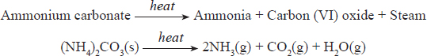

Hydrogen carbonates of metals high in the reactivity series decompose on heating to produce the corresponding metal carbonates, carbon (IV) oxide and water.

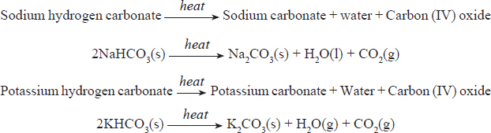The hydrogen carbonates of calcium and magnesium exist only in solution whereas hydrogen carbonates of aluminium and iron **do not exist.**

## Action of Heat on Nitrates

All nitrates decompose on heating.

***Discussion Questions***

**1.   Identify the products when each nitrate is heated.**

**2.   Write equations for the reactions that occur when the metal nitrates were heated.**

**3.   What is the general trend of the action of heat on nitrates?**

Potassium nitrate and sodium nitrate decompose to form oxygen and a white residue which is potassium nitrite and sodium nitrite respectively.

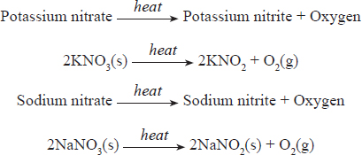

The nitrates of calcium, zinc, lead and copper decompose on heating to form the metal oxide, nitrogen (IV) oxide and oxygen gas.

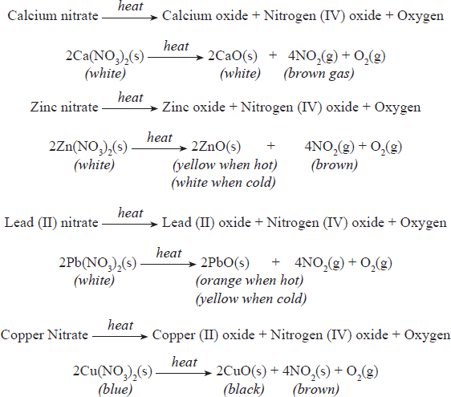

The general equation for the decomposition of nitrates is shown below;



The nitrates of silver and mercury decompose to give nitrogen (IV) oxide, oxygen and the corresponding metal.

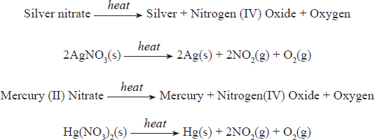

The general equation for the decomposition of these nitrates is:



The ease with which metal nitrates decompose on heating increases down the reactivity series of metals. Ammonium nitrate decomposes to give steam and nitrogen (I) oxide.

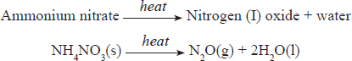

## Effect of heat on sulphates.

***Discussion Questions***

1. **Which sulphates are not affected by heat? Give a reason.**

The sulphates of **potassium, sodium, calcium and magnesium** are stable and are not affected by heat.

However, if hydrated they lose water of crystallisation on heating which condenses high up in the test tube.

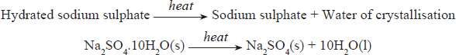

**2.   Write equations for the reactions that occur when some metal sulphates are heated.**

Zinc sulphate and copper (II) sulphate decompose on strong heating to form the metal oxide, water and sulphur (VI) oxide gas which is colourless. The gas turns moist blue litmus paper red.

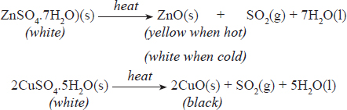

Iron (II) sulphate crystals decompose to give iron (II) oxide, sulphur (IV) oxide, sulphur (VI) oxide and water.

## ReviewExercises

1. 2006 Q 27 P1

Study the flow chart below and answer the questions that follow.

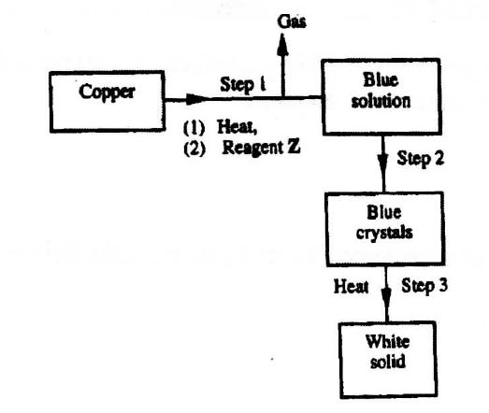

1. Name reagent **Z**. (1 mark)
2. Describe the process which takes place in step 2. (1 mark)
3. Identify the white solid. (1 mark)
4. 2007 Q 6 P1

In an experiment, a few drops of concentrated nitric acid were added to aqueous iron(II) sulphate in a test-tube. Excess sodium hydroxide solution was then added to the mixture.

* + - 1. State the observations that were made when:

1. Concentrated nitric acid was added to aqueous iron (II) sulphate (1 mark)
2. Excess sodium hydroxide was added to the mixture. (1 mark)
   * + 1. Write an ionic equation for the reaction which occurred in (a) (ii) above. (1 mark)
3. 2007 Q 9 P1

Study the flow chart below and answer the questions that follows.

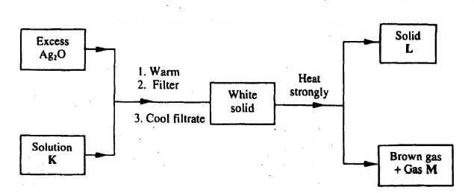

Identify:

1. Solution K
2. Solid L
3. Gas M (3 marks)
4. 2007 Q 13a(i) P1

Name the process that takes place when crystals of zinc nitrate change into solution when exposed to air (1 mark)

1. 2007 Q 18 P1

Starting with sodium metal, describe how a sample of crystals of sodium hydrogen carbonate may be prepared. (3 marks)

1. 2007 Q 3 P2

The flow chart below shows a sequence of chemical reactions starting with copper study it and answer the questions that follow.

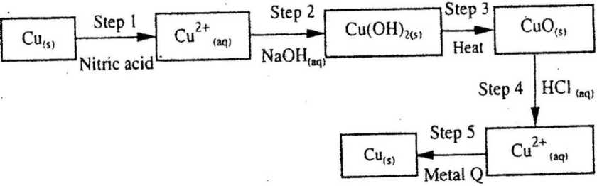

* 1. In step 1, excess 3M nitric acid was added to 0.5g of copper powder
     1. State two observations which were made when the reactions was in progress. (1 mark)
     2. Explain why dilute hydrochloric acid cannot be used in step 1 (2 marks)
     3. I. Write the equation for the reaction that took place in step 1 (1 mark)

II. Calculate the volume of 3M nitric that was needed to react completely with 0.5g of copper powder. (Cu = 63.5) (3 marks)

* 1. Give the names of the types of reactions that took place in steps 4 and 5 (1 mark)
  2. Apart from the good conductivity of electricity, state two other properties that make it possible for copper to be extensively used in the electrical industry. (2 marks)

1. 2008 Q 15 P1

The table below gives the solubilities of substances J, K and L at different temperatures

|  |  |  |  |  |
| --- | --- | --- | --- | --- |
| Substance | Solubility in grams per 100 g water at: | | | |
|  | 0°C | 20°C | 40°C | 60°C |
| J | 0.334 | 0.16 | 0.097 | 0.0058 |
| K | 27.60 | 34.0 | 40.0 | 45.5 |
| L | 35.70 | 36.0 | 40.0 | 37.3 |

Select the substance which, when dissolved in water, heat is given out. Give a reason. (2 marks)

1. 2008 Q 16

Starting with copper metal, describe how a sample of crystals of copper (II) chloride may be prepared in the laboratory. (3 marks)

1. 2008 Q 17

A compound whose general formula is M(OH)3 reacts as shown by the equation below.

M(OH)3(s) + OH-(aq)  M(OH)4-(aq)

M(OH)3(s) + 3H+(aq)  M3+(aq) + 3H2O(l)

1. What name is given to compounds which behave like M(OH)3 in the two reactions. (1 mark)
2. Name two elements whose hydroxides behave like that of M (2 marks
3. 2008 Q 17 P1

When solid B1 was heated, a gas which formed a white precipitate when passed through lime water was produced. The residue was dissolved in dilute nitric (V) acid to form a colourless solution B2. when dilute hydrochloric acid was added to solution B2 a white precipitate which dissolved on warning was formed.

* 1. Write the formula of the;

1. Cation in solid B1 (1 mark)
2. Anion in solid B1 (1 mark)
   1. Write an ionic equation for the reaction between the residue and dilute nitric (V) acid (1 mark)
3. 2008 Q 2 P2, 2016 Q7 P2
   1. Write an equation to show the effect of heat on the nitrate of:

(i) Potassium (ii) silver (2 marks)

* 1. The table below gives information about elements A1 , A2 , A3, and A4

|  |  |  |  |
| --- | --- | --- | --- |
| **Element** | **Atomic**  **Number** | **Atomic**  **Radius (nm)** | **Ionic radius (nm)** |
| A1 | 3 | 0.134 | 0.074 |
| A2 | 5 | 0.090 | 0.012 |
| A3 | 13 | 0.143 | 0.050 |
| A4 | 17 | 0.099 | 0.181 |

1. In which period of the periodic table is element A2? Give a reason.
2. Explain why the atomic radius of:

I A1 is greater than that of A2;

II A4 is smaller than its ionic radius (2 marks)

1. Select the element which s in the same group as A3 (1 mark)
2. Using dots (.) and crosses(x) to represent outermost electrons. Draw a diagram to show the bonding in the compound formed when A1 reacts with A4 (1 mark)
3. 2009 Q 11 P1

Starting with 50 cm3 of 2.8M sodium hydroxide, describe how a sample of pure sodium sulphate crystals can be prepared. (3 marks)

1. 2009 Q 18 P1

Bottle of sodium carbonate, sodium chloride and sugar have lost their labels. A Student prepares and tests an aqueous solution of a sample from each bottle. The results obtained are as shown in the table below.

|  |  |  |  |
| --- | --- | --- | --- |
| **Bottle** | **PH** | **Electrical conductivity** | **Correct label** |
| 1 | 7 | Conducts |  |
| 2 | 7 | Does not conducts |  |
| 3 | 10 | Conducts |  |

Complete the table by filling the correct label for each bottle. (3 marks)

1. 2009 Q 23 P1

Use the flow chart below to answer the questions that follow.

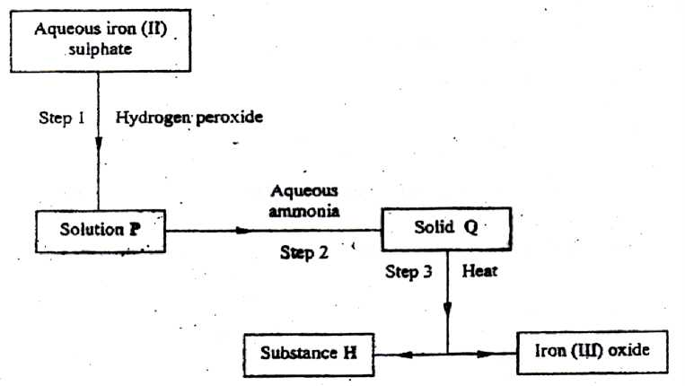

1. What observation would be made in step I (1 mark)
2. Name another substance that could be used in step 2 (1 mark)
3. Give the name of substance H. (1 mark)
4. 2009 Q 25 P1

For each of the following reactions, state the observation and write the formula of the compound responsible for the observation

(a) Bromide water is added to aqueous potassium iodine (1½ marks)

(b) Excess aqueous ammonia is added to copper (II) hydroxide (precipitate) (1½ marks)

1. 2010 Q 1 P1

(a) Distinguish between a deliquescent and a hygroscopic substance. (2 marks)

(b) Give one use of hygroscopic substances in the laboratory. (1 mark)

1. 2010 Q 5 P1

Hydrated cobalt (II) chloride exists as pink crystals and anhydrous cobalt (II) chloride is a blue powder. Describe a laboratory experiment that can be used to show that the action of heat on hydrated cobalt (II) chloride is a reversible reaction. (3 marks)

1. 2010 Q 24 P1

Describe how a solid sample of the double salt, ammonium iron (II) sulphate, can be prepared using the following reagents; Aqueous ammonia, sulphuric (VI) acid and iron metal. (3 marks)

1. 2011 Q 3 P1

A mixture contains ammonium chloride, copper (II) oxide and sodium chloride. Describe how each of the substances can be obtained from the mixture (3 marks)

1. 2011 Q 13 P1

Distinguish between the terms deliquescent and efflorescent as used in chemistry. (2 marks)

1. 2011 Q 30 P1

A sample of river water is suspected to contain zinc ions. Describe how the presence of zinc ions and sulphate ions can be established. (3 marks)

1. 2011 Q 4 P2
   1. When excess calcium metal was added to 50 cm3 of 2 M aqueous copper (II) nitrate in a beaker, a brown solid and bubbles of gas were observed.
   2. Write two equations for the reactions which occurred in the beaker. (2 marks)
   3. Explain why it is not advisable to use sodium metal for this reaction. (2 marks)
   4. Calculate the mass of calcium metal which reacted with copper (II) nitrate solution. (relative atomic mass of Ca=40) (2 marks)
   5. The resulting mixture in (a) above was filtered and aqueous sodium hydroxide added to the filtrate drop wise until in excess. What observations were made? (1 mark)
   6. (i) Starting with calcium oxide, describe how a sample of calcium carbonate can be prepared. (3 marks)

(ii) Name one use of calcium carbonate. (1 mark)

1. 2012 Q6 P1

Study the information in the table below and answer the questions that follow:

|  |  |  |
| --- | --- | --- |
| **Salt** | **Solubility (g/100g water)** | |
|  | At 40°C | At 60°C |
| CuSo4 | 28 | 38 |
| Pb(NO3)2 | 79 | 98 |

A mixture containing 35g of CuSO4 and 78g of Pb(NO3)2 in 100g of water at 60°C was cooled to 400C.

(a) Which salt crystallised out? Give a reason (2 marks)

(b) Calculate the mass of the salt that crystallised out. (1 mark)

1. 2012 Q16 P1

Use the following information on substances S, T, V and hydrogen to answer the questions that follow:

* 1. T displaces V from a solution containing V ions
  2. Hydrogen reacts with the heated oxide of S but has no effects on heated oxide of V.
  3. Arrange substances S, T, V and hydrogen in the order of increasing reactivity. (1 mark)
  4. If T and V are divalent metals, write an ionic equation for the reaction in (i) above. (2 marks)

1. 2012 Q25 P1

Describe how a solid sample of potassium sulphate can be prepared starting with 200cm3 of 2M potassium hydroxide. (3 marks)

1. 2012 Q6 P2

The flow chart below shows a sequence of reaction involving a mixture of two salts, mixture M. study it and answer the questions that follow.

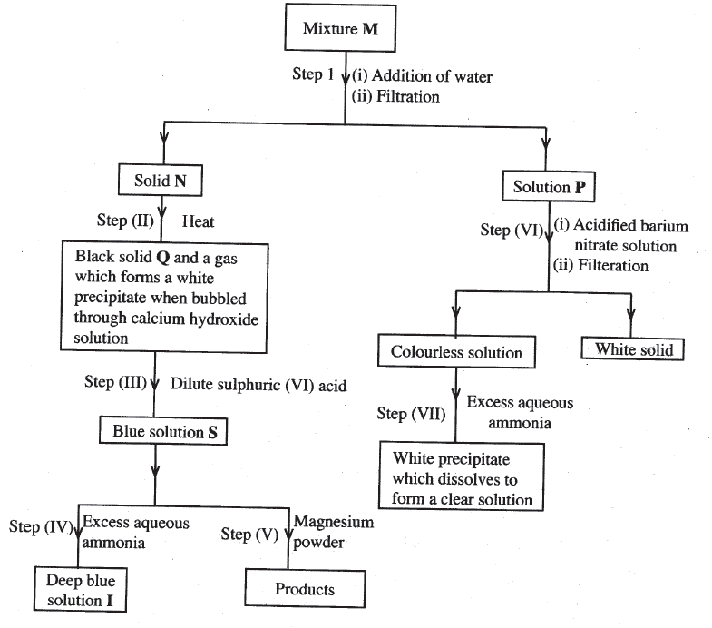

* + 1. Write the formula of the following

(i) Anion in solid **Q** (1 mark)

(ii) The two salts present in mixture **M** (2 marks)

* + 1. Write an ionic equation for the reaction in step (VI) (1 mark)
    2. State and explain the observations made in step (V) (3 marks)
    3. (i) Starting with Lead (II) oxide, describe how a pure solid sample of lead sulphate can be prepared in the laboratory (2 marks)

(ii) How can one determine whether the led sulphate prepared is pure? (2 marks)

1. 2013 Q2 P1

Write equations to show the effect of heat on each of the following:

(a) Sodium hydrogen carbonate (1 mark)

(b) Silver nitrate (1 mark)

(c) Anhydrous iron (II) sulphate (1 mark)

1. 2013 Q5 P1

The diagram below illustrates a method of preparing salts by direct synthesis

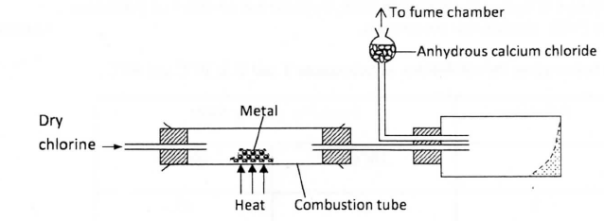

1. This method can be used to prepare either aluminium chloride or iron (III) chloride. Explain why it cannot be used to prepare sodium chloride. (2 marks)
2. Describe how a sample of sodium chloride can be prepared in the laboratory by direct synthesis. (2 marks)
3. 2013 Q26 P1

By using aqueous sodium chloride, describe how a student can distinguish calcium ions from lead ions

1. 2013 Q5a-b P2
2. Describe one method that can be used to distinguish between sodium sulphate and sodium hydrogen sulphate. (2 marks)
3. Describe how a pure sample of lead (II) sulphate can be prepared in the laboratory starting with lead metal. (2 marks)
4. 2014 Q 2 P1

When dilute hydrochloric acid was reacted with solid B, a colourless gas which extinguished a burning splint was produced. When an aqueous solution of solid B was tested with a blue litmus paper, the paper turned red / pink.

* 1. Identify the anion present in solid B. (1 mark)
  2. Write an ionic equation for the reaction between solid B and dilute hydrochloric acid. (1 mark)

1. 2014 Q5 P2
   1. The scheme below shows some of the reaction of solution D. Study it and answer the questions that follow

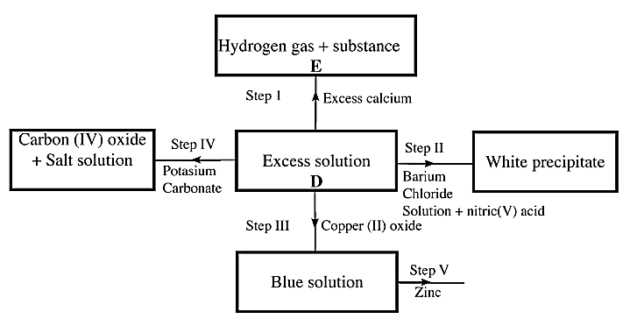

1. Give a possible caution present in solution D (1 mark)
2. Write an ionic equation for the reaction in Step II (1 mark)
3. What observations would be made in Step V? Give a reason (2 marks)
4. Explain why the total volume of hydrogen gas produced in step 1 was found to be very low although calcium and solution D were in excess. (2 marks)
5. State one use of substance E. (1 mark)
   1. Starting with solid sodium chloride, describe how a pure sample of lead (II) Chloride can be prepared in the laboratory (3 marks)
   2. (i) State a property of anhydrous calcium chloride which makes it suitable for use as a drying agent for chlorine gas. (1 mark)

(ii) Name another substance that can be used to dry chlorine gas (1 mark)

1. 2015 Q8 P1

When solid A was heated strongly, it gave off water and a solid residue. When water was added to the solid residue, the original solid A, was formed

(a) What name is given to the process described? (1 mark)

(b) Give one example of solid A (1 mark)

1. 2015 Q21 P1

Describe how samples of lead (II) sulphate, ammonium chloride and sodium chloride can be obtained from a mixture of the three. (3 marks)

1. 2015 Q25 P1

Starting with barium nitrate solution, describe how a pure sample of barium carbonate can be prepared in the laboratory. (3 marks)

1. 2016 Q5 P1

Starting with sodium metal, describe how a sample of crystals of sodium hydrogen carbonate may be prepared. (3 marks)

1. 2017 Q15 P1.

Starting with copper, describe how a pure sample of copper (II) carbonate can be prepared. (3 marks)

1. 2018 Q15 P1.

You are provided with solid potassium hydrogen carbonate. Describe how a solid sample of potassium nitrate can be prepared. (3 marks)

1. 2019 P1 Q24.

Starting with copper turnings, describe how a sample of copper (II) Sulphate crystals can be prepared in the laboratory. (2 marks)

**INTRODUCTION TO ELECTROLYSIS**

**(ELECTROLYTIC CELL)**

**1**.Electrolysis is defined simply as the **decomposition** of a **compound** by an electric current/**electricity**.

A compound that is decomposed by an electric current is called an electrolyte. Some electrolytes are **weak** while others are **strong**.

**2**.Strong electrolytes are those that are fully ionized/dissociated into (many) ions.

Common strong electrolytes include:

(i)all **mineral** acids

(ii)all strong **alkalis**/sodium hydroxide/potassium hydroxide. (iii)all soluble **salts**

**3**.Weak electrolytes are those that are partially/partly ionized/dissociated into (few) ions.

Common weak electrolytes include:

(i)all **organic** acids

(ii)all **bases** except sodium hydroxide/potassium hydroxide.

(iii)**Water**

A compound that is **not** decomposed by an electric current is called nonelectrolyte.

Non-electrolytes are those compounds /substances that exist as molecules and thus cannot ionize/dissociate into(any) ions .

Common non-electrolytes include: (i) most organic solvents (e.g.

petrol/paraffin/benzene/methylbenzene/ethanol)

(ii)all hydrocarbons(alkanes /alkenes/alkynes)

(iii)Chemicals of life(e.g. proteins, carbohydrates, lipids, starch, sugar)

An electrolytes in **solid** state have **fused** /joined ions and therefore do **not** conduct electricity but the **ions** (cations and anions) are **free** and **mobile** in **molten** and **aqueous** (solution, dissolved in water) state.

**6**.During electrolysis, the free ions are attracted to the **electrodes**.

An electrode is a rod through which current enter and leave the electrolyte during electrolysis.

An electrode that does not influence/alter the products of electrolysis is called an **inert electrode.**

Common inert electrodes include:

(i)**Platinum**

(ii)**Carbon graphite**

Platinum is not usually used in a school laboratory because it is very **expensive**. Carbon graphite is **easily**/readily and **cheaply** available (from used dry cells).

**7**.The **positive** electrode is called **Anode**.The anode is the electrode through which **current enter** the electrolyte/**electrons leave** the electrolyte

**8**.The **negative** electrode is called **Cathode**. The cathode is the electrode through which **current leave** the electrolyte / **electrons enter** the electrolyte

During the electrolysis, free **anions** are attracted to the **anode** where they **lose** /**donate** electrons to form **neutral** atoms/molecules. i.e.

M(l) -> M+(l) + e (for cations from molten electrolytes)

M(s) -> M+(aq) + e (for cations from electrolytes in aqueous state / solution / dissolved in water)

The neutral atoms /molecules form the **products** of electrolysis at the anode. This is called **discharge** at anode

During electrolysis, free **cations** are attracted to the **cathode** where they **gain** /**accept/acquire** electrons to form **neutral** atoms/molecules.

X+ (aq) + 2e -> X(s) (for cations from electrolytes in aqueous state / solution / dissolved in water)

2X+ (l) + 2e -> X (l) (for cations from molten electrolytes)

The neutral atoms /molecules form the **products** of electrolysis at the cathode. This is called **discharge** at cathode.

The below set up shows an electrolytic cell.

For a compound /salt containing only two ion/binary salt the products of electrolysis in an electrolytic cell can be determined as in the below examples:

**a)To determine the products of electrolysis of molten Lead(II)chloride**

(i)Decomposition of electrolyte into free ions;

PbCl2 (l) -> Pb 2+(l) + 2Cl-(l)

(Compound decomposed into free cation and anion in **liquid** state)

(ii)At the cathode/negative electrode(-);

Pb 2+(l) + 2e -> Pb (l)

(Cation / Pb 2+ gains / accepts / acquires electrons to form free **atom)**

(iii)At the anode/positive electrode(+);

2Cl-(l) -> Cl2 (g) + 2e

(Anion / Cl- donate/lose electrons to form free **atom** then agas **molecule)**

(iv)Products of electrolysis therefore are; I.At the cathode grey beads /solid lead metal.

II.At the anode pale green chlorine gas.

**b)To determine the products of electrolysis of molten Zinc bromide** (i)Decomposition of electrolyte into free ions;

ZnBr2 (l) -> Zn 2+(l) + 2Br-(l)

(Compound decomposed into free cation and anion in **liquid** state)

(ii)At the cathode/negative electrode(-);

Zn 2+(l) + 2e -> Zn(l)

(Cation / Zn2+ gains / accepts / acquires electrons to form free **atom)**

(iii)At the anode/positive electrode(+);

2Br-(l) -> Br2 (g) + 2e

(Anion / Br- donate/lose electrons to form free **atom** then aliquid **molecule** whichchange to **gas** on heating)

(iv)Products of electrolysis therefore are;

I.At the cathode grey beads /solid Zinc metal.

II.At the anode **red** bromine **liquid** / **red/brown** bromine **gas.**

**c)To determine the products of electrolysis of molten sodium chloride**

(i)Decomposition of electrolyte into free ions;

NaCl (l) -> Na +(l) + Cl-(l)

(Compound decomposed into free cation and anion in **liquid** state)

(ii)At the cathode/negative electrode(-);

2Na+(l) + 2e -> Na (l)

(Cation / Na+ gains / accepts / acquires electrons to form free **atom)**

(iii)At the anode/positive electrode(+);

2Cl-(l) -> Cl2 (g) + 2e

(Anion / Cl- donate/lose electrons to form free **atom** then agas **molecule)**

(iv)Products of electrolysis therefore are;

I.At the cathode grey beads /solid sodium metal.

II.At the anode pale green chlorine gas.

**d)To determine the products of electrolysis of molten Aluminium (III)oxide**

(i)Decomposition of electrolyte into free ions; Al2O3 (l) -> 2Al 3+(l) + 3O2-(l)

(Compound decomposed into free cation and anion in **liquid** state)

(ii)At the cathode/negative electrode(-);

4Al 3+ (l) + 12e -> 4Al (l)

(Cation / Al 3+ gains / accepts / acquires electrons to form free **atom)**

(iii)At the anode/positive electrode(+);

6O2-(l) -> 3O2 (g) + 12e

(Anion /6O2- donate/lose 12 electrons to form free **atom** then threegas **molecule)**

(iv)Products of electrolysis therefore are;

I.At the cathode grey beads /solid aluminium metal.

II.At the anode colourless gas that relights/rekindles glowing splint.

**13.**In industries electrolysis has the following uses/applications:

**(a)Extraction of reactive metals from their ores.**

Potassium, sodium ,magnesium, and aluminium are extracted from their ores using electrolytic methods.

**(b)Purifying copper after exraction from copper pyrites ores.**

Copper obtained from copper pyrites ores is not pure. After extraction, the copper is refined by electrolysing copper(II)sulphate(VI) solution using the **impure** copper as **anode** and a thin strip of **pure** copper as **cathode**. Electrode ionization take place there:

(i)At the cathode; **Cu2+ (aq)**  **+ 2e -> Cu(s)** (Pure copper deposits on the strip (ii)At the anode; **Cu(s) ->Cu2+ (aq) + 2e** (impure copper erodes/dissolves)

**(c)Electroplating**

The label EPNS(**E**lectro **P**lated **N**ickel **S**ilver) on some steel/metallic utensils mean they are plated/coated with silver and/or Nickel to **improve** their **appearance**(**add** their **aesthetic** value)and **prevent**/slow **corrosion**(**rusting** of iron). Electroplating is the process of coating a metal with another metal using an electric current.

During electroplating, the **cathode** is made of the metal to be **coated**/impure.

**Example:**

During the electroplating of a spoon with silver

(i)the spoon/impure is placed as the cathode(negative terminal of battery) (ii)the pure silver is placed as the anode(positive terminal of battery) (iii)the pure silver erodes/ionizes/dissociates to release electrons: **Ag(s) ->Ag+ (aq) + e** (impure silver erodes/dissolves)

(iv) silver (**Ag+**)ions from electrolyte gain electrons to form pure silver deposits / coat /cover the spoon/impure

**Ag+ (aq)**  **+ e ->Ag(s)**  (pure silver deposits /coat/cover on spoon)

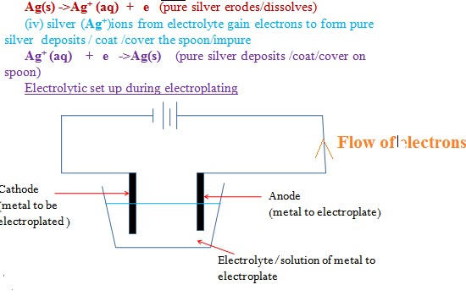

**CARBON AND SOME OF ITS COMPOUNDS**

**Table of Contents**

Carbon and its allotropes - 3 -

Chemical Properties of Carbon - 4 -

Burning in air - 5 -

Reducing property of carbon. - 5 -

Reaction of Carbon with concentrated nitric (V) acid and sulphuric acids - 7 -

Review Questions: Carbon and its allotropes. - 8 -

Carbon (IV) oxide (CO2) - 8 -

Preparation of Carbon (IV) oxide - 8 -

Properties of carbon (IV) oxide - 9 -

Uses of Carbon (IV) oxide gas - 10 -

Review Questions: Carbon (IV) oxide - 10 -

Carbon (II) Oxide - 10 -

Preparation of carbon (II) oxide - 11 -

Properties of carbon (II) oxide - 12 -

Carbonates - 14 -

Reaction of carbonates and hydrogen carbonates with dilute acids - 15 -

Action of Heat on Carbonate and Hydrogen Carbonates - 16 -

Large scale production of Sodium Carbonate and Sodium Hydrogen Carbonate - 17 -

Extraction from Trona - 17 -

The Solvay Process - 18 -

Effects of Carbon (IV) oxide and Carbon (II) oxide on the Environment - 20 -

The Carbon Cycle - 21 -

(20 Lessons)

**Objectives**

**By the end of this chapter, the learner should be able to:**

(a)   Define the terms allotropy and allotropes.

(b)   State and explain some physical and chemical properties of carbon.

(c)   Describe the laboratory preparation of carbon (IV) and carbon (II) oxides

(d)   State and explain the physical and chemical properties of carbon (IV) and carbon (II) oxide

(e)   State the uses of carbon, carbon (IV) and carbon (II) oxides.

(f)   Describe the chemical properties of carbonates and hydrogen carbonates.

(g)   Describe the extraction and manufacture of sodium carbonate.

(h)   State the effects of carbon (IV) and carbon (II) oxides on the environment.

**CARBON AND SOME OF ITS COMPOUNDS**

Carbon is the first element in group (IV) of the periodic table. It has an electron arrangement of 2.4. It forms covalent bonds in most of its compounds.

It occurs in the **pure state** as **diamond and graphite,** and in the impure state as **amorphous carbon.** It also occurs in the **combined state** in compounds such as **carbonates, mineral oils, organic matter, and carbon (IV) oxide.**

# Carbon and its allotropes

**Allotropy** is the existence of an element in more than one form, in the same physical state. The different forms are called **allotropes**.

Carbon has two naturally occurring allotropes, **diamond** and **graphite**.

Carbon can be manipulated using energy such as laser beams to form other allotropes known as fullerenes or ‘buckyballs’.

### **Diamond**

This is one of the stable allotropes of carbon. It is a colourless, transparent shiny crystalline solid.

In diamond, carbon **uses all the four valence electrons to form covalent bonds**. Since it uses all the four electrons in the outermost energy level for bonding, it **does NOT conduct both electricity and heat.**

Diamond has a density of 3.51 g/cm3. The **high density is due to continuous close packing of carbon atoms.**

Diamond has a high melting point (3700ºC). The **high melting point is due to the strong covalent bonds.**

Diamond is one of the hardest naturally occurring substances. **The hardness is due to the uniformity of covalent bonds between the atoms throughout the structure.**

Diamond has a giant atomic structure in which each carbon atom is bonded to four other carbon atoms arranged in a regular tetrahedron shape. The whole structure of diamond extends in all directions forming a rigid mass of atoms.

Diamond is found in some parts of India, South Africa and in Tanzania where it is mined. It is used as a **jewel** because of its **shiny appearance when polished.** It is used in **glass cutters and drill bits**because **of its hardness.**

### **Graphite**

This is another stable allotrope of carbon. It is a **black, soft, slippery crystalline solid.** Graphite is made up of **hexagonally arranged carbon atoms bonded together in layers** where each atom is bonded to **three carbon atoms**. The layers are held together by **van der Waals forces.**

Graphite has a density of 2.3g/cm3. The **low density is due to the spaces between the layers**. It is **soft and slippery** because the **layers in the structure can slide over each other due to the weak van der Waals forces**.

In graphite, each carbon atom uses only three electrons in the outer energy level to form covalent bonds with other carbon atoms. **One electron** in the outer energy level of each atom is **not used in bonding**. It is **delocalised hence graphite conducts heat and electricity.**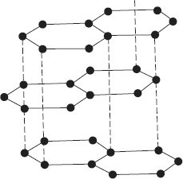

Both melting point (3500ºC) and boiling point (4800ºC) of graphite are **high because of the strong covalent bonds between the atoms in its layers.** Graphite has a giant atomic structure in which layers are held together by van der Waals forces.

The **high melting point** and **its slippery nature** makes graphite a **good lubricant in moving machine parts where a lot of heat is produced**.

The high melting point also makes graphite useful in **making moulds for casting metals**. It has **delocalised** electrons within its structure hence is used as an **electrode**.

Graphite is **mixed with clay to make pencil ‘leads’ becaus**e the carbon layers **can slide over each other.** Graphite is found in South Africa, Brazil, Sweden, Germany and U.S.A.

### **Fullerenes**

Fullerenes are **synthetic allotropes of carbon**. They are found in different shapes such as spherical, tubular or elliptical. The best known fullerene is the **spherical C60 molecule** which consists of hexagonally arranged carbon atoms similar to the panels of some soccer balls.

### **Amorphous Carbon**

This is an **impure form of carbon**. Examples are **charcoal, soot, coke and coal**. They contain small amounts of graphite. They **do not conduct electricity or heat, because of the irregular arrangement of graphite crystals in their structure.**

Amorphous carbon especially charcoal has the ability to **adsorb gases and liquids**. It is therefore used in **gas masks**.

Charcoal is used to **adsorb colored impurities in sugar refining industries.**

Carbon black is mixed with rubber in the manufacture of **tyres as a filler to improve tensile strength and reduce wear and tear. It also gives tyres the black appearance.**

## Chemical Properties of Carbon

### **Burning in air**

When carbon is heated, it glows red. A colourless gas is produced which reacts with calcium hydroxide to form a white precipitate. The red glow shows that the reaction produces heat. The white precipitate shows that the gas produced is carbon (IV) oxide.

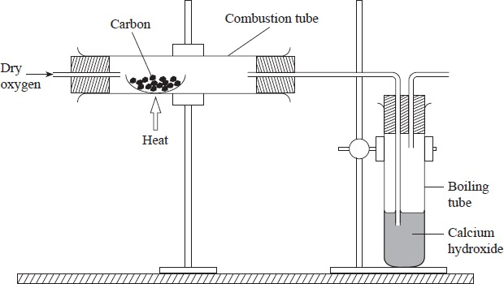

When pure carbon is used in this experiment there is no residue in the combustion tube.

Carbon + oxygen carbon (IV) oxide

C(s) + O2(g) CO2(g)

Carbon (IV) oxide + Calcium hydroxide Calcium carbonate + water

CO2(g) + Ca(OH)2(aq) CaCO3(s) + H2O(l)

*(white)*

All forms of carbon burn in oxygen to produce carbon (IV) oxide. However, the **temperature at which they burn varies from one allotrope to another.**

### **Reducing property of carbon.**

Place a small amount of copper (II) oxide and powdered charcoal in a test tube and mix well. Set up the apparatus as shown and heat.

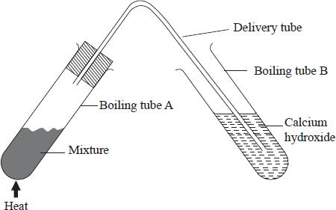 Effect of heating carbon with some metal oxides

When a mixture of copper (II) oxide and carbon is heated the black mixture turns into a brown powder. A colourless gas produced forms a white precipitate with calcium hydroxide. The brown powder is copper metal and the colourless gas is carbon (IV) oxide.

Copper (II) oxide + Carbon Copper + Carbon (IV) oxide

2CuO(s) + C(s) 2Cu(s) + CO2 (g)

(black) (black) (brown) (colourless)

Similarly, carbon removes combined oxygen from zinc oxide, lead (II) oxide and iron (III) oxide.

Lead (II) oxide + Carbon  Lead + Carbon (IV) oxide

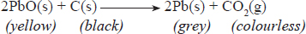

Zinc oxide + Carbon  Zinc + Carbon (IV) oxide

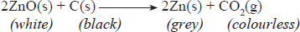

Iron (III) oxide + Carbon  Iron + Carbon (IV) oxide



Carbon has the ability to **remove combined oxygen from some metals**. In these reactions, carbon is **oxidised** to **carbon (IV) oxide** and the metal oxides are **reduced to metals**.

In terms of competition for combined oxygen, carbon can be placed in the reactivity series of metals between Aluminium and Zinc. Thus, it **reduces the oxides of all the metals below it in the reactivity series**. Therefore, carbon is a **reducing agent**.

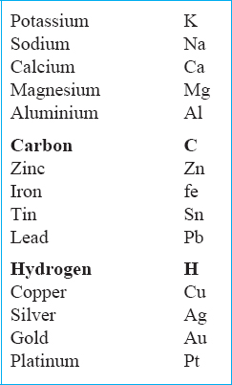

*The reactivity series of metals showing the position of carbon and hydrogen*.

The **reducing property** of carbon is used in the **extraction of metals from their oxides.**

At temperatures of about 1200ºC, carbon reduces steam to hydrogen gas. Carbon is in turn oxidised to carbon (II) oxide. A mixture of the two gases is called **water gas**.

Carbon + Steam  Carbon (II) oxide + Hydrogen

### **Reaction of Carbon with concentrated nitric (V) acid and sulphuric acids**

Carbon **reduces** hot concentrated **nitric acid to brown nitrogen (IV) oxide gas and water**. Carbon is in turn **oxidized to carbon (IV) oxide gas**.

Hot **concentrated sulphuric acid** is **reduced to sulphur (IV) oxide** and **water** while **carbon is oxidized to carbon (IV) oxide** gas. Both sulphur (IV) oxide and carbon (IV) oxide react with calcium hydroxide to form a white precipitate of calcium sulphite and calcium carbonate respectively.

Carbon + Conc. Nitric (V) acid  Nitrous (IV) oxide + Carbon (IV) oxide + water



Carbon + Conc. Sulphuric (VI) acid  Sulphur (IV) oxide + carbon (IV) oxide + water

C(s) + 2H2SO4(l)  2SO2(g) + CO2(g) + 2H2O(l)

The two hot concentrated acids react with carbon because they are strong oxidizing agents.

# Carbon (IV) oxide (CO2)

This is the most stable oxide of carbon. In carbon (IV) oxide, the carbon atom forms strong covalent bonds with two oxygen atoms. Carbon (IV) oxide is a **molecular substance.** The gas accounts for 0.03% of the volume of air. However, it occurs in some regions at a higher concentration due to various activities such as volcanic action. In Kenya, these regions are: Esageri near Eldama Ravine and Kerita in Kimabu where commercial tapping of the gas is done.

## ImagePreparation of Carbon (IV) oxide

Carbon (IV) oxide is prepared by reacting calcium carbonate with dilute hydrochloric acid.

***Questions***

1. **What is observed in the conical flask containing the reactants?**

When dilute hydrochloric acid is added to calcium carbonate, a **vigorous effervescence occurs releasing carbon (IV) oxide gas**.

1. **Write an equation for the reaction that occurs between calcium carbonate and dilute hydrochloric acid.**

Calcium carbonate + Dil. hydrochloric acid  Calcium chloride + Carbon (IV) oxide + Water

CaCO3(s) + 2HCl(aq)  CaCl2(aq) + CO2(g) + H2O(l)

1. **Explain the purpose of sodium hydrogen carbonate in this set-up.**

The gas is passed through **sodium hydrogen carbonate or water** to remove traces of hydrochloric acid fumes in the gas.

**4.   Explain why the gas is passed through concentrated suphuric acid.**

When required **dry**, the gas is passed through **concentrated sulphuric (VI) a**cid which acts as a drying agent.

1. **Suggest an alternative to concentrated sulphuric (VI) acid**.

**Anhydrous calcium chloride** can be used in place of concentrated sulphuric (VI) acid as a **drying agent**.

**6. Which other reactants can be used to prepare carbon(IV) oxide? Is there an exception?**

A**ny other carbonate can be used** with a **suitable acid**.

Dilute sulphuric (VI) acid **SHOULD NOT BE** reacted with **calcium carbonate, barium carbonate and lead carbonate**. This is because **insoluble sulphates** produced form a **coating on the carbonates and prevent further reaction**. For the same reasoned dilute hydrochloric acid is not reacted with lead carbonate.

## Properties of carbon (IV) oxide

Carbon (IV) oxide is a colourless, odourless gas. It is denser than air and neither burns nor supports combustion. It is an acidic gas and dissolves in water to form weak carbonic acid. As a test for the gas, It forms a white precipitate with calcium hydroxide.

***Questions***

1. **Explain why carbon (IV) oxide is collected by downward delivery.**

The gas is **denser than air and this explains why it is collected by down ward delivery.**

1. **What deductions can be made about the properties of carbon (IV) oxide gas from the following tests?**

**(a)   Bubbling the gas through water containing the universal indicator.**

The gas is acidic, and turns the universal indicator solution **red**.

**(b)   Inverting separate gas jars of carbon (IV) dioxide in troughs of water and sodium hydroxide solution.**

Carbon (IV) oxide gas slightly **dissolves in water** to form **carbonic acid**, a **weak acid**.

Carbon (IV) oxide + Water  Carbonic acid

CO2(g) oxide + H2O(g)  H2CO3(g)

Carbon (IV) oxide gas is **acidic** and **readily reacts with sodium hydroxide** solution to form sodium carbonate.

Sodium hydroxide + Carbon (IV) oxide  Sodium carbonate + Water

2NaOH(aq) + CO2(g)  Na2CO3(aq) + H2O(l)

If the gas is in **excess**, a further reaction occurs that leads to the formation of **sodium hydrogen carbonate.**

Sodium carbonate + Water + Carbon (IV) oxide  Sodium hydrogen carbonate

Na2CO3(aq) + H2O(l) + CO2(g)  2NaHCO3(aq)

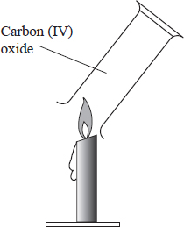**(c)Inverting a gas jar full of carbon (IV) oxide over a candle flame as shown below.**

Carbon (IV) oxide **neither burns nor supports combustion. This is why the gas puts off a burning candle.**

1. **Explain using equations, the change observed when carbon (IV) oxide is bubbled through limewater until there is no further change.**

**When Carbon (IV) oxide is bubbled through calcium hydroxide for a short while, a white precipitate is formed. The white precipitate is due to the formation of the insoluble calcium carbonate. *This is the confirmatory test for carbon (IV) oxide*.**

Calcium hydroxide + Carbon (IV) oxide  Calcium carbonate + Water

Ca(OH)2(aq) + CO2(g)  CaCO3(s) + H2O(l)

When the gas is passed through the mixture for a while the **white precipitate dissolves to form a colourless solution of calcium hydrogen carbonate.**

Calcium carbonate + Water + Calcium (IV) oxide  Calcium hydrogen carbonate

CaCO3(s) + H2O(l) + CO2(g) Ca(HCO3)2(aq)

**4.   Write chemical equations for the reactions that take place when:**

**(a)   Magnesium is burnt in carbon (IV) oxide gas.**

Although the gas does not support combustion, **burning magnesium continues to burn in it to produce a white powder of magnesium oxide and black specks of carbon. The burning magnesium produces a lot of heat that decomposes carbon (IV) oxide to carbon and oxygen.**

Magnesium + Carbon (IV) oxide  Magnesium oxide + Carbon

2Mg(s) + CO2(g)  2MgO(s) + C(s)

The addition of dilute nitric (V) acid dissolves magnesium oxide leaving black specks of carbon.

**(b)   Carbon (IV) oxide is reacted with sodium hydroxide solution for a few seconds**.

2NaOH(aq) + CO2(g)  Na2CO3(aq) + H2O(l)

## Uses of Carbon (IV) oxide gas

1. Carbon (IV) oxide gas is used as a refrigerating agent for perishable goods. This is because **solid carbon (IV) oxide sublimes when heated, leaving no residue.**
2. Carbon (IV) oxide is used to **extinguish fires** because it is **non-flammable** and has a **higher density than air** therefore it forms a ‘blanket’ on fire cutting off oxygen supply.
3. It is used in the manufacture of sodium carbonate in the **Solvay process**.
4. Carbon (IV) oxide is dissolved in water to make aerated drinks to add taste, it is also used to make baking powder.

# Carbon (II) Oxide

This is another oxide of carbon in which a carbon atom forms three covalent bonds with one oxygen atom. It is a molecular substance.

***Structure of Carbon (II) oxide***

The dot (·) and cross (×) diagram shows the three covalent bonds in a carbon (II) oxide molecule one of which is **a dative bond**.

## Preparation of carbon (II) oxide

Carbon (II) oxide may be prepared by dehydrating methanoic acid using concentrated 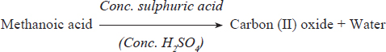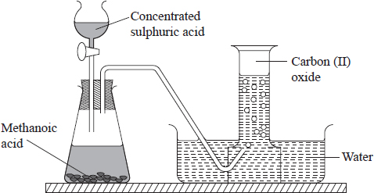sulphuric (VI) acid.

**HCOOH(s)  CO(g) + H2O(l)**

Ethanedioic acid (oxalic acid) may be used in place of methanoic acid as shown below.

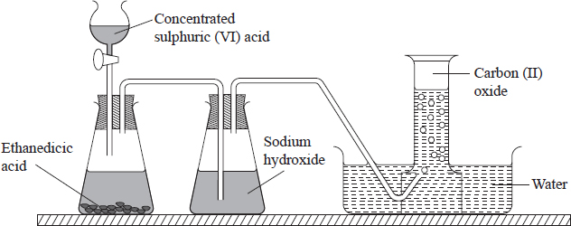

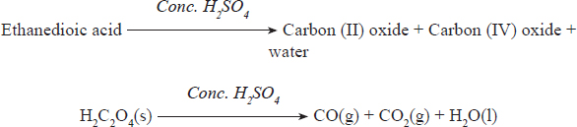

The gaseous mixture should be passed through a concentrated solution of sodium hydroxide to remove the carbon (IV) oxide, CO2. The gas may also be prepared by passing Carbon (IV) oxide over heated charcoal as shown in the set up below.

Carbon (IV) oxide + Carbon  Carbon (II) oxide

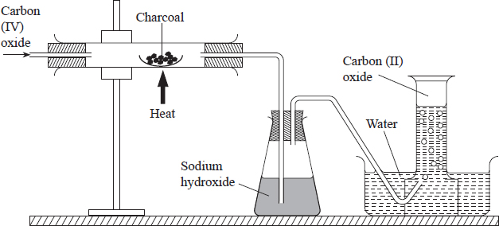CO2(g) + C(s)  2CO(g)

## Properties of carbon (II) oxide

### **Physical properties of Carbon (II) oxide**

Carbon (II) oxide gas is colourless, odourless and slightly less dense than air.

It has a low boiling point of -111ºC. The low boiling point is because of the weak forces of attraction between the molecules.

The gas is slightly soluble in water. The solution formed is neutral.

The gas is extremely poisonous. It combines with haemoglobin in the blood to form a stable compound known as **carboxy-haemoglobin**. The carboxy-haemoglobin formed prevents formation of oxyhaemoglobin leading to suffocation.

### **Chemical properties of Carbon (II) oxide**

#### Combustion.

Carbon (II) oxide burns in air with a blue flame to form Carbon (IV) oxide

Carbon (II) oxide + Oxygen  Carbon (IV) oxide

2CO(g) + O2(g)  2CO2(g)

The set up below is for the combustion of Carbon (II) oxide.

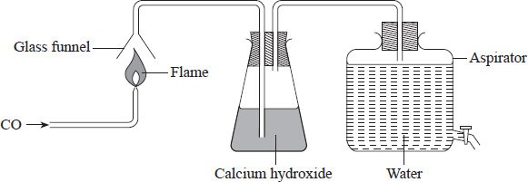

**Reduction property.**

The following set up that may be used to show the effect of Carbon (II) oxide on hot metallic oxide, Carbon (II) oxide gas readily removes combined oxygen from metals low in the reactivity series such as copper, lead and iron. It is in turn oxidized to carbon (II) oxide. **Therefore carbon (II) oxide is a reducing agent.**

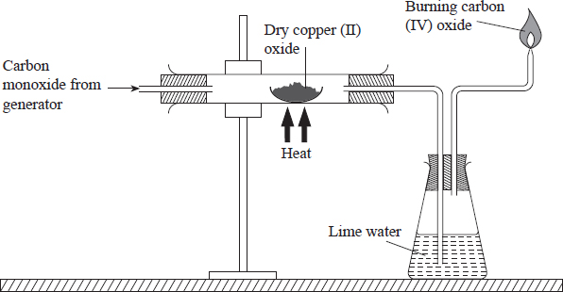

Copper (II) oxide + Carbon (II) oxide  Copper + Carbon (IV) oxide

CuO(s) + CO(g)  Cu(s) + CO2(g)

Zinc (II) Oxide + Carbon (II) oxide  Zinc + Carbon (IV) oxide

ZnO(s) + CO(g)  Zn(s) + CO2(g)

Lead (II) oxide + Carbon (II) oxide  Lead + Carbon (IV) oxide

PbO(s) + CO(g)  Pb(s) + CO2(g)

Iron (III) oxide + Carbon (II) oxide  Iron + Carbon (IV) oxide

Fe2O3(s) + 3CO(g)  2Fe(s) + CO2(g)

The **reducing property of carbon (II) oxide** makes the gas useful in the **extraction of some metals from their oxides.**

### Other Sources of Carbon (II) oxide

Carbon (II) oxide is encountered almost in every day situations through combustion of charcoal and fossil fuels such as kerosene, diesel, petrol and coal.

When charcoal burns in a charcoal stove (jiko) three reactions occur in the various regions after fire as shown below.

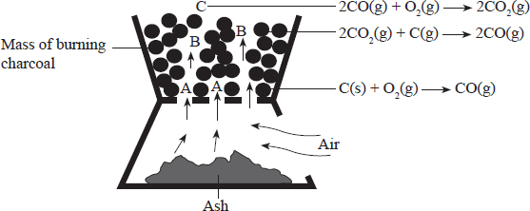

**Region A:** Region a in this region **plenty of air** enters the jiko allowing **complete combustion** of carbon to carbon (IV) oxide.

**Carbon + Oxygen  Carbon (IV) oxide**

**C(s) + O2(g*)* CO2(g)**

**Region B:** The carbon (IV) oxide produced in region ‘A’ rises up to region ‘B’ where it is reduced.

**Carbon (IV) oxide + Carbon  Carbon (II) oxide**

**CO2(g) + C(s)  2CO(g)**

**Region C:** Here, there is **enough oxygen** therefore carbon (II) oxide produced in region B burns to form carbon (IV) oxide.

**Carbon (II) oxide + Oxygen  Carbon (IV) oxide**

**2CO(g) + O2(g)  2CO2(g)**

In case of insufficient air, some carbon (II) oxide produced in region B is released into the atmosphere. This is common in **poorly ventilated rooms.**

#### Carbonates

Carbonates are salts of metal ions or ammonium ions with carbonate ions. The carbonate ions are indirectly obtained from carbonic acid (H2CO3) formed when carbon (IV) oxide is dissolved in water. Carbonates occur naturally in rocks as limestone (CaCO3), malachite (CuCO3.Cu(OH)2 and dolomite, CaCO3.MgCO3. In Kenya, dolomite is mined in Kariandusi near Gilgil.

Hydrogencarbonates are salts derived from carbonic acid formed by the partial displacement of hydrogen by a metal or ammonium radical. Hydrogencarbonates of sodium, potassium and ammonium exist as solids at room temperature, where as those of calcium and magnesium only exist in solution. The hydrogen carbonates of other metals do not exist.

### **ImageReaction of carbonates and hydrogen carbonates with dilute acids**

**All carbonates give off carbon (IV) oxide when reacted with acids.** For example:  
Calcium carbonate + Dil. Hydrochloric acid  Calcium chloride + Carbon (IV) oxide + Water

CaCO3(s) + 2HCl(aq)  CaCl2(aq) + *C*O2(g*)* + H2O(l)

Zinc carbonate + Dil. Hydrochloric acid  Zinc chloride + Carbon (IV) oxide + Water

ZnCO3(s) + 2HCl(aq)  ZnCl2(aq) + CO2(g) + H2O(l)

Sodium hydrogen carbonate + Dil. Hydrocloric acid  Sodium chloride + Water + Carbon (IV) oxide

NaHCO3 + HCl(aq)  NaCl(aq) + H2O(g) + CO3(g)

Lead carbonate + Dil. Nitric acid  Lead + Carbon (IV) oxide + Water

PbCO3(s) + 2HNO3(aq) Pb(NO3)2(aq) + CO2(g*) +* H2O(l)

Sodium carbonate + Dil. Sulphuric (VI) acid  Sodium sulphate + carbon (IV) oxide + Water

NaCO3(s) + H2SO4(aq)  Na2SO4(aq) + CO2(g) + H2O(l)

The reaction between **calcium** carbonate or **lead** carbonate with dilute sulphuric acid **does not go to completion. This is due to the formation of insoluble calcium sulphate and lead sulphate respectively.** The insoluble sulphates form a **coating on the carbonate and prevent further reaction**.

The reaction between **lead carbonate and hydrochloric acid** also does not go to completion because of the formation of the **insoluble lead chloride**.

Calcium carbonate + Dil. Sulphuric (VI) acid  Calcium sulphate + Carbon (IV) oxide + Water

CaCO3(s) + H2SO4(aq)  CaSO4(s) + CO2(g) + H2O(l)

Lead carbonate + Dil. Sulphuric (VI) acid  Lead sulphate + Carbon (IV) oxide + Water

PbCO3(s) + H2SO4(aq)  PbSO4(s) + CO2(g) + H2O(l)

Lead carbonate + Dil. Hydrochloric acid  Lead chloride + Carbon (IV) oxide + Water

PbCO3(s) + 2HCl(aq)  PbCl2(s) + CO2 + H2O

### ImageAction of Heat on Carbonate and Hydrogen Carbonates

**All** carbonates **except** the carbonates of potassium and sodium decompose when heated to produce a metal oxide and carbon (IV) oxide. The ease of decomposition **depends on the position of the metal in the reactivity series. Those lower in the reactivity series are easily decomposed**.

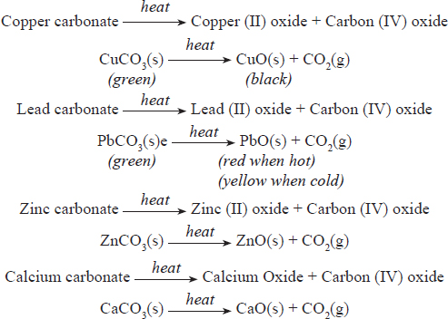

**Ammonium** carbonate decomposes when heated to produce **ammonia, carbon (IV) oxide and water.**

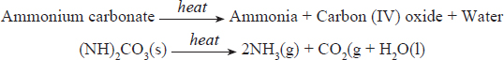

**Hydrogen carbonates** decompose on heating to produce a **carbonate, carbon (IV) oxide and water.**

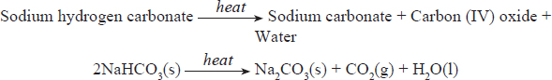

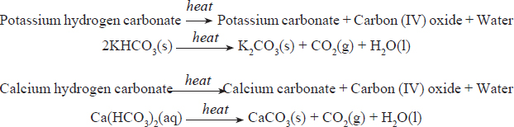

The calcium carbonate is further decomposed by heat to produce an oxide and hydrogen carbonate.

Calcium carbonate  Calcium oxide + Carbon (IV) oxide

CaCO3(s) CaO(s) + CO2(g)

## Large scale production of Sodium Carbonate and Sodium Hydrogen Carbonate

Sodium carbonate is an important raw material in the glass and paper industries. It is also used in water treatment plants. This important raw material is obtained in two ways extraction from trona and preparation by Solvay process.

### **Extraction from Trona**

Trona is a **double salt** containing **sodium carbonate, sodium hydrogen carbonate and water of crystallisation**, **Na2CO3.NaHCO3.H2O,** found in some lakes in the Rift valley. These lakes have only in-lets but no out-lets. Lake Magadi in Kenya is a good example.

The flow chart below shows the steps in the extration of trona from salty water.

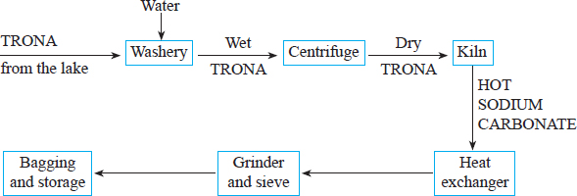

*Steps in the manufacture of sodium carbonate*

Lake Magadi contains large amounts of solid trona and small amounts of sodium chloride. Trona is dug by bucket dredges and taken to the washery where it is washed in water to remove mud and small rocks. The wet trona is then centrifuged to remove water and to purify it further. The dry trona is then heated to about 300ºC in a kiln to decompose the sodium carbonate.

After removal of the trona from the lake, a solution rich in sodium chloride remains. The solution is pumped into shallow basins where evaporation takes place until the percentage of sodium chloride is 14%. The solution is then transfered to another basin for crystalisation.

During the day when the temperature is about 40ºC tronacrystalises and is removed. During the night when the temperature is about 21ºC sodium chloride crystalises and is removed.

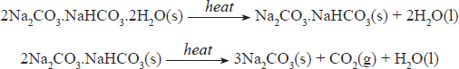

The sodium carbonate obtained is cooled, ground,, sieved and bagged ready for storage and transportation to the consumers.

### **The Solvay Process**

In places where trona is not available, sodium carbonate and sodium hydrogen carbonate are manufactured by the Solvay process.

**Raw Materials**

1. **Sodium chloride (brine)**-obtained from sea salt by evaporating the water to obtain crystals.
2. **Calcium carbonate and coke**-Sources of CO2 when heated and roasted respectively.

CaCO3(s) CaO(s) + CO2(g) (thermal decomposition)

C(s) + O2(g)  CO2(g) (roasting)

1. **Ammonia**-Obtained from the Haber process.

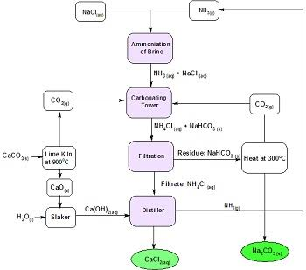

**Ammonia** is dissolved in **brine** in the Solvay tower to produce **ammoniacal brine**. A lot of **heat is produced** in the process. The amount of heat produced is controlled by **regulating the flow of brine into the Solvay tower.**

The ammoniacal brine is then **pumped into the carbonator from the top** where it **trickles down the carbonator while carbon (IV) oxide** from the kiln is **pumped from the base**. The carbonator has to be cooled regularly to reduce the amount of heat produced in it.

**Sodium hydrogen carbonate** being **less soluble** than **ammonium chloride at low temperatures,** forms crystals in the lower cooled part of the carbonator. The reactions that take place in the carbonator are as follows:

Ammonia + Carbon (IV) oxide + Water  Ammonium hydrogen carbonate

**NH3(g) + CO2(g) + H2O(l)  NH4HCO3(aq)**

Ammonium hydrogen carbonate + Sodium chloride  Sodium hydrogen carbonate + Ammonium chloride

**NH4HCO3(aq) + NaCl(aq)  NaHCO3(s) + NHC4(aq)**

The reaction in the carbonator can be summarized by the equation below:

Ammonia + Carbon (IV) oxide + Sodium chloride + Water  Sodium hydrogen carbonate + Ammonium chloride

**NH3(g) + CO2(g) + NaCl(aq) + H2O(l)  NaHCO3(s) + NH4Cl(aq)**

Sodium hydrogen carbonate is separated from ammonium chloride by **filtration**. Sodium hydrogen carbonate is **dried and decomposed by heat at 300ºC** to produce **sodium carbonate.**

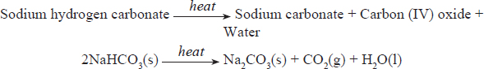

The **calcium oxide** produced in the limestone kiln is **slaked (combined) with water** and **mixed with the filtrate ammonium chloride** to produce **ammonia gas, water and calcium chloride.**

Calcium oxide + Water  Calcium hydroxide

**CaO(s) + H2O(l) Ca(OH)2(s)**

Calcium hydrogen carbonate + Ammonium chloride  Ca lcium chloride + Water + Ammonia

**Ca(OH)2(s) + 2NH4Cl(aq)  CaCl2(s) + 2H2O(l) + 2NH3(g)**

The Solvay process is one of the best examples of an **efficient industrial chemical process,** because pollution problems are considerably reduced. The **carbon (IV) oxide and ammonia gases** produced are **recycled** to minimise costs.

The **water** produced is also **recycled** to minimise**thermal effects on the water source** near the plant. The process **does not involve large consumption of energy** because the **coke burned in the kiln supplies the necessary heat in the process.**

**In brief:**

1. Only by-product which is not recycled is calcium chloride
2. Recyclable substances - NH3, H2O, CO2 (this explains why this is an efficient process).
3. Sodium carbonate is used in water softening, glass making, paper industry and making of sodium silicate. The sodium silicate is used in the making of detergents.
4. Sodium hydrogen carbonate is used in the making of health drinks and as baking powder in the food
5. Calcium chloride is used as a drying agent in the school laboratory preparation of gases., In the Downs cell (process for extraction of Sodium) to lower the melting point of rock salt, used as a food additive, food preservative, and used for de-icing roads in winter
6. The best site for the Solvay process plant should be close to a river or large source of water to cool down the carbonator.

# Effects of Carbon (IV) oxide and Carbon (II) oxide on the Environment

The level of carbon (IV) oxide in the atmosphere is increasing due to the use of fossil fuels such as petrol, diesel, natural gas and coal. This increase is causing global warming due to the green house effect. Some of the effects of global warming include melting of polar ice caps which leads to the rise in the sea water levels and erratic weather patterns.

Vehicle exhaust fumes make-up more than 60% of all the carbon (II) oxide emitted into the atmosphere. Carbon (II) oxide emissions are highest during cold weather. This is because low temperatures make combustion less complete. Carbon (II) oxide can cause death through suffocation. Luckily, carbon (II) oxide is quickly removed from the atmosphere by micro-organisms in the soil.

### **The Carbon Cycle**

The way in which carbon compounds circulate in nature constitutes the carbon cycle which is shown below. The processes that release carbon (IV) oxide to the atmosphere include combustion of fuels, respiration in both animals and plants, fermentation, decomposition of carbonates and hydrogen carbonates. Those processes that remove carbon (IV) oxide in the atmosphere include photosynthesis in plants, dissolving of carbon (IV) oxide in seas and oceans. The amount of carbon (IV) oxide in the atmosphere has remained fairly constant at 0.03% owing to the delicate balance between the processes that absorb the gas and those that evolve it. Lately, the balance is being interfered with by human activity leading to an increase in the level of carbon (IV) oxide in the atmosphere thus causing global warming since carbon (IV) oxide has a greenhouse effect.

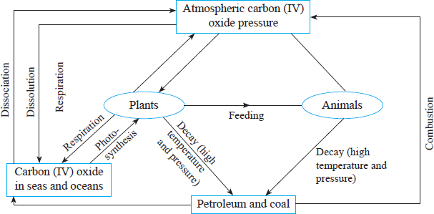

1. 2006 P1 Q22.

The diagram below represents part of a set – up used to prepare and collect gas T.

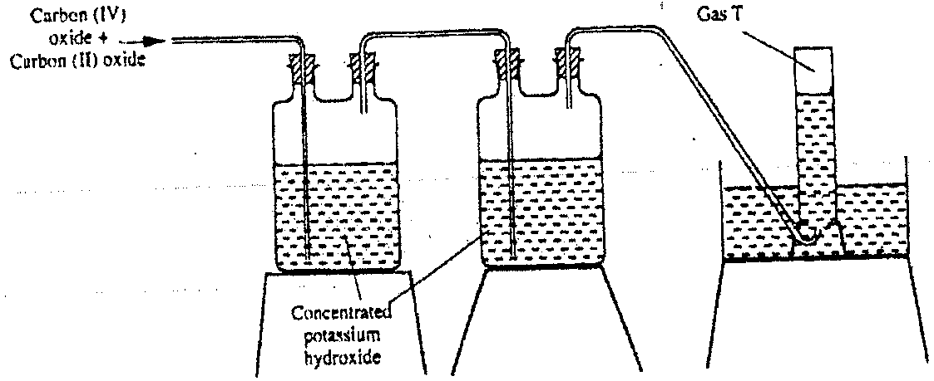

1. Name two reagents that are reacted to produce both carbon (IV) oxide and carbon(II) oxide. (1 mark)
2. Write the equation for the reaction which takes place in the wash bottles. (1 mark)
3. Give a reason why carbon (II) oxide is not easily detected. (1 mark)
4. 2007 P1 Q1.

The diagram below shows a “Jiko” when in use. Study it and answer the questions that follow.

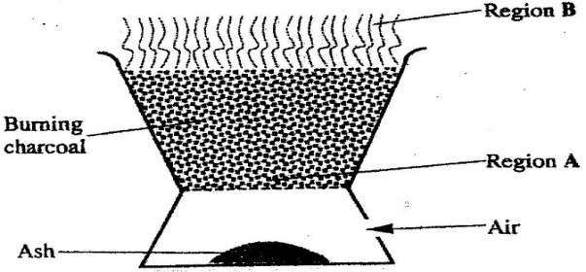

(a) Identify the gas formed at region A. (1 mark)

(b) State and explain the observation made at region B. (2 marks)

1. 2009 P2 Q4.
2. The schematic diagram shows part of the Solvay process used for the manufacture of sodium carbonate.

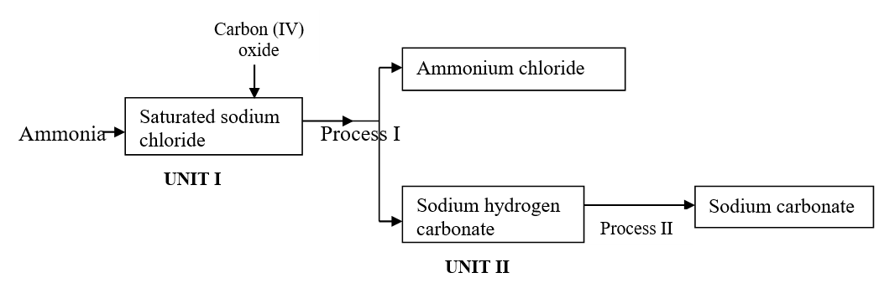

* 1. Explain how the sodium chloride required for this process is obtained from sea water. (2marks)
  2. Two main reactions take place in UNIT I . The first one is the formation of ammonium hydrogen carbonate.

I. Write an equation for this reaction (1 mark)

II. Write an equation for the second reaction (1 mark)

* 1. State how the following are carried out:

I. Process I (1 mark)

II. Process II (1 mark)

* 1. In an experiment to determine the percentage purity of the sample of sodium carbonate produced in the Solvay process, 2.15 g of the sample reacted completely with 40.0cm3 of 0.5 M sulphuric acid.
     1. Calculate the number of moles of sodium carbonate that reacted. (1 mark)
     2. Determine the percentage of sodium carbonate in the sample.

(Na= 23.0, C= 12.0, O = 16.0) (2 marks)

1. Name two industrial uses of sodium carbonate. (2 marks)
2. 2010 P1 Q15.

Carbon (II) oxide is described as a “silent killer”

* 1. State one physical property of carbon (II) oxide that makes it a “silent killer” (1 mark)
  2. State and explain one chemical property that makes carbon (II) oxide poisonous to human beings (2 marks)

1. 2011 P1 Q11.

Exhaust fumes of some cars contain carbon(II)oxide and other gases.

* 1. Explain how carbon (II) oxide is formed in the internal combustion engines. (1 mark)
  2. Name two gases other than carbon (II) oxide that are contained in exhaust fumes and are pollutants. (2 marks)

1. 2011 P1 Q21.

Graphite is one of the allotropes of carbon.

(a) Name one other element which exhibits allotropy. (1 mark)

(b) Explain why graphite is used in the making of pencil leads. (2 marks)

1. 2012 P1 Q1 ,2016 P1 Q25

Charcoal is a fuel that is commonly used for cooking. When it burns it forms two oxides.

(a) Name the two oxides. (2 marks)

(b) State one use of any of the two oxides. (1 mark)

1. 2013 P1 Q19.
   1. Diamond and graphite are allotropes of carbon. What is meant by an allotrope? (1 mark)
   2. Explain why graphite can be used as a lubricant while diamond cannot. (1 mark)
2. 2015 P1 Q27.
   1. Describe how carbon (IV) oxide can be distinguished from Carbon (II) Oxide using calcium hydroxide solution. (2 marks)
   2. What is the role of carbon (IV) oxide in fire extinguishing? (1 mark)
3. 2015 P2 Q1. (a)
   1. Carbon (IV) oxide is present in soft drinks. State two roles of carbon (IV) oxide in soft drinks. (1 mark)
   2. Explain the observation made when a bottle containing a soft drink is opened. (2 marks)
   3. Carbon (IV) oxide dissolves slightly in water to give an acidic solution. Give the formula of the acid. (1 mark)
4. 2016 P1 Q22.

The set up below was used to collect a dry sample of a gas

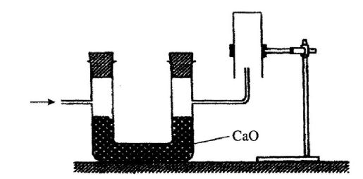

Give two reasons why the set up cannot be used to collect carbon (IV) oxide gas. (2 marks)

1. 2018 P1 Q2.
   1. Explain why it is not advisable to prepare a sample of carbon(IV) oxide using barium carbonate and dilute sulphuric(VI) acid. (2 marks)
   2. State a method that can be used to collect dry carbon(IV) oxide gas. Give a reason. (1 mark)
2. 2018 P2 Q6.
   1. In Kenya, sodium carbonate is extracted from trona at Lake Magadi.
   2. Give the formula of trona. (1 mark)
   3. Name the process of extracting sodium carbonate from trona. (2 marks)
   4. The flow chart in **Figure 5** summarises the steps involved in the production of sodium carbonate. Use it to answer the questions that follow.

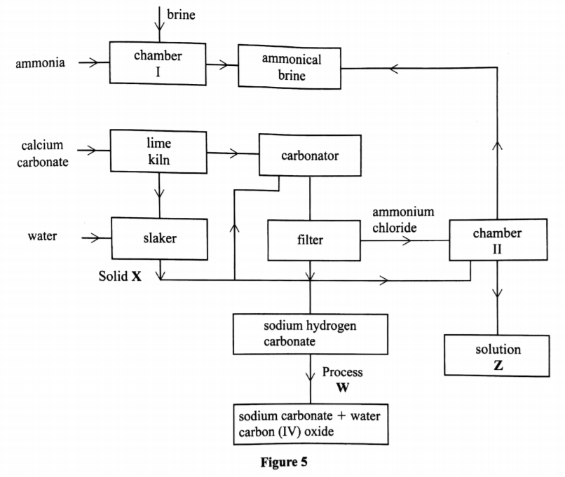

* 1. Name the process illustrated in **Figure 5**. (1 mark)
  2. Identify the starting raw materials required in the production of sodium carbonate. (2 marks)
  3. Write equations for the two reactions that occur in the carbonator.

(2 marks)

* 1. Name two substances that are recycled. (2 marks)
  2. Identify:

Solid X; ................ (1 mark)

Process W ............... (1 mark)

* 1. Write an equation for the reaction that produces solution Z. (1 mark)
  2. Apart from softening hard water, state two other uses of sodium carbonate. (2 marks)

1. 2019 P1 Q20.

During laboratory preparation of carbon (IV) oxide gas, substance **L** in a conical flask.

* 1. Identify substance L. (1 mark)
  2. Write an equation that produces carbon (IV) oxide. (1 mark)
  3. State the observations made when the gas produced WHS bubbled through calcium hydroxide solution for a long time. (1 mark)

|  |
| --- |
| **END OF FORM TWO WORK**  **PREPARED BY: MR AHMED YARROW KHEIR**  **TELL:O724706355/0768388373**  **GMAIL:** [**ahmedkheir1988@gmail.com**](mailto:ahmedkheir1988@gmail.com) |
| **I THANK TO GOD.**  **ITS NOT MY POWER AND KNOWLEDGE TO WRITE THIS BUT ITS THE HELP OF GOD.** |



**THIS BOOK CALLED REAL CHEMISTRY FORM ONE AND TWO HAS WELL PREPARED NOTES AND COVERS ALL TOPICS IN FORM ONE AND TWO AS PER SYLLABUS REQUIRMENT WITH EXAMINATION QUESTIONS, THE BOOK HAS WELL DIAGRAMES TO HELP THE LEARNER.**

**HOPE IT WILL BE HELPFUL FOR FORM ONE AND TWO STUDENT.**



**TRY REVISION BOOK FORM ONE AND TWO**

**REAL CHEMISTRY REVISION BOOK FORM ONE AND TWO**

Compile by: Mr. *Ahmed Yarrow Kheir.*

Mobile number: *+254724706355/+254768388373*

E-mail: *ahmadkheir1988@gmail.com*

P.O.BOX 427 WAJIR